
Core Banking – Global Solution Delivery
Baseline Functional Specification

Document ID | SETOFF BFS CACHE
Process | Analysis / Design
Status | Working Draft  Under Peer Review  Approved
Date Last Updated | 08/06/2015

==============================================

©ANZ All rights reserved. Confidential, for internal distribution only for the use of the intended recipients. This document contains copyright material of Australia and New Zealand Banking Group Limited ABN 11 005 357 522 ("ANZ"). Except with the written permission of Australia and New Zealand Banking Group Limited this document, or its contents, shall not be published or disclosed to others or used for any other purpose, or duplicated in whole or in part.
TABLE OF CONTENTS

1 Document Details 5
1.1 Purpose 5
1.2 Definitions 5
1.3 Related References 5
2 Overview of Setoffs for Interest Purposes 6
3 Subproduct Code’s for DDA 99 7
4 Assumptions and Exclusions 8
5 Opening the Setoff Arrangement 10
5.1 DDA 99 Account Open 10
5.2 DDA 99 Account Re-open 10
5.3 SO Account Open 10
6 Setoff Account to Account Relationships 11
7 DDA Accounts participating in a setoff arrangement 13
7.1 Setoff Start Date 13
8 Interest and Setoff Arrangements 14
8.1 Debit and Credit Interest Codes 14
8.2 DDA 99 account Interest Details 14
8.3 DDA 99 account Allowable Interest Codes 15
8.4 Default Interest Rate Structure 16
8.5 Penalty Interest Indicator 16
8.6 Basic Limit Loaded for Penalty Interest Calculation 16
8.7 Changing Penalty Interest 17
8.8 Backdating Penalty Interest Limit 18
8.9 Deleting a Basic Limit Loaded on DDA 99 Account 19
8.10 Adding a Basic Limit on DDA 99 Account for Penalty Interest Calculation 21
8.11 ORION and Penalty Interest (via Facilities Tab) 23
8.12 Changing the Interest Rate Structure 24
8.13 Effective Dated Interest Rate Structure/Code Change request 24
8.14 Weighted Average Interest Rate 25
8.15 Interest Rate for accounts participating in a setoff arrangement 26
9 DDA 99 Account Subproduct Transfer 27
10 Opening the DDA 99 account 28
10.1 Opening the SO account 31
10.2 Changing the DDA 99 account Interest Rate Structure 36
10.3 Procedure Table 36
11 History of Interest Rate structure 40
12 Transactions of the DDA99 sub product SOA 46
12.1 Balance Load “B” transactions 46
12.2 Net Movement “M” transactions 47
12.3 Effective Dated “E” transactions 48
12.4 Reversal “R” transactions 48
12.5 Transaction Reversal process 48
12.6 Transaction History Details 49
12.7 Trace ID 49
12.8 Transaction Description 49
13 Driver Processing 50
13.1 DDA 99 Account Balance Update 50
13.2 Driver Instruction Inquiry 50
13.3 Driver Instruction Functionality 50
14 Setoff Fees 64
14.1 Setoff Establishment Fee 64
14.2 Fee Default Amount 64
14.3 Fee Waiver 64
14.4 Fee Payment 64
14.5 Fee processing 64
14.6 Fee Charge Code 65
14.7 Fee Transaction Reporting 65
14.8 Setoff Service Fee 67
14.9 Fee Default Amount 68
14.10 Fee Waiver 69
14.11 Individual DDA account Fee Waiver 69
14.12 Group level DDA 99 Setoff Account Fee Waiver 69
14.13 Fee No. of Items counter 69
14.14 Individual DDA account 69
14.15 Group level DDA Setoff account 70
14.16 Fee Payment 72
14.17 Fee processing 72
14.18 Fee Charge Code 72
14.19 Fee Transaction Reporting 73
15 Error Messages 78
15.1 Setoff Error Messages 78
15.2 Transactions Error Messages 79
15.3 DDA 99 Account Relationship System Error Messages 80
15.4 Fee Processing Error Messages 81
16 Maintaining the Setoff arrangement details 83
16.1 Adding DDA accounts to the setoff arrangement (Linking) 83
16.2 Group Limit Participant 83
16.3 Setoff Start Date 83
16.4 Manual Calculation of Interest 85
16.5 Deleting DDA accounts from the setoff arrangement 88
16.6 Procedure 89
16.7 De-linking an account today 89
16.8 Backdate an account De-linking 93
16.9 Closing the DDA 99 account 100
16.10 Rejected Closure of DDA 99 account 100
16.11 DDA 99 Account Maintenance 113
16.12 SO Subproduct 01 Account Maintenance 114
16.13 Regulatory Requirements 114
17 Trancodes 115
17.1 DDA 99 Trancodes 115
17.2 Fee Trancodes 116
18 Screens 117
18.1 Screen References 117
18.2 Screen Flow Diagram 119
19 Letters / Notices 120
19.1 Letter / Notice References 120
19.2 Letter / Notice Flow Diagram 120
19.3 Purpose of the Customer Advice 120
19.4 Printed Form 120
19.5 Example of Customer Advice 122
19.6 Multiple Copies 123
19.7 Production Method 125
19.8 “In balance” file 126
19.9 Accessing the “In balance” file 126
19.10 “Out of balance” file 127
19.11 “Out of balance” criteria 127
19.12 Accessing the “Out of balance” file 128
19.13 Review of “Out of balance” file 128
19.14 Mailing of Customer Advice 129
19.15 Statement of Account 129
20 Report References 130
20.1 CR0010 New/Reopened/Transferred Accounts Report 131
20.2 CR5286 Setoff Arrangement Details Report 131
20.3 CR0290 DDA Maintenance Audit Journal 131
20.4 CR5199 Maintenance Audit Journal 131
20.5 AR0004 CIS Maintenance Audit Report 131
20.6 CR0091 Driver Relationship Report 131
20.7 CR5149 Transaction Posting Journal 131
20.8 CR5159 Trial Balance Report 131
20.9 CR5285 Interest Cycled on Setoff Account Report 131
20.10 CR5286 Setoff Arrangement Details Report 133
20.11 CR5203 Account Exceptions Report 134
20.12 SR0005 OTP Input List 135
20.13 CR5149 Transaction Posting Journal 136
20.14 CR5159 Trial Balance Report 137
21 PCD / Parameter Tables 138
21.1 PCD / Parameter Table References 138
22 Interfaces 140
22.1 Online 140
22.2 Batch 140
23 Hints and Tips 141
23.1 Testing Considerations 141
23.2 CACHE Setoff Arrangements FAQs 143
24 Tiered Interest Rate Structure Examples: 145
25 Summary of Amendments 147

Document Details

  - Purpose
The purpose of this document is to provide an introduction to the system’s business functionality developed for the CACHE system as part of the Automation of Interest calculation for Setoff arrangements installed in Release 2002.2 (June 2002).
The view is composed of several levels, each level representing a decomposition of the one above and showing more detailed functionality. Within the baseline, each group represents a discrete set of functions, with each belonging to one and only one grouping.
This is a living reference document, which needs to be updated for changes/ enhancements made to the function(s) described within.
Refer to the Baseline Documentation page on Core Banking Sharepoint site for guidelines on how to update this document and for a description of the Baseline Documentation Process.

  - Definitions
The Core Banking (CB) Glossary of Terms and Acronyms is available in Sharepoint via the following link:
http://sharepoint.apps.anz/teams/CBBT/coss/SA/Shared%20Documents/SA%20Tools%20-%20Lists/Acronyms%20and%20Glossary.doc

  - Related References
Document | Description
 | File for diagram showing the SOI and SOA relationships in this document.
CACHE Codes Manual | (PVCS) X:\Project\CACHE _ORION\Baseline Documentation\CACHE\Other
CACHE Screens Manual | (PVCS) X:\Project\CACHE _ORION\Baseline Documentation\CACHE\Other
CACHE Reports Manual | (PVCS) X:\Project\CACHE _ORION\Baseline Documentation\CACHE\Other
PCDs BFS | (PVCS) X:\Project\CACHE _ORION\Baseline Documentation\CACHE
CACHE ERROR CODES | (PVCS) X:\Project\CACHE _ORION\Baseline Documentation\CACHE
CACHE Interfaces BFS | (PVCS) X:\Project\CACHE _ORION\Baseline Documentation\CACHE

Overview of Setoffs for Interest Purposes

The objective of a Setoff for Interest Purposes (SOI) is to mitigate the amount of debit interest paid by a customer.

The system was changed from manual excel based to automation in July 2002.

The automated system works using a driver account for all calculations (DDA sub product 99).

The DDA 99 account (or Setoff Account, aka Setoff Driver Account);

- Updates balances at Setoff Group level when transactions are backdated to individual accounts.

- Automatically charges the Establishment Fee at Setoff Group level when the arrangement is initially setup. This is a once only fee charged when the Group Setoff account (DDA99) is opened.

- Automatically charge the cyclical Service Fee at Setoff Group level based on the number of accounts in the arrangement.

- Pass required data to interfaces for accurate external and internal Customer reporting.

- Cycle interest from the DDA Setoff monthly on the first business day of the month. Interest will be calculated up to and including the first business day of the month and will include end of month third party backdated transactions, any Day 1 backdated transactions and all normal Day 1 transactions.

Subproduct Code’s for DDA 99

The DDA Setoff subproduct ‘99’ is able to:

- Calculate interest automatically at Setoff Group Level on the NET Setoff Account Balance.

- Calculate interest automatically at either one interest rate or tiered rates.

- Calculate Penalty Interest above a nominated limit amount or on the entire debit balance where no limit exists.

- Cycle interest calculated at Setoff Group level to a nominated DDA.

- Retain a daily history for each Setoff Group’s movement and NET balance.

- Automatically update Setoff Group total balances and interest accruals on CACHE when transactions are backdated on accounts within current interest cycle.

- Automatically generate interest adjustments to account, update Setoff Group total balances and interest accruals on CACHE when transactions are effectively backdated up to 60 days to a prior cycle(s).

- Provide reporting for DDA Setoff subproduct of the daily interest rate, daily Net Balance, daily interest accrued and total interest charged/paid for the Setoff arrangement on a monthly basis.

- Report via ANZ OnLine and provide Customers with daily balance and daily weighted interest rate.

Assumptions and Exclusions

The system development was based on the following assumptions:

- Interest will be calculated on the NET balance of Setoff Groups only.

- Monthly interest will cycle to a nominated third party DDA account to include effectively backdated third party end of month transactions.

- No Interest Foregone is calculated or recorded by CACHE.

- One Setoff Service fee will be charged per Group calculated according to the number of accounts in the Setoff arrangement.

- The current process of opening a SO Subproduct 01 for each Setoff arrangement will continue to be performed.

- Reporting of daily Net balance, interest rate and accumulated interest accruals for the DDA Setoff subproduct will be available to Customers via ANZ OnLine, as is currently available for existing DDA’s. This will be an inquiry only function.

The system does NOT:

- Provide additional unique information currently provided under special arrangements for some Customers.

- Replicate/generate the current spreadsheets used for this function.

- Produce Interest Foregone figures (interest foregone will no longer be calculated).

- Provide a Differential Interest Rate for debit interest calculation

- Include Setoff for Other Purposes (i.e. Principal) Groups.

- Provide for a setoff arrangement being a combination of multiple setoff arrangements.

- Include Setoff arrangements known as “ANZ Chequeout accounts” that are currently recorded on CACHE with a SO Subproduct code.

- Include accounts involved in Setoff arrangements held on systems other than CACHE, e.g. Foreign Currency Loans recorded by Treasury, accounts held by Funds Management.

- Change any functionality for interest calculations currently performed by CACHE.

- Change any functionality of current interest cycle codes.

Assumptions and Exclusions (cont.)

- Change any functionality of current DDA subproducts.

- Include any system changes related to Gross/Net Limits.

- Include any system changes for Downgrading accounts to Unproductive status. When an account involved in a Setoff arrangement is to be downgraded, manual process of deciding whether to continue its inclusion in the Setoff arrangement must be undertaken by the Account Manager. Any required maintenance to the account arrangement will be performed manually.

- Change any current standard Interest Setoff Agreement documents used to establish Setoff arrangements.

Opening the Setoff Arrangement

The setup of the automated Setoff arrangement requires the following activities to be completed on CACHE:

- DDA 99 account open
- SO account open
- Account to Account relationships established between the DDA 99 and SO accounts
- Account to Account relationships established between the SO account and the individual DDA accounts participating in the setoff arrangement.

  - DDA 99 Account Open

The DDA 99 account is a “driver” account that is used to calculate a net account balance for the group of accounts participating in a setoff arrangement. The availability of this account balance allows interest to be automatically calculated at the net balance level based on one interest rate or a tiered interest rate structure (loaded via DD11, DD12 or DD13).

The DDA 99 account must be in the DDA sub product range. New accounts must be allocated by ANGI.

  - DDA 99 Account Re-open

The DDA 99 account cannot be re-opened using the DDRE function.

A new DDA 99 account must be opened if the original DDA 99 account was closed in error.

  - SO Account Open

The 10 digit SO account is setup to facilitate the linking of the DDA 99 account and the individual DDA accounts participating in the setoff arrangement.

Setoff Account to Account Relationships

The successful operation of the automated setoff arrangement is dependant on the creation of the account to account relationships between the SO account, DDA 99 account and individual DDA accounts.

The SO account and DDA 99 account must be linked with an “SOA” account to account relationship.

The SO account and the individual DDA accounts must be linked with an “SOI” account to account relationship.

The individual DDA accounts are not directly linked to the DDA 99 account.

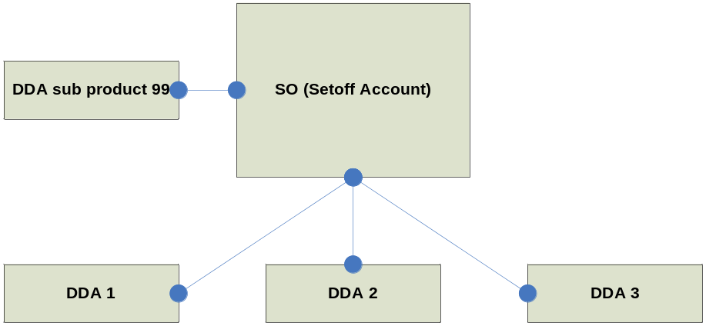

The system automatically creates an “SO” Driver type between the individual DDA account and the DDA 99 account when the “SOI” account to account relationship is recorded. The “SO” Driver ensures the net amount of funds processed to the individual DDA account is reflected in the group DDA 99 account balance during every night’s processing. This will exclude the effective dated transactions. Effective dated transactions will be reflected in the DDA99 account separately and as individual amounts.

Diagram Illustration

The example below illustrates the “relationships” for 3 DDA accounts participating in an automated setoff arrangement on CACHE.

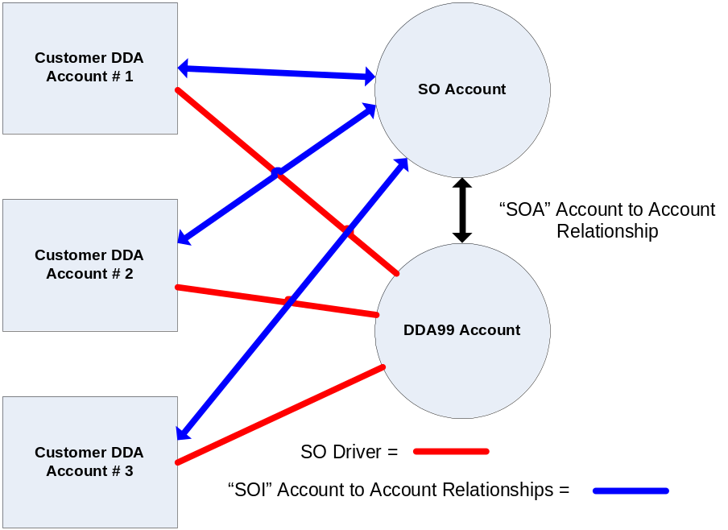

DDA Accounts participating in a setoff arrangement

The inclusion of a DDA account into a setoff arrangement is restricted to certain subproduct codes as detailed in the table below:

Subproduct Code | Type of Account
01 | CANBI Government
03 | CABI Payable Bank Cheque
04 | CANBI Public Trading
08 | CANBI Business
50 | CABI Business
52 | CABI Other Bank/Government
53 | NCIA Non Cheque Issuing Account
54 | CABI Public Trading
58 | Short Term Account (STA)
60 | ANZ Corporate Investment Account
70 | One Day Term Deposit (ODTD)

If an attempt is made to include a DDA account that is not an allowable subproduct code into a setoff arrangement, the system will display:

Error message: 788 INVALID SETOFF SUBPROD.

  - Setoff Start Date

The commencement/start date of the individual DDA account being in the Setoff arrangement will be defaulted with the date that the Account to Account Relationship of “SOI” is established between the individual DDA account and the SO account.

If the commencement/start date is required to be an earlier date, maintenance to the date must be performed on the IDS DDA Account Coding Structure (DD01) screen for the individual DDA account. This maintenance must be completed on the date that the “SOI” relationship is established.

The commencement/start date of the individual DDA account being included in the Setoff arrangement can be specified to a date up to 60 days prior to today’s system date or to the open date of the DDA Subproduct 99 account, whichever is the later date. This backdating allows for the inclusion of an account within the setoff arrangement when an error/omission had occurrred with the arrangement setup.

The open date of the DDA Subproduct 99 account is displayed on the DDA Account Coding Structure (DD01) screen for information purposes.

Interest and Setoff Arrangements
  - Debit and Credit Interest Codes

The Debit and Credit Interest Codes on the DDA accounts participating in the setoff arrangement are automatically changed to “00” when the account is successfully linked to the SO account with the “SOI” account to account relationship.

This ensures that there is no debit or credit interest accrued on the accounts whilst they participate in the setoff arrangement.

When an account is removed from the setoff arrangement, the Debit and Credit Interest Codes automatically return to the codes that were loaded on the account prior to the linkage into the setoff arrangement.

  - DDA 99 account Interest Details

The Interest rate on the DDA Subproduct 99 can be recorded either at a single Interest Rate or a Tiered Interest Rate structure.

Interest Code details for the DDA Subproduct 99 are recorded on the DDA Interest/Fees (DD02) screen. Specific details are also recorded on the DDA Interest Rate Info DD11, DD12 and DD13 screens to record % factors, points difference and tiered limit amounts.

A Weighted Average Interest Rate is calculated by CACHE when the DDA 99 account uses a tiered interest rate structure. This weighted interest rate is displayed on the Customer Advice produced after interest has cycled on the DDA 99 account.

Interest is calculated
- daily on the end of day balance of the DDA 99 account and cycled on the first business day of the month, and
- cycled at the closure of the DDA 99 account.

Interest accrued on the DDA 99 account is updated for the current cycle when effective dated transactions are posted to the account.

  - DDA 99 account Allowable Interest Codes

The following table details the allowable interest codes that can be recorded on the DDA 99 account:

Debit Interest Code | Debit Interest Description
00 | No interest calculated
D1 | Grade 3 Default
D2 | Prime Acct Lvl Int Rate
D3 | Fixed Rate Interest
D5 | Grade 3 Default
D8 | Prime Acct Lvl Int Rate
D9 | Bank Bill Swap Reference Rate DR

Credit Interest Code | Credit Interest Description
00 | No interest calculated
A1 | Calculated Cash Rate
A2 | Calculated Cash Rate
C1 | Business Deposit Rate
C2 | Prime Acct Lvl Int Rate
C3 | Fixed Rate Interest
C4 | Business Deposit Rate
C5 | Prime Acct Lvl Int Rate
C6 | Bank Bill Swap Reference Rate CR
C8 | Business Deposit Rate
C9 | Bank Bill Swap Reference Rate CR
E1 | Official Cash Rate 1 – E1
E2 | Official Cash Rate 2 – E2
F1 | Corporate Deposit Rate 1 – F1
F2 | Corporate Deposit Rate 2 – F2
G1 | Corporate Deposit Rate 1 – G1
G2 | Corporate Deposit Rate 2 – G2
O1 | Overnight Cash Rate 1 – Split
O2 | Overnight Cash Rate 2 – Entire Balance

External link  | Refer to Codes BFS.  This can be located via PVCS – click here for Web Access.  Location: X\Projects\CACHE_ORION\Baseline Documentation\CACHE\.....

  - Default Interest Rate Structure

The account setup default interest codes for the DDA 99 account are as follows:

- Debit Interest: D2
- Credit Interest: C2

These codes are defaulted on the DDA Interest/Fees (DD02) screen during the account setup screen flow.

One of the following screens will automatically be defaulted during the account setup screen flow, depending on the Interest Code loaded on the account on the DD02 screen:

- DDA Interest Rate Info (DD11) screen for Points Difference and % Factor,
- DDA Interest Rate Info (DD12) screen for Fixed Interest Rate, or
- DDA Interest Rate Info (DD13) screen for Tiered Interest Rate structure.

When the Interest Rate Code is changed/maintained after the completion of the account setup, the change must be made on the DD02 screen and the appropriate DD11, DD12 or DD13 screen selected and maintained as required.

  - Penalty Interest Indicator

The Penalty Interest (Y/N) indicator is displayed on the DDA Account Coding Structure (DD01) screen.

Enquiry and maintenance is performed on the DD01 screen for this indicator.

Penalty Interest is automatically calculated on the DDA 99 account if the Penalty Interest Applicable flag is “Y” and

- the account is in debit, or
- the account is in excess of the Basic Limit loaded for Penalty Interest calculations.

The current CACHE Penalty Interest rate is 4% for DDA accounts.

When the DDA 99 account has a recorded Basic Limit, the penalty interest amount is calculated on whole balance, including the amount in excess.

Refer to Setoff Arrangement Maintenance & Closure Reference Module for details on adding and deleting Penalty Interest details.

If the Penalty Interest indicator on the DDA 99 account is “Y”, Penalty Interest will be automatically calculated on:
- the entire debit balance of the account if there is no limit recorded, or
- the entire debit balance including the amount exceeding the recorded limit.

  - Basic Limit Loaded for Penalty Interest Calculation

The O/D Limit INQ / Maint (ODMU) screen is used to record the Basic Limit amount for the DDA 99 account.

The recorded limit is relevant when the Penalty Interest flag on the DDA 99 account is set to “Y”.

The following fields are relevant for data entry on the ODMU screen for the DDA 99 account:

- Limit 1 Type
- Limit 1 Amount
- Limit 1 Start Date
- Limit 1 Expiry Date
- Limit 1 R/T Indicator.

- When maintenance is attempted on any of the above detailed fields for Limits 2 and 3 on the ODMU screen for a DDA 99 account, the system will display the following error message:

2068 ONLY LIMIT 1 VALID FOR DDA99

- If a Limit Type other than ‘81’ is entered for Limit 1 on the DDA 99 account, the system will display:

Error message: 2069 LIMIT TYPE INVALID FOR DDA99

- All other fields on the ODMU screen are not applicable for the Basic Limit loaded for Penalty Interest calculation or the DDA 99 account. If maintenance is attempted on any of these fields that permit data entry on the ODMU screen, the system will display:

Error message: 2074 CAN ONLY CHANGE LIMIT 1 VALUES

  - Changing Penalty Interest

Question: Is there any way to change penalty interest.

Answer: You can't actually change the penalty interest rate -- it is set within CACHE. However, you can effectively charge a different penalty rate by using a D5 interest code and then tiering the debit interest on the DD13 screen.

You could then set (for example) balances over $4MIL to attract an extra 2% margin. In this case you would switch the penalty interest off on the DDA 99. Best to keep a note in the file if this occurs, as someone else looking at it might just assume that there is no penalty at all, switch it on and we would then charge +6%.

Additionally if a “D5” interest code is used then penalty interest on DD01 cannot be set to “Y” so the system cannot double charge the customer.

Note: if the normal DDA account that is taking part in the setoff has a Net Limit loaded on the ODMU screen then this is the limit that should be held on the DDA 99 account as the OD Limit.

The Net Limit on a normal account shows the limit when the account is part of a group limit (GLP – Group Level Participant). This Net Limit should also be reflected on the DDA 99 account. If it is not this needs to be investigated with the account controller and fixed as there may be a serious interest problem in the making.

When a Net Limit is loaded on a normal DDA account or a DDA 99 account the flag on DD01 should be manually changed to “Y” for penalty interest otherwise there is no point in having the limit loaded.

NOTES:
1. The Gross Limit must always be equal to or greater than the Net Limit.

2. The Net Limit loaded on the nominated DDA account in a setoff arrangement should also be on the DDA 99 account.

3. The Gross Limit is the maximum total of all debit balances of accounts within a group limit arrangement (e.g. a setoff).

Example. Four accounts in setoff: A, B, C & D.
a) Balance A: $4M DR
B: $6M DR
C: $8M CR
D: $5M CR
Setoff (i.e. net): $3MIL CR
Gross: $10MIL DR (i.e. sum of accounts in debit, A & B)
If the gross limit is lower than $5MIL, then the setoff is in excess.

4. Anything over the net limit will charge penalty interest if flagged as "Y" on DD01 for the DDA 99 account. As per point 2, the net limit should be the same as the DDA 99 limit. Note that CACHE charges penalty interest according to the DDA 99 limit.

5. Penalty interest cannot be charged against a gross limit, however, excess fees can be.

  - Backdating Penalty Interest Limit

The Limit Start Date of Limit 1 for a DDA 99 account can be backdated only if the Setoff Driver Account (DDA 99) and the setoff account (SO 01) were opened with a backdated date, and the setoff arrangement has not become active, i.e. balances have never been loaded to the account.

It is a standard of CACHE that activity (including Setoff calculations) cannot take place for a period prior to the opening. So the account linking cannot go beyond the date of the arrangement.

If the situation occurs where it is not possible to backdate to the required date then a manual interest calculation for the Penalty Interest component will need to be calculated for the period between the Setoff account activation and the current system date, i.e. when the limit will be loaded. In addition, all future backdated transactions into the period when the Penalty Interest limit was not loaded will need to be manually calculated. These manual interest calculations must be posted to the Interest Payment DDA Third Party account for the DDA 99 account.

The Limit Start Date cannot be backdated for a DDA 99 account if the actual open date of the DDA 99 was not backdated.

Error codes may include: 2075, 2076 & 2077.

Refer to CACHE Error Codes doc in PVCS https://pvcs.sdlc.anz:8443/Cache_Orion

X\Project\CACHE_Orion\Baseline Documentatio\CACHE\BFS\CACHE ERROR CODES.doc

  - Deleting a Basic Limit Loaded on DDA 99 Account

Use the following procedure when a request is received to delete/remove the Basic Limit loaded on the DDA 99 account:

Procedure Table

Step | Action
1 | Access IDSR > ODMU  Enquire on the DDA 99 account  Result  O/D Limits Inq/Maint (ODMU) screen  Basic limit is displayed in the Limit 1 fields as an “81” Limit Type
2 | Press: <enter>  Result  Screen message ACTION SUCCESSFUL is displayed  Basic Limit has been deleted from the DDA 99 account
  Complete fields | With:
  ACTION | CHG
  ACT (Limit 1) | D
3 | Is Penalty Interest to be charged to the account?  If Yes, go to step 5  If No, go to step 4
4 | Access IDSR > DDMN > DD01 screen for the DDA 99 account  Press: <enter>  Result  Screen message ACTION SUCCESSFUL is displayed  Penalty Interest will not be calculated on debit balances for the DDA 99 account.
  Complete fields | With:
  ACTION | CHG
  PENALTY INTEREST APPLICABLE (Y/N) | N
5 | Complete any manual procedures, e.g. filing of Setoff Schedule of Arrangements Form, Request for maintenance of Setoff Arrangement.

Next Day

- Confirm the deletion of the Basic Limit Details of the DDA 99 account

Enquire on the CR5199 Maintenance Audit Journal

Confirm the display of the following Basic Limit details that have been deleted:
- LT Description 1
- Limit Amount 1
- Limit Start Dt 1
- Limit Exp Date 1
- R/T Indicator 1

Verify these details are being displayed in the “Old Data” section and the “New Data” section is displaying blanks.

- Confirm the maintenance to the Penalty Interest indicator of the DDA 99 account (if applicable)

Enquire on the CR5199 Maintenance Audit Journal

- Confirm the display of the following Penalty Interest indicator

Verify “Y” is being displayed in the “Old Data” section and the “New Data” section is displaying “N”.

  - Adding a Basic Limit on DDA 99 Account for Penalty Interest Calculation

Use the following procedure when a request is received to add a Basic Limit for the DDA 99 account:

Procedure Table

Step | Action
1 | Access IDSR > ODMU  Enquire on the DDA 99 account  Result  O/D Limits Inq/Maint (ODMU) screen
2 | Press: <enter>  Result  Screen message ACTION SUCCESSFUL is displayed  Basic Limit has been added to the DDA 99 account
  Complete fields | With:
  ACTION | ADD
  For Limit 1:
  ACT | A
  TYPE | 81
  LIMIT | Amount of required Penalty Interest Limit
  START | Start date
  EXPIRY | Expiry date
  R/T | R
3 | Access IDSR > DDMN > DD01 screen for the DDA 99 account  Is the Penalty Interest indicator displayed as “Y”?  If Yes, go to step 5  If No, go to step 4
4 | Press: <enter>  Result  Screen message ACTION SUCCESSFUL is displayed
  Complete fields | With:
  ACTION | CHG
  PENALTY INTEREST APPLICABLE (Y/N) | Y
5 | Complete any manual procedures, e.g. filing of Setoff Schedule of Arrangements Form, Request for maintenance of Setoff Arrangement.

Next Day Procedure

Next Day

- Confirm the addition of the Basic Limit Details of the DDA 99 account

Enquire on the CR5199 Maintenance Audit Journal

Confirm the display of the following Basic Limit details that have been added:
- LT Description 1
- Limit Amount 1
- Limit Start Dt 1
- Limit Exp Date 1
- R/T Indicator 1

Verify these details are being displayed in the “New Data” section and the “Old Data” section is displaying blanks.

- Confirm the maintenance to the Penalty Interest indicator of the DDA 99 account (if applicable)

Enquire on the CR5199 Maintenance Audit Journal

- Confirm the display of the following Penalty Interest indicator

Verify “N” is being displayed in the “Old Data” section and the “New Data” section is displaying “Y”.

  - ORION and Penalty Interest (via Facilities Tab)

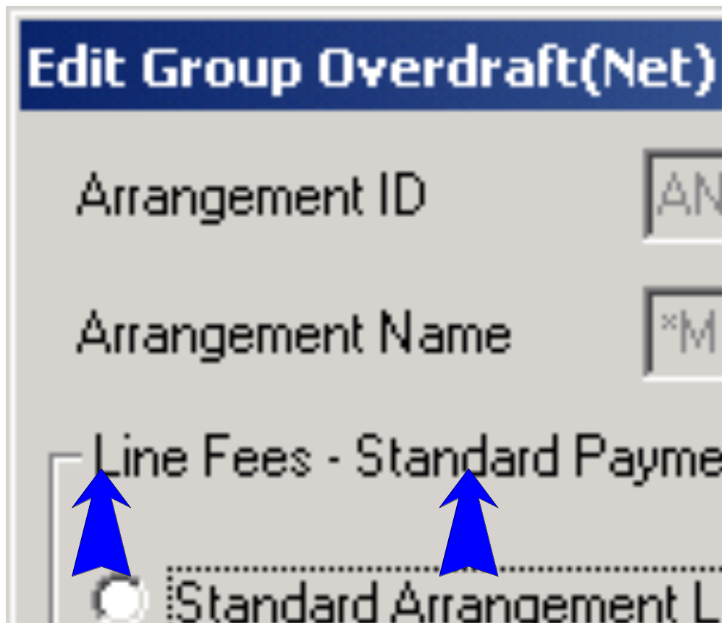

For a SETOFF it’s CACHE that will charge the Penalty Interest!

So when these above fields for GROSS & NET Limit are not changed to 0.00 you will find Orion charging Penalty Interest Incorrectly.

  - Changing the Interest Rate Structure

A request to change the Interest Rate Structure on the DDA 99 account from one structure to another must be completed by “adding” the new code and effective dated details.

Changes to the Interest Rate Code on the DDA 99 account should be performed at the beginning of the new interest cycle, ie. on the second business day of the month.

Question: Is interest calculated from the date that the limit is amended?

Answer: No. Interest is calculated from the start to the end of the current CACHE Cycle, regardless when the change is made during the current Cycle. The Driver (DDA 99 A/C) calculates interest at the end of CACHE Cycle and calculates it at whatever Limit is loaded on cache at that time.

The DDA 99 account should only have a maximum of 2 Interest Codes during the month, ie. the Interest Code should only be changed once during the interest cycle period. If there are more than 2 Interest Codes applicable for the DDA 99 account during the interest cycle period, the Customer Advice generated by the system, after interest has cycled, will be held on the “Out of Balance” file and will require manual action – refer Setoff Arrangement Customer Reporting reference module.

It is preferable to maintain the Interest Rate Structure on the DDA 99 account applicable at the current system date, rather than backdating the new structure’s effective date, as the interest accrual amounts have been calculated and stored for each transaction posted to the account.

If the change to the Interest Rate Structure must be applied with a backdated effective date, the change can be completed on CACHE, however additional manual procedures must be undertaken. Refer details listed at “Effective Dated Interest Rate Structure/Code Change request”.

  - Effective Dated Interest Rate Structure/Code Change request

The Effective Date of a new Interest Code automatically defaults to the current system date on the DD11, DD12 or DD13 screen, depending on the new interest code recorded on the account.

If the Effective Date is amended to be a date in the past, the interest accrual adjustments are NOT automatically processed on the previous transactions.

To update the interest accrual for the account when a backdated interest rate code/structure change is applied to the account:

- all transactions posted to the DDA 99 account since the date of the new interest rate structure must be reversed online, remembering to reverse in the order of “last in, first out”, and then re-posted with the applicable effective date, OR

- manually calculate and post the interest adjustment for the period when the “new” interest rate structure should have been applicable. This interest adjustment must be posted to the DDA 99 Third Party account.

If the latter option is adopted, all backdated transactions that are subsequently processed in the future into the period when the “old” structure was applicable, will require a manual interest adjustment. These transactions are reported on the CR5203 Account Exceptions Report with the message “Backdate Beyond Interest Code Change – Current Cycle”.

  - Weighted Average Interest Rate

The Weighted Average Interest Rate is calculated as follows:

(TL1 X TIR1) + {(TL2 – TL1) X TIR2 } + {(TL3 – TL2) X TIR3 } +{(TL4 – TL3) X TIR4 } +{(TL5 – TL4) X TIR5 } +{(TL6 – TL5) X TIR6 } +{(TL7 – TL6) X TIR7 } +{(TL8 – TL7) X TIR8 } + {(TL9 – TL8)X TIR9} X 100
Balance of Account

TL1 = Tier 1 Limit
TIR1 = Tier 1 Interest Rate
TL2 = Tier 2 Limit
TIR2 = Tier 2 Interest Rate
TL3 = Tier 3 Limit
TIR3 = Tier 3 Interest Rate
TL4 = Tier 4 Limit
TIR4 = Tier 4 Interest Rate
TL5 = Tier 5 Limit
TIR5 = Tier 5 Interest Rate
TL6 = Tier 6 Limit
TIR6 = Tier 6 Interest Rate
TL7 = Tier 7 Limit
TIR7 = Tier 7 Interest Rate
TL8 = Tier 8 Limit
TIR8 = Tier 8 Interest Rate
TL9 = Tier 9 Limit
TIR9 = Tier 9 Interest Rate

Note: When subtracting Limit of Tier 1 from Limit of Tier 2, if the limit of Tier 2 is less than the account balance, utilise the limit amount.
When substracting Limit of Tier 2 from Limit of Tier 3, if the limit of Tier 3 is less than the account balance, utilise the limit amount.
When substracting Limit of Tier 3 from Limit of Tier 4, if the limit of Tier 4 is less than the account balance, utilise the limit amount.
When substracting Limit of Tier 4 from Limit of Tier 5, if the limit of Tier 5 is less than the account balance, utilise the limit amount.
When substracting Limit of Tier 5 from Limit of Tier 6, if the limit of Tier 6 is less than the account balance, utilise the limit amount.
When substracting Limit of Tier 6 from Limit of Tier 7, if the limit of Tier 7 is less than the account balance, utilise the limit amount.
When substracting Limit of Tier 7 from Limit of Tier 8, if the limit of Tier 8 is less than the account balance, utilise the limit amount.
When substracting Limit of Tier 8 from Limit of Tier 9, if the limit of Tier 9 is less than the account balance, utilise the limit amount.

If the limits are greater than the account balance, then utilise the account balance.

DDA 99 account 8452XXXXX utilises the Credit Interest Code of C6 with a 9 tier structure as follows:

Level 1 Minus 0.75000 of C6 rate for amounts up to $10,000,000.00

Level 2 Minus 0.25000 of C6 rate for amounts of equal to and greater than $10,000,000.00 but less than $15,000,000.00

Level 3 Minus 0.15000 of C6 rate for amounts equal to and greater than $15,000,000.00

Level 4 Say zero because limit for level 3 is set as maximum.
Level 5 Say zero because limit for level 3 is set as maximum.
Level 6 Say zero because limit for level 3 is set as maximum.
Level 7 Say zero because limit for level 3 is set as maximum.
Level 8 Say zero because limit for level 3 is set as maximum.
Level 9 Say zero because limit for level 3 is set as maximum.

To calculate the Weighted Average Interest Rate for a particular day:

Daily Balance of the account = $16,719,359.40

Interest Rate for the C6 Interest Code = 4.93%

$9,999,999.99 x (4.93 – 0.75) + (($14,999,999.99 – 9,999,999.99) x (4.93 – 0.15)) + (($16,719,359.40 – 14,999,999.99) x (4.93 – 0.15)) + ((9,999,999.99 - 9,999,999.99) X (1 – 1 )) + ((9,999,999.99 - 9,999,999.99) X (1 – 1 )) + ((9,999,999.99 - 9,999,999.99) X (1 – 1 )) + ((9,999,999.99 - 9,999,999.99) X (1 – 1 )) + ((9,999,999.99 - 9,999,999.99) X (1 – 1 )) + ((9,999,999.99 - 9,999,999.99) X (1 – 1 )) + ((9,999,999.99 - 9,999,999.99) X (1 – 1 )) + ((9,999,999.99 - 9,999,999.99) X (1 – 1 ))
_____________________________________________________________________ x 100
16,719,359.40

734,185.37937 x 100
16,719,359.40

= 4.39122%
  - Interest Rate for accounts participating in a setoff arrangement

The Debit and Credit Interest Codes on the individual DDA account involved in a setoff arrangement are automatically set to “00” (No interest charged) when they are linked to the setoff arrangement, ie the “SOI” link is established.

The previous Interest Code for each individual DDA account is stored on the account and used as the default code if the account is removed from the setoff arrangement.

____ DD02 2 IDS DDA INTEREST/FEES 09/02/2010 18.17
DDMN MESSAGE: ACTION SUCCESSFUL
ACTION INQ PRODUCT DDA ACCOUNT 837399999

INTEREST INFORMATION CODE CYCLE
DEBIT INTEREST 00 DA INTEREST PYMT METHOD TA
CREDIT INTEREST 00 DA ACCT TO DR/CR - PROD
- ACCT
INTEREST TERM - DAYS
DATE NXT DB INT CYCLE

FEES INFORMATION CHARGE CODE WAIVE CODE AMT PER ITEM NO. OF ITEMS
SERVICE CHARGE 81 00
STMT COLLECTION FEE 81 00 7.00
SWEEP SERVICE FEE 81 00 1.50
STOP PAYMENT FEE 81 00 15.00
SETOFF SERVICE FEE 81 00 2.38

GOV DUTIES PYMT METHOD TA
BANK FEES CYCLE CODE 32 BANK FEES PYMT METHOD TT
ACCT TO DEBIT - PROD DDA
- ACCT 305200000

ACCOUNT # 000000837399999 ACTION INQ PROD DDA
FIELD 78 (97=MENU) RESULT ACTION COMPLETE
MAINTENANCE DDA ANZ SPECIFIC DATA2
-- MISCELLANEOUS BANK FEES TABLE DATA -- -- SETOFF FIELD VALUES --
TY WV FEE PER ITEM TOTAL ITEMS SETOFF ACAC LINK TYPE: I
1. 81 00 0.00 0 SETOFF ACCOUNT NO : 845299999
2. 81 00 0.00 0 SETOFF DDA99 OPEN : 02/09/2002
3. 81 00 0.00 0 SETOFF START DATE : 22/10/2003
4. 81 00 0.00 0 SETOFF LOAD DATE : 23/10/2003
5. 0.00 0 SETOFF REL DRV SEQ: 3
6. 0.00 0 SETOFF FEE CHARGED:
7. 0.00 0
8. 0.00 0 LAST DR INT CODE : D2
9. 0.00 0 LAST DR INT CD CHG: 23/10/2003
10. 0.00 0 LAST CR INT CODE : C2
LAST CR INT CD CHG: 23/10/2003

SUB PRODUCT CODE : 50
PORTFOLIO PRODUCT CODE:
COST CENTRE OVERRIDDEN:

DDA account 837399999 had a Debit Interest Code of “D2” and Credit Interest Code of “C2” prior to it being linked to the setoff arrangement on 23/10/2003. If this account is removed from the setoff arrangement, ie the “SOI” link is removed, the Interest Codes will be restored to these values.

DDA 99 Account Subproduct Transfer

The DDA 99 account cannot be transferred to another subproduct code. Conversely, other subproduct codes cannot be transferred to a subproduct 99 account.

If a subproduct transfer is attempted on the DDA 99 account using the DDT2 DDA Sub-product Change screen, the system will display the following error message:

270 NEW SUBPROD CANT BE TRANSFERRED TO

If a subproduct transfer is attempted on an individual DDA account that is currently in a setoff arrangement, to be a subproduct that is not an “allowable” subproduct for inclusion in a setoff arrangement, the system will display the following error message:

2066 INVALID SUBPROD FOR SETOFF

Opening the DDA 99 account

Pre-requisite: | Accrued Interest on the individual DDA accounts in the Setoff arrangement must have been cycled prior to setting up the automated processing account to account relationships, i.e. cycled in the previous night’s batch cycle.  Setoff Schedule of Arrangements form received from Account Manager

Prior to CACHE ANGI (Installed in Release 11.3)

Note: User would obtain an Account Number from the Register reserved for DDA 99 Setoff accounts. The Account Number range of 845257043 to 845318117 was allocated for CACHE DDA 99 accounts. This range was HARD CODED in CACHE.

Post CACHE ANGI (Installed in Release 11.3)

Note: User can obtain an Account Number from ANGI (ANIN screen/or via Orion) for DDA accounts or have one auto allocated at Step #4. The Account Number range in ANGI has been allocated for CACHE DDA accounts (any sub product) by CAP ANGI.

There is NO Hard Coding related to the account number since Release 11.3 was installed in Sept 2011.

- Logon to CACHE

- Access IDSR > DDMN > DD04 for each individual DDA account
Confirm each DDA account has zero interest accrued for both debit and credit interest

Note: | The individual DDA account will not be able to be linked to the setoff arrangement unless all interest accrued has been cycled. However, the account setup of the DDA 99 account and SO account can continue. The linkage of the individual DDA account can be completed next day, with an effective dated link date, once the interest accrued has been successfully cycled.

- Use CIS Account Setup (ACSU) function to open the DDA 99 account (either include the pre-allocated account number on the HCIR/HCIS screen or allow the system to auto allocate a DDA account number for you.

- The DDA 99 account Open Date can be backdated if required.
- Use the same Cost Centre and Officer details as recorded on the SO account.
- The Mailing Title for the account will be used for the mailing of the Customer Advice document.
- Maintain Setoff Establishment Fee and Setoff Service Fee details depending on Fee pricing arrangement for the customer.
- Use a DDA Third Party account for the payment of Interest and Fees that is NOT an account participating in the setoff arrangement. NB: this is a suggested business rule and has no system validations to enforce it (i.e. it can be and often is not followed).
- If the DDA Interest Rate Info (DD11) screen is displayed, ensure the Account Level Percentage Factor % is changed to 1.0000.
- Ensure care is taken with loading of tiered interest rate structures on DD13 when required, e.g. % Factor, Limit Amount of all “9’s”, if tier is up to $5000.00, load a value of $4,999.99.
- Maintain the Number of Copies field on the DD03 screen if the customer requires more than 1 copy of the Customer Advice.
- Ensure the DDA 99 account is linked to a Customer record that has a TFN/ABN recorded, otherwise Withholding Tax will be calculated and charged to the account.
Result

The account setup scenario is completed when the Screen Message 400 ACCOUNT SUCCESSFULLY ADDED is displayed on the CIS Common Functions Menu (MEN1) screen

- Does the Setoff arrangement require Penalty Interest rate to be recorded?

If Yes, go to Step 6
If No, go to Step 7

- Access the IDSR > ODMU screen for the DDA 99 account.
Add the Penalty Interest Rate limit amount in Line 1 using an “A” line action code and a Type 81 limit.
Enter the required effective date of the Penalty Interest limit.
The limit will be displayed as a Basic Limit type.

The Effective dates of the Penalty Interest limit amount can be effective dated, both in the future, and in the past to accommodate a backdated DDA 99 account open. The limit cannot be backdated once a transaction has been posted to the DDA 99 account.

Check PCD 71151 for the account to display any multiple effective dated entries.

Go to Step 8

- Access the IDSR > DDMN > DD01 screen for the DDA 99 account.
Maintain the Penalty Interest flag - to be “N” if no or “Y” for yes (Penalty Interest).

- Does the DDA 99 account require access to the ANZ OnLine enquiry function?

If Yes, go to step 8
If No, go to step 9

- Access IDSR > ANZC screen for the DDA 99 account

Complete fields | With:
Action | CHG
ANZ OnLine Facility (Y/N) | Y
ANZ OnLine Cust Number | Customer Number

Press: <Enter>

Result:

ANZC Screen should be returned with the following message displayed:

Message: 1754 CONFIRM ARP CODE CHANGES

PLEASE CONFIRM THE CHANGES (Y/N) “Y” is displayed

Press: <Enter>

Result:

Screen should be returned with the following message displayed:

Message: ACTION SUCCESSFUL.

- DDA 99 account setup is complete. Continue to open SO account and establish the account to account linkages for the automated setoff arrangement.

  - Opening the SO account

Step | Action
1 | Obtain Account Number from Register reserved for the 10 digit SO account number
2 | Use CIS Account Setup (ACSU) function to open the SO account  - The SO account Open Date can be backdated if required – the Open Date of the SO account should be the same date as the Open Date for the DDA 99 account  - Ensure the Cost Centre and Officer details coincide with those details recorded on the DDA 99 account  - Ensure the ACAC Additional Setup Screens option is selected with a “Y” on the CIS SO Account Setup screen
3 | When the ACAC screen is displayed in the setup scenario,  Link the DDA 99 account and the individual DDA accounts to the SO account by completing the following:  Repeat the “SOI” entries for each individual DDA account to be included in the setoff arrangement  Press: <Enter>  Result:  ACAC Screen is returned with the following message displayed:  Message: 64183 ALL ACCT RELAT. PROCESSED  “-ADD” is displayed for each account relationship added to the SO account.
  Complete fields | With:
  ACT | A
  PRD | DDA
  ACCOUNT | DDA 99 account number
  RELATIONSHIP | SOA
  Complete fields | With:
  ACT | A
  PRD | DDA
  ACCOUNT | Individual DDA account number
  RELATIONSHIP | SOI
4 | Press: <PF2>  Result:  Account Profile (ACPR) screen is displayed for the SO account  Confirm the DDA 99 account number is displayed in the “DDA Setoff A/C” field  Confirm the DDA 99 account and the individual DDA accounts are displayed in the “Related Account” section of the screen

Step | Action
5 | Press: <PF2>  Result:  The account setup scenario is completed when the following message is displayed on the CIS Common Functions Menu (MEN1) screen:  Message: ACTION SUCCESSFUL
6 | Is the setup of the setoff arrangement required to be backdated?  If Yes, go to step 7  If No, go to step 8
7 | The Setoff Start Date for the individual DDA accounts must be maintained to the backdated effective date.  Access IDSR > DDMN > DD01 for each individual DDA account  The Setoff Start Date will have defaulted to the system date.  Press:<enter>  Result  Screen is returned with the following message:  Message: ACTION SUCCESSFUL  Note: The maintenance to the Setoff Start Date for the individual DDA accounts must be completed on the day that the “SOI” links are created for the accounts. If a batch cycle has been run since the “SOI” link was created, the Setoff Start Date cannot be maintained to a backdated effective date. Refer to Setoff Arrangement Maintenance reference module for required action.
  Complete fields | With:
  ACTION | CHG
  SETOFF START DATE | Backdated effective date of the commencement of the setoff arrangement
8 | Access the DDA Interest/Fees (DD02) screen for each individual DDA account participating in the setoff arrangement:  - Confirm/Change Interest Payment Method to “TA”  - Confirm/Change Bank Fees Payment Method to “TA”.

Step | Action
9 | Confirm the completion of the linkages and establishment of the SO Driver instructions  - Access IDSR > DDMN > DD05 for each individual DDA account  Confirm that each DDA account has an “SO” Driver type with the DDA 99 account as the Related Account.  - Access IDSR > DDMN > DD02 for each individual DDA account  Confirm the Debit and Credit Interest Codes have been updated to ‘00”.  - Access IDSR > DDMN > DD01 for each individual DDA account  Confirm the DDA 99 account number is displayed in the “Setoff A/C” field.  Confirm the required commencement date is displayed in the “Setoff Start Date”.  - Access DDMU78 for the DDA 99 account  Confirm “A” is displayed in the “Setoff ACAC Link Type” field.  Confirm the 10 digit SO account number is displayed in the “Setoff Account Number” field.  Confirm the open date is displayed in the “Setoff DDA99 Open” field.  Confirm the system date is displayed in the “Setoff Load Date” field as this represents the date the “SOA” link was created between the SO and DDA 99 accounts.

Verification Options

Verification of the opening of the DDA 99 account and the associated automated setoff arrangement can be performed on the next business day using CACHE reports and CACHE screens.

Reports
The following CACHE reports can be used to assist verification using Control-D/Control-D-Web:

CR0010 New/Reopened/Transferred Accounts Report
DDA 99 account open details.

CR5286 Setoff Arrangement Details Report
“SOA” relationship created between the SO account and the DDA 99 account & “SOI” relationship created between the SO account and the individual DDA accounts.

CR0290 DDA Maintenance Audit Journal
DDA 99 account details, e.g. ANZIC Code, Withhold Code, Penalty Interest Indicator, Third Party Interest Payment DDA account number

CR5199 Maintenance Audit Journal
DDA 99 account Tiered Interest details, Third Party Bank Fee Payment DDA account number, Setoff Service Fee maintenance details, DDA 99 account Load Date and related SO account number

AR0004 CIS Maintenance Audit Report
DDA 99 account name, Mailing Title and Account to Customer relationship details

CR0091 Driver Relationship Report
SO Driver created for the individual DDA account with the DDA 99 account being the Related Account

CR5149 Transaction Posting Journal
Balance Load transactions posted to the DDA 99 account
Any Movement transactions (if open date was backdated) and Effective Dated transactions posted to the DDA 99 account Setoff Establishment Fee transaction posted to the DDA 99 account

CR5159 Trial Balance Report
DDA 99 account Current Balance, Limit, Debit Interest Accrued and Credit Interest Accrued details

Screens
Access IDSR > DDMN > DD06 for the DDA 99 account

Confirm the Account Balance History is displayed for the DDA 99 account.

Access IDSR > THMU for the DDA 99 account

Confirm the posting of the Balance Load and any applicable Movement and Effective Dated transactions to the DDA 99 account

Note: | Refer to the Setoff Arrangement Transaction processing module for detailed information regarding the transactions processed and applicable to the DDA 99 account.
Access IDSR > DDMN > DD01 for the DDA 99 account

Confirm the “Setoff Start Date” field displays the date of the first batch cycle in which the account was processed, i.e. last night’s cycle.

Access DDMU option 78 for the DDA 99 account

Confirm the system date of the nightly batch cycle is displayed in the “Setoff Start Date” field if transactions have been processed to the DDA 99 account. The “Setoff Start Date” is populated during the batch cycle when the first transactions are processed resulting from an SO driver instruction being operational.

 | Complete any manual procedures, e.g. filing of Setoff Schedule of Arrangements Form.

  - Changing the DDA 99 account Interest Rate Structure

  - Procedure Table

Use this procedure to change the Interest Rate Structure/Code for the DDA 99 account:

Step | Action
1 | Access IDSR > DDMN  Enquire on DDA Interest/Fees (DD02) screen for the DDA 99 account  Result  DDA Interest/Fees (DD02) screen
2 | Press: <enter>  Result  DDA Interest/Fees (DD02) screen with message ACTION SUCCESSFUL displayed
  Complete fields | With:
  ACTION | CHG
  DEBIT INTEREST CODE | New interest code applicable for the DDA 99 account
  CREDIT INTEREST CODE | New interest code applicable for the DDA 99 account
3 | Is the “new” Interest Code one of the following:  - D1  - D2  - D4  - D6  - C1  - C2  If Yes, go to step 4  If No, go to step 7
4 | Enquire on the DDA Interest Rate Info (DD11) screen for the DDA 99 account.  Result  DDA Interest Rate Info (DD11) screen with message ACTION SUCCESSFUL displayed  Confirm the “new” Interest Code is displayed and the current system date is displayed in the “Effective Date” field.
5 | Do you need to update the default % factor or Points Difference (Margin)?  If Yes, go to step 6  If No, go to step 7

Step | Action
6 | Press: <enter>  Result  DDA Interest Rate Info (DD11) screen with message ACTION SUCCESSFUL displayed  Ensure current system date is displayed in “Effective Date” of the “new” details
  Complete fields | With:
  ACTION | ADD
  ACCOUNT LEVEL PERCENTAGE FACTOR (%) | New Percentage factor,  Eg. Enter 80% of the Business Deposit Rate as “.80”  OTHERWISE Enter 1.0000
  ACCOUNT LEVEL POINTS DIFFERENCE (+/-) | New Margin,  Eg. Enter 2.5 points below Business Deposit Rate as “-2.5”.
7 | Is the “new” Interest Code one of the following:  - D3  - C3  If Yes, go to step 8  If No, go to step 11
8 | Enquire on the DDA Interest Rate Info (DD12) screen for the DDA 99 account.  Result  DDA Interest Rate Info (DD12) screen with message ACTION SUCCESSFUL displayed  Confirm the “new” Interest Code is displayed and the current system date is displayed in the “Effective Date” field.
9 | Do you need to update the defaulted Account Level Rate  If Yes, go to step 10  If No, go to step 11
10 | Press: <enter>  Result  DDA Interest Rate Info (DD12) screen will display message  ACTION SUCCESSFUL  Ensure current system date is displayed in “Effective Date” of the “new” details
  Complete fields | With:
  ACTION | ADD
  ACCOUNT LEVEL RATE | New Fixed Rate,  E.g. Enter 5.75% as “5.75”.

Step | Action
11 | Is the “new” Interest Code one of the following:  - D5  - D9  - A1  - A2  - C4  - C5  - C6  - C8  - C9  If Yes, go to step 12  If No, go to step 14
12 | Do you need to update the default % factor, Points Difference (Margin) or Tier Limit amounts?  If Yes, go to step 13  If No, go to step 14
13 | NOTE:  - Enter 0.00000 in the Percentage Factor if a Threshold Amount is to apply to the Level 1.  - Ensure the default limit of “99,999,999,999.99” is entered in Level 2, 3, 4, 5, 6, 7 and 8 limit if there is only 1 specified tier detailed in Level 1.  Press: <enter>  Result  DDA Interest Rate Info (DD13) screen with message ACTION SUCCESSFUL displayed  Ensure current system date is displayed in “Effective Date” of the “new” details
  Complete fields | With:
  ACTION | ADD
  LEVEL 1, 2 , 3, 4,5,6,7,8 & 9 PERCENTAGE FACTOR (%) | New Percentage factor,  Eg. Enter 80% of the Business Deposit Rate as “.80”.
  LEVEL 1, 2, 3, 4, 5, 6, 7, 8 & 9 POINTS DIFFERENCE (+/-) | New Margin,  Eg. Enter 2.5 points below Business Deposit Rate as “-2.5”.
  LEVEL 1, 2, 3, 4, 5, 6, 7 & 8 LIMIT | New $ Limit amount,  Eg, Up to $10,000.00, enter as “9,999.99”
14 | Complete any manual procedures, eg, filing Account Maintenance requests.
 | Next Day
Access Control-D/Control-D Web
Verify successful account maintenance is reported on the CR5199 Maintenance Audit Journal for the DDA 99 account

History of Interest Rate structure

The history of multiple interest rate structures on the DDA 99 account can be viewed on the DDA Interest Rate Info (DD11, DD12 and DD13) screens by changing the effective date with an “INQ” action code OR by typing “NXI” in the Action field.

In addition to these screens, the DDMU 78 screen displays the last Interest Rate Code and the Change Date as detailed below:

ACCOUNT # 000000837347954 ACTION INQ PROD DDA
FIELD 78 (97=MENU) RESULT ACTION COMPLETE
MAINTENANCE DDA ANZ SPECIFIC DATA2
-- MISCELLANEOUS BANK FEES TABLE DATA -- -- SETOFF FIELD VALUES --
TY WV FEE PER ITEM TOTAL ITEMS SETOFF ACAC LINK TYPE: I
1. 81 00 0.00 0 SETOFF ACCOUNT NO : 845299999
2. 81 00 0.00 0 SETOFF DDA99 OPEN : 02/09/2002
3. 81 00 0.00 0 SETOFF START DATE : 22/10/2003
4. 81 00 0.00 0 SETOFF LOAD DATE : 23/10/2003
5. 0.00 0 SETOFF REL DRV SEQ: 3
6. 0.00 0 SETOFF FEE CHARGED:
7. 0.00 0
8. 0.00 0 LAST DR INT CODE : D2
9. 0.00 0 LAST DR INT CD CHG: 23/10/2003
10. 0.00 0 LAST CR INT CODE : C2
LAST CR INT CD CHG: 23/10/2003

SUB PRODUCT CODE : 50
PORTFOLIO PRODUCT CODE:
COST CENTRE OVERRIDDEN:

Details above indicate that the last Credit Interest Code for this account was “C2” and was maintained on 23/10/2003.

These fields are modifiable for System Support purposes only – Do not maintain these dates unless advised by CACHE/ORION Second Level Support staff.

The DDA 99 account 845299999 currently displays a Credit Interest Code of “A1”. This Credit Interest Code has an effective date of 09/07/2000 which corresponds with the last change date displayed on the DDMU 78 screen for the account.

This DDA 99 account was changed from a Credit Interest Code of “C6” to “A1” on 09/07/2000.

____ DD13 2 IDS DDA INTEREST RATE INFO 09/09/2099 15.00
DDMN MESSAGE: ACTION SUCCESSFUL
ACTION INQ PRODUCT DDA ACCOUNT 845299999

INTEREST RATE INFORMATION

DEBIT INTEREST CODE 00

PERCENTAGE FACTOR (%) POINTS DIFFERENCE LIMIT EFF DATE

LEVEL 1 .00000 .00000 .00
LEVEL 2 .00000 .00000 .00
LEVEL 3 .00000 .00000
EXPIRY DATE

CREDIT INTEREST CODE A1

PERCENTAGE FACTOR (%) POINTS DIFFERENCE LIMIT EFF DATE

LEVEL 1 1.00000 .20000- 1000000.00 09/07/2000
LEVEL 2 1.00000 .07000- 99999999.00
LEVEL 3 1.00000 .00000 99999999999.99
LEVEL 4 .00000 .00000 99999999999.99
LEVEL 5 .00000 .00000 99999999999.99
LEVEL 6 .00000 .00000 99999999999.99
LEVEL 7 .00000 .00000 99999999999.99
LEVEL 8 .00000 .00000 99999999999.99
LEVEL 9 .00000 .00000
EXPIRY DATE 31/12/2799

DDA 99 account Example:

The DDA 99 account 845299999 has the following Interest Code details:

- Debit Interest Code of “D2”
- Credit Interest Code of “C6”.

____ DD02 2 IDS DDA INTEREST/FEES 09/02/2010 18.11
DDMN MESSAGE: ACTION SUCCESSFUL
ACTION INQ PRODUCT DDA ACCOUNT 845299999

INTEREST INFORMATION CODE CYCLE
DEBIT INTEREST D2 32 INTEREST PYMT METHOD TT
CREDIT INTEREST C6 32 ACCT TO DR/CR - PROD DDA
- ACCT 305605211
INTEREST TERM - DAYS
DATE NXT DB INT CYCLE

FEES INFORMATION CHARGE CODE WAIVE CODE AMT PER ITEM NO. OF ITEMS
SERVICE CHARGE 00 00
SETOFF SERVICE FEE 81 00 2.38 69

GOV DUTIES PYMT METHOD TT
BANK FEES CYCLE CODE 33 BANK FEES PYMT METHOD TT
ACCT TO DEBIT - PROD DDA
- ACCT 305605211

The Debit Interest Code of “D2” is displayed in detail on the DDA Interest Rate Info (DD11) screen.

The DDA 99 account 845299999 has a 0.50000 - margin recorded for its applicable debit interest rate.

____ DD11 2 IDS DDA INTEREST RATE INFO 09/01/2014 18.12
DDMN MESSAGE: ACTION SUCCESSFUL
ACTION INQ PRODUCT DDA ACCOUNT 845299999

INTEREST RATE INFORMATION

DEBIT INTEREST CODE D2

ACCOUNT LEVEL PERCENTAGE FACTOR (%) .0000
ACCOUNT LEVEL POINTS DIFFERENCE (+/-) 0.50000 EFFECTIVE DATE 29/09/2003
EXPIRY DATE 31/12/2799

CREDIT INTEREST CODE 00

ACCOUNT LEVEL PERCENTAGE FACTOR (%) .0000
ACCOUNT LEVEL POINTS DIFFERENCE (+/-) .00000 EFFECTIVE DATE 29/09/2003
EXPIRY DATE 31/12/2799

The Credit Interest Code of “C6” is displayed in detail on the DDA Interest Rate Info (DD13) screen.

The DDA 99 account 845299999 has a tiered structure recorded for its applicable credit interest rate.

The tiered structure displayed below shows an effective date of 22/7/2002. Historical record of any previous structure can be viewed by enquiring on the previous effective date, e.g. 21/07/2002 OR by typing “NXI” in the Action field.

____ DD13 2 IDS DDA INTEREST RATE INFO 09/09/2099 15.00
DDMN MESSAGE: ACTION SUCCESSFUL
ACTION INQ PRODUCT DDA ACCOUNT 845299999

INTEREST RATE INFORMATION

DEBIT INTEREST CODE 00

PERCENTAGE FACTOR (%) POINTS DIFFERENCE LIMIT EFF DATE

LEVEL 1 .00000 .00000 .00
LEVEL 2 .00000 .00000 .00
LEVEL 3 .00000 .00000
EXPIRY DATE

CREDIT INTEREST CODE C6

PERCENTAGE FACTOR (%) POINTS DIFFERENCE LIMIT EFF DATE

LEVEL 1 1.00000 .75000- 9999999.99 22/07/2002
LEVEL 2 1.00000 .25000- 14999999.99
LEVEL 3 1.00000 .15000- 99999999999.99
LEVEL 4 .00000 .00000 99999999999.99
LEVEL 5 .00000 .00000 99999999999.99
LEVEL 6 .00000 .00000 99999999999.99
LEVEL 7 .00000 .00000 99999999999.99
LEVEL 8 .00000 .00000 99999999999.99
LEVEL 9 .00000 .00000
EXPIRY DATE 31/12/2799

The previous tiered structure is displayed for the period 2/7/2002 until 21/7/2002 inclusive.

____ DD13 2 IDS DDA INTEREST RATE INFO 09/09/2099 15.00
DDMN MESSAGE: ACTION SUCCESSFUL
ACTION INQ PRODUCT DDA ACCOUNT 845299999

INTEREST RATE INFORMATION

DEBIT INTEREST CODE 00

PERCENTAGE FACTOR (%) POINTS DIFFERENCE LIMIT EFF DATE

LEVEL 1 .00000 .00000 .00
LEVEL 2 .00000 .00000 .00
LEVEL 3 .00000 .00000
EXPIRY DATE

CREDIT INTEREST CODE C6

PERCENTAGE FACTOR (%) POINTS DIFFERENCE LIMIT EFF DATE

LEVEL 1 1.00000 .60000- 10000000.00 02/07/2002
LEVEL 2 1.00000 .30000- 15000000.00
LEVEL 3 1.00000 .15000- 99999999999.99
LEVEL 4 .00000 .00000 99999999999.99
LEVEL 5 .00000 .00000 99999999999.99
LEVEL 6 .00000 .00000 99999999999.99
LEVEL 7 .00000 .00000 99999999999.99
LEVEL 8 .00000 .00000 99999999999.99
LEVEL 9 .00000 .00000
EXPIRY DATE 21/07/2002

Transactions of the DDA99 sub product SOA
Transactions processed to the DDA 99 account can be classified under the following categories:

- “B” transactions = Balance Load
- “M” transactions = Net Movement
- “E” transactions = Effective Dated
- “R” transactions. = Reversal

  - Balance Load “B” transactions

A Balance Load “B” transaction will be processed to the related DDA 99 account whenever a DDA account is linked to a setoff arrangement by adding the “SOI” account to account relationship.

The Balance Load “B” transaction is processed to the DDA 99 account in the nightly batch cycle. The value of the “B” transaction is the “end of day” balance for the individual DDA account for the effective day of the “SOI” relationship, i.e. the Setoff Start Date recorded on the individual DDA account.

The “Balance Load” transactions posted to the DDA 99 account are uniquely identifiable with a Description of the account number being loaded followed by the character “B”. The originating individual account number is also displayed in the “Transfer from Acct” field on the SDET screen.

Transaction History of the DDA 99 account will reflect the “Balance Load” of each individual DDA account participating in the setoff arrangement. If the individual DDA account has a zero balance at ‘end of account processing’, a “balance load” transaction will not be processed to the DDA 99 account.

Note: If the DDA 99 account open has been backdated, there will also be “Movement” transactions processed if the individual DDA account balance has changed daily.

____ STMT 1 THF STATEMENT FORMAT INQUIRY 27/10/2010 11.51
STFD MESSAGE: 50852 ACTION COMPLETE

ACCOUNT 000000845299999 FROM THRU PAGE
13/10/2010 21/10/2010 00001
VALID ACTN: SDET PREVIOUS BALANCE
ACTN POST EFF DESCRIPTION
DATE DATE DEBITS CREDITS BALANCE AFTER
13/10 SO EST FEE POSTING
13/10 100.00 100.00-
13/10 WAIVE FEE
13/10 100.00 .00
14/10 835500000M
11/10 1,373.02 1,373.02-
14/10 835500000B
04/10 73.83 1,446.85-
14/10 835500000M
06/10 1.88 1,444.97-
14/10 775500000B
04/10 19.80 1,464.77-
14/10 775500000M
07/10 10.19 1,454.58-

  - Net Movement “M” transactions

A Net Movement “M” transaction is processed to the DDA 99 account in the nightly batch cycle when there has been a “movement” or change in the account balance of the individual DDA account from the previous day.

The “Movement” transactions posted to the DDA 99 account are uniquely identifiable with a Description of the account number of the originating individual DDA account followed by the character “M”. The originating individual account number is also displayed in the “Transfer from Acct” field on the SDET screen.

The “Movement” transaction value does not include the value of the effective dated transactions. This value is processed separately as individual amounts (Refer Section 12.3 Effective Dated “E” Transactions)

____ STMT 1 THF STATEMENT FORMAT INQUIRY 27/10/2009 10.58
STFD MESSAGE: 50852 ACTION COMPLETE

ACCOUNT 000000845255555 FROM THRU PAGE
02/09/2009 03/09/2009 00003
VALID ACTN: SDET PREVIOUS BALANCE 7,582,941.42
ACTN POST EFF DESCRIPTION
DATE DATE DEBITS CREDITS BALANCE AFTER
02/09 RV INT POSTING
02/09 4.95 7,616,667.58
02/09 775400000E
01/09 41,131.79 7,657,799.37
02/09 775400000M
02/09 255.11 7,657,544.26
02/09 833400000M
02/09 15,017,293.00 7,359,748.74-
02/09 775300000M
02/09 201,146.45 7,158,602.29-
02/09 775600000M
02/09 449,758.33 6,708,843.96-
02/09 833500000M
02/09 17,957,230.17 11,248,386.21

  - Effective Dated “E” transactions

An Effective Dated “E” transaction is processed to the DDA 99 account immediately when an effective dated transaction is posted online to the individual DDA account participating in the setoff arrangement.

The “E” transaction will only be processed when a backdated transaction is posted online to an individual DDA account participating in a setoff arrangement that has previously had the balance of this account loaded to the DDA 99 account.

The “E” transaction is immediately posted to the DDA 99 account to update the setoff account balance. This type of transaction is uniquely identifiable with a Description of the account number to which the backdated transaction was posted followed by the character “E”. The originating individual account number is also displayed in the “Transfer from Acct” field on the SDET screen.

The “E” transaction value will not be included in the end of day “Movement” transaction value which goes to the DDA 99 account.

____ STMT 1 THF STATEMENT FORMAT INQUIRY 27/10/2009 10.56
STFD MESSAGE: 53557 FUNCTION CURRENTLY ACTIVE

ACCOUNT 000000845299999 FROM THRU PAGE
02/09/2009 02/09/2009 00001
VALID ACTN: SDET PREVIOUS BALANCE 7,582,941.42
ACTN POST EFF DESCRIPTION
DATE DATE DEBITS CREDITS BALANCE AFTER
02/09 RV INT POSTING
02/09 .11 7,582,941.31
02/09 RV - RV IN
02/09 .11 7,582,941.42
02/09 775300000E
01/09 1,067.81 7,581,873.61
02/09 RV INT
02/09 .86 7,581,872.75
02/09 RV - RV IN
02/09 .86 7,581,873.61
02/09 775300000E
01/09 7,122.27 7,574,751.34
02/09 775300000E
01/09 .11 7,574,751.23

  - Reversal “R” transactions

A Reversal “R” transaction is processed to the DDA 99 account when a previously posted transaction to the DDA 99 account is reversed using the RVTR function.

  - Transaction Reversal process

Transactions can be reversed on the DDA 99 account using the RVTR action on the IDSR/THFR Single Trans Detail Inq (SDTD) screen.

Refer to the Setoff Arrangement Maintenance & Closure Reference Module for details regarding the circumstances for the reversal of transactions that have been processed to the DDA 99 account.

  - Transaction History Details

  - Trace ID

Transactions generated by the system to the DDA 99 account display a unique Trace ID of “SOIGN….”. (Refer #1 below).
# 1

____ SDTD 2 THF SINGLE TRANS DETAIL INQ 27/10/2010 11.11
STFD MESSAGE: 50852 ACTION COMPLETE
ACTION (RVTR, DISH)

PRODUCT DDA ACCOUNT 000000845299999 SUB-PRODUCT 99 BRANCH 3052
TRAN CODE 4708 DESCRIPTION 775099999B 503568

POST DATE 02/07/2002 EFFECTIVE DATE 02/07/2002 TRACE ID SOIGN102070200000749
TRANSACTION AMOUNT 90,999.98 DR/CR C
AUX DOM EX.AUX.DOM COLLECTION ITEMS

BALANCE AFTER POSTING 90,999.98

TRANSACTION REVERSED N
REVERSAL TRANSACTION N
INTERNALLY GENERATED Y
GLI SOURCE Y

TRANSFER TO ACCT
TRANSFER FROM ACCT 775099999

# 4
# 3
# 2

  - Transaction Description
- The account number of the originating individual DDA account is displayed in the “Description” field followed by a “B” character for the “Balance Load” transaction to the DDA 99 account. (refer #2 above)

- The Subproduct Code and Cost Centre of the originating individual DDA account is displayed in the “Description” field. (refer #3 above)

- The account number of the originating individual DDA account is displayed in the “Transfer From Acct” field. (refer #4 above)

Driver Processing

  - DDA 99 Account Balance Update

Driver Processing facilitates the processing of transactions to the DDA 99 account to reflect the balance of the individual DDA accounts participating in the setoff arrangement.

An ‘SO’ Driver Type is automatically created by the system when the Account to Account relationship of “SOI” is added between the SO account and the individual DDA account.

  - Driver Instruction Inquiry

This ’SO’ Driver Type is displayed on the DDA Org Acct Driver Info (DD05) screen when an enquiry is performed on the individual DDA account participating in the setoff arrangement. The DDA 99 account will be displayed as the Related Account for the “SO” Driver.

The “SO” Driver is also displayed on the Driver Processing Inquiry/Maintenance (DP00) screen. Maintenance cannot be performed on the “SO” Driver type since it is a system generated driver instruction that is:

- created when the “SOI” account to account relationship is added,
- and deleted when the “SOI” account to account relationship is deleted, between the SO account and the individual DDA accounts.

The “SO” Driver is also displayed on the Driver Processing (DP02) screen. All individual DDA accounts participating in the setoff arrangement are displayed when an enquiry is performed on the DDA 99 account.

  - Driver Instruction Functionality

The “SO” Driver ensures the Balance Load “B” transactions and the Net Movement “M” transactions are processed to the DDA 99 account during the nightly batch cycle. Each transaction has a unique Trace-Id of “SOIGN1…” to identify it as a setoff related transaction.

The Effective Dated “E” transactions processed to the DDA 99 account are posted immediately a backdated transaction is posted to the originating individual DDA account so that the account balance of the DDA 99 account reflects the current balance of the individual DDA account. The Trace-Id of “SOIGN1…” is displayed to identify it as a setoff related transaction.

Example:

The Setoff arrangement utilised in this example has 3 participating DDA accounts, account numbers 3999-00000, 8373-99999 and 8328-99999.

The Account to Account Relationships (ACAC) screen displays the accounts related to the SO Account 3052950000 in account number order.

There are two relationship types:

- Customer DDA accounts are linked with the “SOI” relationship
- The DDA 99 account is linked with the “SOA” relationship.

Note: There should only ever be one SOA relationship per setoff.

____ ACAC 0 CIS ACCT TO ACCT RELATIONSHIPS 09/02/2010 18.14
ACAC MESSAGE: 64149 END OF ACCOUNTS REACHED
PRODUCT SO ACCOUNT 3052-950000

ACT: (VALUES-- A-ADD C-CHANGE D-DELETE) NEXT: 1

SEQ ACT PRD ACCOUNT---------------- RELATIONSHIP-------
0001 DDA 3999-00000 SOI S/O INTEREST
0002 DDA 8328-99999 SOI S/O INTEREST
0003 DDA 8373-99999 SOI S/O INTEREST
0004 DDA 8452-99999 SOA S/O ACCOUNT

The DDA Account Coding Structure (DD01) screen for DDA 99 account 845299999 is displayed.

The DDA 99 account was opened on 02/09/2002 however the account was not linked to the Setoff account 3052950000 with the “SOA” relationship code until 05/09/2002.

____ DD01 2 IDS DDA ACCOUNT CODING STRUCTURE 09/02/2010 18.10
DDMN MESSAGE: ACTION SUCCESSFUL
ACTION INQ PRODUCT DDA ACCOUNT 845299999

ACCOUNT CODING STRUCTURE
SUB-PRODUCT 99 ACCOUNT RESTRAINTS CLASS 1 0 3 0
PORTFOLIO PRODUCT:
COST CENTER 3468 DRIVER PROCESSING INDICATOR 1
DOMICILE BRANCH 3497 O/D LIMIT PRESENT Y
ACCOUNT STATUS 09 ARP INDICATOR N
OFFICER 1 0305 OFFICER 2
OWNERSHIP CODE 02 SETOFF A/C 3052950000
ANZSIC CODE 4619 SETOFF A/C OPEN DATE 02/09/2002
AGENCY TYPE SETOFF START DATE 05/09/2002

LARGE ITEM MONITOR CODE 5 EXCESS FEE AMOUNT
OUT OF BOUNDS PROC. (OBP) CODE 01 EXCESS PAYMENT METHOD
PENALTY INTEREST APPLICABLE (Y/N) Y DDA ACCT TO DEBIT
DATE EXCESS BEGAN
OVERDRAFT LIMIT OVER 100K (Y/N) N TOTAL LIMITS OVER 500K (Y/N)
GROUP LIMIT PARTICIPANT (Y/N) N GROUP LIMIT INTERCHANGE (Y/N) N

EVERGREEN INDICATOR (Y/N) N

The DDA Account Coding Structure (DD01) screen for the individual DDA account participating in the setoff arrangement is displayed.

The individual DDA account 8373999999 was linked to the setoff arrangement with a start date of 22/10/2003.

____ DD01 2 IDS DDA ACCOUNT CODING STRUCTURE 09/02/2010 18.16
DDMN MESSAGE: ACTION SUCCESSFUL
ACTION INQ PRODUCT DDA ACCOUNT 837399999

ACCOUNT CODING STRUCTURE
SUB-PRODUCT 50 ACCOUNT RESTRAINTS CLASS 1 0 3 0
PORTFOLIO PRODUCT:
COST CENTER 3468 DRIVER PROCESSING INDICATOR 1
DOMICILE BRANCH 3497 O/D LIMIT PRESENT Y
ACCOUNT STATUS 09 ARP INDICATOR Y
OFFICER 1 0305 OFFICER 2
OWNERSHIP CODE 02 SETOFF A/C 845299999
ANZSIC CODE 4619 SETOFF A/C OPEN DATE 02/09/2002
AGENCY TYPE SETOFF START DATE 22/10/2003

LARGE ITEM MONITOR CODE 5 EXCESS FEE AMOUNT 0.00
OUT OF BOUNDS PROC. (OBP) CODE 01 EXCESS PAYMENT METHOD TA
PENALTY INTEREST APPLICABLE (Y/N) N DDA ACCT TO DEBIT
DATE EXCESS BEGAN
OVERDRAFT LIMIT OVER 100K (Y/N) Y TOTAL LIMITS OVER 500K (Y/N)
GROUP LIMIT PARTICIPANT (Y/N) N GROUP LIMIT INTERCHANGE (Y/N) C

EVERGREEN INDICATOR (Y/N) N

The SETOFF START DATE cannot be older than the SETOFF A/C OPEN DATE or the date interest was last paid.

CACHE Transaction History for the DDA 99 account illustrates the following transactions:

- Setoff Establishment Fee Charge and Waive,
- Balance Load “B” transactions for account numbers 775300000 and 775311111 for 2/7/2002,
- Net Movement “M” transactions for the accounts on 3/7/2002 and 4/7/2002.

____ STMT 1 THF STATEMENT FORMAT INQUIRY 22/07/2002 16.29
STFD MESSAGE: 50852 ACTION COMPLETE

ACCOUNT 000000845255555 FROM THRU PAGE
01/07/2002 09/07/2002 00001
VALID ACTN: SDET PREVIOUS BALANCE
ACTN POST EFF DESCRIPTION
DATE DATE DEBITS CREDITS BALANCE AFTER
01/07 S0 EST FEE POSTING
01/07 100.00 100.00-
01/07 WAIVE FEE
01/07 100.00 .00
02/07 775300000B
02/07 547,297.89 547,297.89-
02/07 775311111B
02/07 381,889.19 929,187.08-
03/07 775300000M
03/07 13,355.29 942,542.37-
03/07 775311111M
03/07 5,872.55 948,414.92-
04/07 775300000M
04/07 15,512.23 932,982.69-

An SDET enquiry on the Balance Load “B” transaction for the DDA account 775344044 is displayed.

The Description field details the DDA account number applicable for the “B” transaction and the Subproduct Code and Cost Centre of the account, i.e. Subproduct code 50 and Cost Centre 3808.

The Trace Id indicates the internally generated Setoff related transaction, i.e. SOIGN1020702.

____ SDTD 2 THF SINGLE TRANS DETAIL INQ 27/10/2010 11.11
STFD MESSAGE: 50852 ACTION COMPLETE
ACTION (RVTR, DISH)

PRODUCT DDA ACCOUNT 000000845299999 SUB-PRODUCT 99 BRANCH 3052
TRAN CODE 4709 DESCRIPTION 775099999B 503808

POST DATE 02/07/2002 EFFECTIVE DATE 02/07/2002 TRACE ID SOIGN102070200000902
TRANSACTION AMOUNT 50,555.99 DR/CR D
AUX DOM EX.AUX.DOM COLLECTION ITEMS

BALANCE AFTER POSTING 50,555.99-

TRANSACTION REVERSED N
REVERSAL TRANSACTION N
INTERNALLY GENERATED Y
GLI SOURCE Y

TRANSFER TO ACCT
TRANSFER FROM ACCT 775099999

The CACHE CR5159 Trial Balance Report displays the end of day balance for each DDA account participating in the setoff arrangement. This value is used for the Balance Load “B” transaction to be posted to the DDA 99 account.

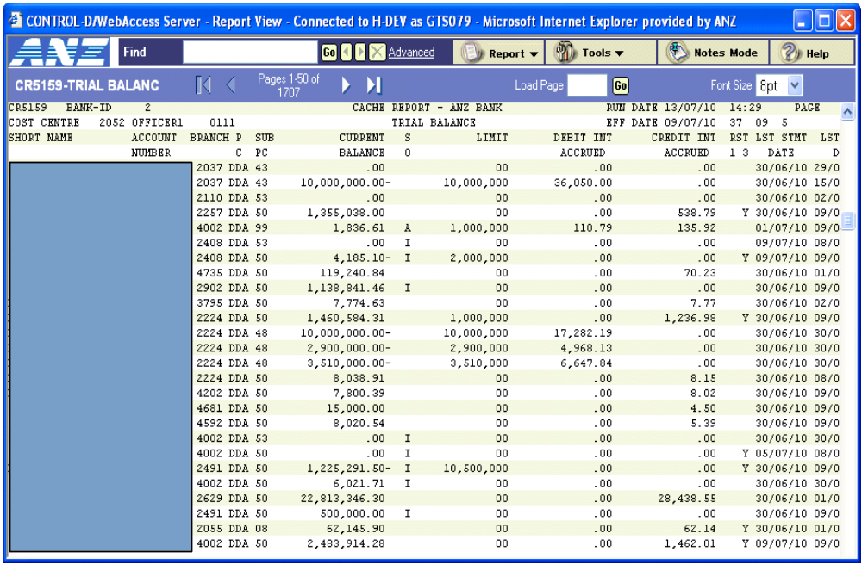

Note: The “I” indicator adjacent to the Current Balance indicates that the account participates in a setoff arrangement, i.e. the account has a “SOI” account to account relationship.

The Net Movement “M” transaction of $855.89 Credit was posted to the DDA 99 account for the 2/10/2009 as a result in the change to the account balance of DDA account 3999905211 between 01/10/2009 and 2/10/2009.

Movement Credit transaction on a DDA99 account.

____ SDTD 2 THF SINGLE TRANS DETAIL INQ 09/02/2010 18.03
THDI MESSAGE: 50852 ACTION COMPLETE
ACTION (RVTR, DISH)

PRODUCT DDA ACCOUNT 000000845299999 SUB-PRODUCT 99 BRANCH 3497
TRAN CODE 4712 DESCRIPTION 399900000M 503468

POST DATE 02/10/2009 EFFECTIVE DATE 02/10/2009 TRACE ID SOIGN109100200000294
TRANSACTION AMOUNT 855.89 DR/CR C
AUX DOM EX.AUX.DOM COLLECTION ITEMS

BALANCE AFTER POSTING 279,378.18-

TRANSACTION REVERSED N
REVERSAL TRANSACTION N
INTERNALLY GENERATED Y
GLI SOURCE Y

TRANSFER TO ACCT
TRANSFER FROM ACCT 399900000

Movement Debit transaction on a DDA99 account.

____ SDTD 2 THF SINGLE TRANS DETAIL INQ 09/02/2010 18.04
THDI MESSAGE: 50852 ACTION COMPLETE
ACTION (RVTR, DISH)

PRODUCT DDA ACCOUNT 000000845299999 SUB-PRODUCT 99 BRANCH 3497
TRAN CODE 4713 DESCRIPTION 399900000M 503468

POST DATE 05/10/2009 EFFECTIVE DATE 05/10/2009 TRACE ID SOIGN109100500000071
TRANSACTION AMOUNT 6,004.76 DR/CR D
AUX DOM EX.AUX.DOM COLLECTION ITEMS

BALANCE AFTER POSTING 285,383.46-

TRANSACTION REVERSED N
REVERSAL TRANSACTION N
INTERNALLY GENERATED Y
GLI SOURCE Y

TRANSFER TO ACCT
TRANSFER FROM ACCT 399900000

The end of day account balance for DDA accounts are displayed on the CR5159 Trial Balance Report (as seen below).

The difference between the balances for the 3/7/2002 and 2/7/2002 represents the Net Movement, i.e. if the balance on the 2/7 was $560,653.18(-) and on the 3/7 its now $547,297.89(-) then the difference is $13,355.29 and would be seen on the DDA 99 with the above account number followed by “M” – being the ‘movement’ of the account since the day prior.

____ STMT 1 THF STATEMENT FORMAT INQUIRY 22/07/2002 16.30
STFD MESSAGE: 50852 ACTION COMPLETE

ACCOUNT 000000845255555 FROM THRU PAGE
01/07/2002 09/07/2002 00002
VALID ACTN: SDET PREVIOUS BALANCE
ACTN POST EFF DESCRIPTION
DATE DATE DEBITS CREDITS BALANCE AFTER
04/07 775311111M POSTING
04/07 35,747.13 968,649.82-
05/07 775300000M
05/07 47,225.47 921,424.35-
05/07 775311111M
05/07 25,814.26 895,610.09-
08/07 775300000M
08/07 19,168.68 876,441.44-
08/07 775311111E
08/07 507.50 875,933.91-
08/07 775311111M
08/07 53,138.84 929,072.75-
09/07 775300000M
09/07 12,719.44 916,353.31-

Transaction History for the DDA 99 account displays Effective Dated “E” transactions that have been processed to the individual DDA account 399900000. These transactions are posted immediately to the DDA 99 account and reflect the effective date of the transaction to the individual DDA account.

____ STMT 1 THF STATEMENT FORMAT INQUIRY 09/02/2010 18.02
STFD MESSAGE: 50852 ACTION COMPLETE

ACCOUNT 000000845299999 FROM THRU PAGE
02/10/2009 14/10/2009 00001
VALID ACTN: SDET PREVIOUS BALANCE 278,318.84-
ACTN POST EFF DESCRIPTION
DATE DATE DEBITS CREDITS BALANCE AFTER
02/10 399900000E POSTING
01/10 35.24 278,354.08-
02/10 INTEREST
02/10 .52 278,354.60-
02/10 RV INT
02/10 .52 278,354.08-
02/10 399900000E
01/10 1,879.99 280,234.07-
02/10 399900000M
02/10 855.89 279,378.18-
05/10 399900000E
01/10 .52 279,378.70-
05/10 399900000M
05/10 6,004.76 285,383.46-

____ SDTD 2 THF SINGLE TRANS DETAIL INQ 22/07/2002 16.34
STFD MESSAGE: 50852 ACTION COMPLETE
ACTION _ (RVTR, DISH)

PRODUCT DDA ACCOUNT 000000845299999 SUN-PROFUCT 99 BRANCH 3052
TRAN CODE 4716 DESCRIPTION 775300000E 503008

POST DATE 11/07/2002 EFFECTIVE DATE 02/07/2002 TRACE ID S0IGH102071100000001
TRANSACTION AMOUNT 937.59 DR/CR C
AUX DOM EX.AUX.DOM COLLECTION ITEMS

BALNCE AFTER POSTING 857,768.94-

TRANSACTION REVERSED N
REVERSAL TRANSACTION N
INTERNALLY GENERATED Y
GLI SOURCE Y

TRANSFER TO ACCT
TRANSFER FRO MACCT 775300000

Effectively Dated Debit transaction on a DDA99 account.

____ SDTD 2 THF SINGLE TRANS DETAIL INQ 09/02/2010 18.03
THDI MESSAGE: 50852 ACTION COMPLETE
ACTION (RVTR, DISH)

PRODUCT DDA ACCOUNT 000000845299999 SUB-PRODUCT 99 BRANCH 3497
TRAN CODE 4717 DESCRIPTION 399900000E 503468

POST DATE 02/10/2009 EFFECTIVE DATE 01/10/2009 TRACE ID SOIGN109100200000001
TRANSACTION AMOUNT 35.24 DR/CR D
AUX DOM EX.AUX.DOM COLLECTION ITEMS

BALANCE AFTER POSTING 278,354.08-

TRANSACTION REVERSED N
REVERSAL TRANSACTION N
INTERNALLY GENERATED Y
GLI SOURCE Y

TRANSFER TO ACCT
TRANSFER FROM ACCT 399900000

The backdated transaction posted to the DDA account 775300000 was posted on 11/7/2002 with an effective date of 25/6/2002.

The corresponding shadow posted transaction to the DDA 99 account was processed with an effective date of 02/07/2002 as the DDA 99 account setoff arrangement commenced on 02/07/2002. Consequently, the transaction could not be processed with an effective date (25/06/2002) that is prior to the Setoff Start Date.

In this example, a manual calculation of the interest for the period 25/06/2002 to 02/07/2002 would need to be completed and an adjustment entry processed to the DDA 99 account’s Third Party Interest payment DDA account.

____ STMT 1 THF STATEMENT FORMAT INQUIRY 22/07/2002 16.48
STFD 1 MESSAGE: 53552 PREVIOUS SCREEN RETURNED

ACCOUNT 000000845299999 FROM THRU PAGE
08/07/2002 11/07/2002 00008
VALID ACTN: SDET PREVIOUS BALANCE
ACTN POST EFF DESCRIPTION
DATE DATE DEBITS CREDITS BALANCE AFTER
11/07 REVERSAL POSTING
10/07 937.50 458,362.89-
11/07 TRANSFER
02/07 937.50 457,424.59-
11/07 AXXXXXXXXXXX
11/07 128.57 457.296.02-
11/07 AAA XXXXXXXXXXXX XXXXXXXXXXXXXXXXX
11/07 504.25 457,791.77-
11/07 AAA XXXXXXXXXXXX XXXXXXXXXXXXXXXXX
11/07 505.90 456,285.87-
11/07 AAAAA XXXXXXXXXXXXXXXXXXXXXXXXXXX
11/07 1,333.58 454,952.29-
11/07 AAA XXXXXXXXX
11/07 1793.65 454,772.64-

____ STMT 1 THF STATEMENT FORMAT INQUIRY 22/07/2002 16.31
STFD MESSAGE: 50852 ACTION COMPLETE

ACCOUNT 000000845299999 FROM THRU PAGE
01/07/2002 17/07/2002 00004
VALID ACTN: SDET PREVIOUS BALANCE
ACTN POST EFF DESCRIPTION
DATE DATE DEBITS CREDITS BALANCE AFTER
12/07 775300000M POSTING
12/07 37,644.61 824,527.65-
12/07 775311111M
12/07 31,158.06 793,369.59-
15/07 775300000M
15/07 75,589.13 717,788.46-
15/07 775311111M
15/07 4,942.02 722,722.48-
16/07 775300000M
16/07 10,533.98 712,188.50-
16/07 775311111M
16/07 8,412.80 703,775.78-
17/07 775300000M
17/07 21,180.93 724,956.63-

____ STMT 1 THF STATEMENT FORMAT INQUIRY 22/07/2002 16.31
STFD MESSAGE: 50852 ACTION COMPLETE

ACCOUNT 000000845299999 FROM THRU PAGE
01/07/2002 19/07/2002 00005
VALID ACTN: SDET PREVIOUS BALANCE
ACTN POST EFF DESCRIPTION
DATE DATE DEBITS CREDITS BALANCE AFTER
17/07 775311111M POSTING
12/07 315,919.71 409,036.92-
18/07 775300000M
18/07 78,585.49 479,622.41-
18/07 775311111M
18/07 9,874.35 489,496.76-
19/07 775300000M
19/07 4,993.40 494,490.16-
19/07 775311111M
19/07 17,903.91 476,586.25-

Setoff Fees

The following fees are associated with the automated Setoff arrangement processing:

- Setoff Establishment Fee
- Setoff Service Fee.

  - Setoff Establishment Fee

The Setoff Establishment Fee is charged automatically during the opening of the DDA 99 account.

The Setoff Establishment Fee is a once-only fee that is applicable for the setup of the setoff arrangement.

  - Fee Default Amount

The standard policy amount for the Setoff Establishment Fee is currently $100.00.

The fee amount can be changed to an amount between the value of $0.01 and $9,999.99 in accordance with the customer agreement for the particular setoff arrangement.

The Setoff Establishment Fee is defaulted on the DDA Interest/Fees (DD02) screen during the DDA 99 account open scenario.

The Setoff Establishment Fee narrative and default value is only displayed on the DD02 screen during the account open scenario, i.e. an enquiry on the DD02 screen for the DDA 99 account after the successful account open will not display the Setoff Establishment Fee narrative or details.

  - Fee Waiver

The Setoff Establishment Fee can be waived if the Relationship Manager has agreed not to charge this fee. The Fee Waive is recorded on the DDA Interest/Fees (DD02) screen by entering a Waive Code of 02 during the DDA 99 account open scenario.

  - Fee Payment

The Setoff Establishment Fee must be paid using the Third Party account processing method.

The fee will be charged and reversed to/from the DDA 99 account and then charged to the DDA account loaded as the Bank Fees Payment Method Acct to Debit.

  - Fee processing

The Setoff Establishment Fee transaction is processed:

- During the overnight batch cycle if the standard fee default value is charged during DDA 99 account open, or
- Immediately if the default value is amended to a non standard fee amount during the DDA 99 account open, or
- Immediately if the fee is waived during the DDA 99 account open.

The Setoff Establishment Fee can also be charged online to the Third Party Fee Payment DDA account using the DDA On Line Transaction (DBD$) function. This fee charging method would be used if the Setoff Establishment Fee had been waived during the account open of the DDA 99 account and then it was decided/realised later that an Establishment Fee should have been charged for the arrangement.

  - Fee Charge Code

The Charge Code for the Setoff Establishment Fee must be:

- “81” for the standard default value for the fee amount, or
- “71” for the non standard fee amount.

  - Fee Transaction Reporting

The Setoff Establishment Fee transaction is reported on the CR5149 Transaction Posting Journal.

Example:

The Setoff Establishment Fee (SO EST FEE) for DDA 99 account number 845299999 was waived.

____ STMT 1 THF STATEMENT FORMAT INQUIRY 27/10/2009 11.11
STFD MESSAGE: 50852 ACTION COMPLETE

ACCOUNT 000000845299999 FROM THRU PAGE
02/09/2009 26/10/2009 00006
VALID ACTN: SDET PREVIOUS BALANCE
ACTN POST EFF DESCRIPTION
DATE DATE DEBITS CREDITS BALANCE AFTER
02/09 SO EST FEE POSTING
02/09 100.00 100.00-
02/09 WAIVE FEE
02/09 100.00 .00

Note: the Fee is seen going both in and out, both Debit then Credit. This is because the fee is actual funds while the DDA 99 is only a calculation. For this reason the fee is reversed as WAIVE FEE. The below is an example of where the fee is not waived but charges to third party account and is therefore reversed by the system from the DDA99 account and charged to the nominated account for fees (re: DD03 screen).
This will be the first transaction seen on a newly created/opened DDA99 account.

____ STMT 1 THF STATEMENT FORMAT INQUIRY 25/10/2015 11.50
STFD 1 MESSAGE: 50852 ACTION COMPLETE

ACCOUNT 000000845299999 FROM THRU PAGE
21/10/2015 25/10/2015 00001
VALID ACTN: SDET PREVIOUS BALANCE
ACTN POST EFF DESCRIPTION
DATE DATE DEBITS CREDITS BALANCE AFTER
21/10 SO EST FEE POSTING
21/10 100.00 100.00-
21/10 REV FEE
21/10 100.00 .00
25/10 835519134B
14/10 25,811.66 25,811.66
25/10 835519134M
17/10 66,612.66 40,801.00-
25/10 835519134M
18/10 63,459.31 22,658.31
25/10 835519134M
19/10 143,331.27 165,989.58
25/10 835519134M
20/10 18,142.74 147,846.84

____ DD02 2 IDS DDA INTEREST/FEES 25/10/2015 18.11
DDMN MESSAGE: ACTION SUCCESSFUL
ACTION INQ PRODUCT DDA ACCOUNT 845299999

INTEREST INFORMATION CODE CYCLE
DEBIT INTEREST D2 32 INTEREST PYMT METHOD TT
CREDIT INTEREST C1 32 ACCT TO DR/CR - PROD DDA
- ACCT 399905211
INTEREST TERM - DAYS
DATE NXT DB INT CYCLE

FEES INFORMATION CHARGE CODE WAIVE CODE AMT PER ITEM NO. OF ITEMS
SERVICE CHARGE 00 00
SETOFF SERVICE FEE 81 00 2.38 69

GOV DUTIES PYMT METHOD TT
BANK FEES CYCLE CODE 33 BANK FEES PYMT METHOD TT
ACCT TO DEBIT - PROD DDA
- ACCT 399900000
# 1

# 2
The Setoff Establishment Fee is NOT displayed on the DD02 screen for the DDA 99 account since the account has been previously opened.

During the Account open scenario, the Setoff Establishment Fee narrative would be displayed at the position of the blue boxed area. Refer to #1.

The Setoff Establishment Fee is charged to the Third Party DDA account detailed on the DD02 screen for the DDA 99 account. Refer to #2.

  - Setoff Service Fee

The Setoff Service Fee is charged cyclically for each account that is involved in a setoff arrangement.

The fee is charged according to the Bank Fee Cycle Code that is recorded on the DDA 99 account, i.e. monthly, quarterly, half-yearly or yearly.

This fee is charged for the operation of the system processing the transfer of details of each account to the DDA 99 account in order to calculate the appropriate interest charge on the Net Balance of that account.

The system will calculate a Service Fee for the setoff arrangement based on the number of accounts in the arrangement. Each account is one item every business night it is linked to the setoff. The number of items and the amount per item (AMT PER ITEM) is what constitutes the Setoff Service Fee when it is charged.

- AMT PER ITEM x NUMBER OF ITEMS = SETOFF SERVICE FEE.

If the participating account is also part of an AFT (Automatic Funds Transfer) arrangement to zero balance, then one of the two arrangements should be cancelled. Otherwise the customer is being double charged, i.e. you either setoff the balance or if you move the funds and the account is 0.00 there is nothing to setoff and so the customer would get a charge for Setoff and AFT.

The Setoff Service Fee will display on subproducts other than DDA99. The purpose is to allow the manager to exclude the account from being counted in the nightly NO OF ITEMS. By using a 02 (waiving of fee) at account level for Setoff Service Fee, the account level is not counted in total on the DDA99.

This fee is only applicable to the DDA99 and will be charged on DDA99 and TT’d. This fee is always accumulated and also charged during batch (X75105) according to number of accounts in Setoff each business night.

____ DD02 2 IDS DDA INTEREST/FEES 10/11/2011 11.20
DDMN MESSAGE: ACTION SUCCESSFUL
ACTION NXT PRODUCT DDA ACCOUNT 845200000

INTEREST INFORMATION CODE CYCLE
DEBIT INTEREST D2 32 INTEREST PYMT METHOD TT
CREDIT INTEREST E1 32 ACCT TO DR/CR - PROD DDA
- ACCT 775400000
INTEREST TERM - DAYS
DATE NXT DB INT CYCLE

FEES INFORMATION CHARGE CODE WAIVE CODE AMT PER ITEM NO. OF ITEMS
SERVICE CHARGE 00 00
SETOFF SERVICE FEE 81 02 2.38 43

GOV DUTIES PYMT METHOD TT
BANK FEES CYCLE CODE 32 BANK FEES PYMT METHOD TT
ACCT TO DEBIT - PROD DDA
- ACCT 775400000

  - Fee Default Amount

The standard policy amount for the Setoff Service Fee is currently $2.38.

The fee amount can be changed to an amount between the value of $0.01 and $9,999.99 in accordance with the customer agreement for the particular setoff arrangement.

The Setoff Service Fee of $2.38 is defaulted on the DDA Interest/Fees (DD02) screen during the DDA 99 account open scenario.

The displayed $ value is a daily fee amount since the system will count and record each day the account is operating in the setoff arrangement. The number of days will be multiplied by the daily rate to determine the appropriate fee to be charged at fee cycling time

The Setoff Service Fee of $2.38 is also displayed on the DDA Interest/Fees (DD02) screen for an individual DDA account that is participating in a setoff arrangement.

NOTE: The standard default amount for the Setoff Service Fee was $3.30 when this Reference module was written. It has subsequently been revised to $2.38 however for illustrative purposes, the value of $3.30 has been retained in the examples.

  - Fee Waiver

The Setoff Service Fee can be waived if the Relationship Manager has agreed not to charge this fee for a particular account within the setoff arrangement or for all accounts within the setoff arrangement.

  - Individual DDA account Fee Waiver

The Waive Code of “02” is utilised to ensure the Setoff Service Fee is never charged to the account; i.e. waive the fee permanently. If the Account Manager requires this fee to be waived for only one cycle, the Waive Code must be “01”. After the first cycle the fee cycling will change automatically to 00.

The recording of a Waive Code at the individual DDA account level is an “exception” type situation as in most cases; the setoff arrangement would need a Waive Code on the DDA 99 account to ensure the entire Service Fee is not charged for the arrangement as a whole rather than waiving a single account from the fee calculation.

  - Group level DDA 99 Setoff Account Fee Waiver

The Waive Code of “01” is utilised to ensure the Setoff Service Fee is not charged for the entire arrangement for one cycle. After the fee has been waived for one cycle, the system automatically changes the Waive Code to 00 so that the fee will now be charged.

The Waive Code of “02” will be utilised to ensure the Setoff Service Fee is never charged for the entire arrangement; i.e. waive the fee permanently.

The Fee Waive is recorded on the DDA Interest/Fees (DD02) screen by entering a Waive Code of “01” or “02” during the DDA 99 account open scenario or in the future as an account maintenance activity.

  - Fee No. of Items counter

The No. of Items counter is incremented to represent an account participating in the setoff arrangement. The counter is incremented during the nightly batch cycle.

As there is not batch on the weekends or National Public Holidays it will not increase the increment on those days.

If trying to manually calculate if the fee is correct, only count the number of “business days” the account was linked to the setoff arrangement. Add the number of days for all customer accounts in the arrangement (i.e. excluding the SO and DDA99) and divide the fee charged by the total count. If this does not equal the amount found on DD02 per item, then either:

- The fee amount has been updated since the fee was charged
- The fee is incorrect.

The fee will always charge the total No. of Items by the rate held at the time of charging. It will not charge as a split, meaning if the rate changed mid cycle, part of the count charging at one rate and the remainder of the count at another.

  - Individual DDA account

The Fee Counter for the Setoff Service Fee will be incremented by 1 each day. This will occur from an account level whenever the account is involved in the setoff arrangement and has a recorded Waive Code.

When an account is removed from the setoff arrangement, the value of the Setoff Service Fee Counter will remain until the cyclical fee cycling for the account has occurred.

  - Group level DDA Setoff account

The Fee Counter for the Setoff Service Fee will be incremented by 1 at the Group level DDA 99 account every night for each individual DDA account in the setoff arrangement that does not have a recorded Waive Code.

Examples

Example 1:

A Setoff Service Fee will be calculated and charged to the DDA 99 account as follows:

- A fee charge of 37 days multiplied by the daily $ rate will be reported for DDA 99 Account.
- A fee charge and waiver of 19 days multiplied by the daily $ rate will be reported for Account 1
- A fee charge and waiver of 20 days multiplied by the daily $ rate will be reported for Account 2.

Account | Number of days in Setoff | Waive Code | DDA Fee Counter
Account 1 | 19 | 02 | 19
Account 2 | 20 | 02 | 20
Account 3 | 22 | 00 | 0
Account 4 | 15 | 00 | 0
DDA 99 | NA | 00 | 37

Example 2:

A Setoff Service Fee will be calculated and charged to the DDA Subproduct 99 account as follows:

A fee charge and waiver of 76 days multiplied by the daily $ rate will be reported for the DDA 99 account.

Account | Number of days in Setoff | Waive Code | DDA Fee Counter
Account 1 | 19 | 00 | 0
Account 2 | 20 | 00 | 0
Account 3 | 22 | 00 | 0
Account 4 | 15 | 00 | 0
DDA 99 | NA | 02 | 76

Example 3:

A Setoff Service Fee will be calculated and charged to the DDA Subproduct 99 account as follows:

- A fee charge of 76 days multiplied by the daily $ rate will be reported for DDA 99 Account.

Account | Number of days in Setoff | Waive Code | DDA Fee Counter
Account 1 | 19 | 00 | 0
Account 2 | 20 | 00 | 0
Account 3 | 22 | 00 | 0
Account 4 | 15 | 00 | 0
DDA 99 | NA | 00 | 76

Example 4:

A Setoff Service Fee will be calculated and charged to the DDA Subproduct 99 account as follows:

- A fee charge and waiver of 37 days multiplied by the daily $ rate will be reported for DDA 99 Account.
- A fee charge and waiver of 19 days multiplied by the daily $ rate will be reported for Account 1
- A fee charge and waiver of 20 days multiplied by the daily $ rate will be reported for Account 2.

After the completion of the fee cycling:

Account | Number of days in Setoff | Waive Code | DDA Fee Counter
Account 1 | 19 | 02 | 19
Account 2 | 20 | 02 | 20
Account 3 | 22 | 00 | 0
Account 4 | 15 | 00 | 0
DDA 99 | NA | 01 | 37

- The Waive Code recorded on DDA 99 Account will automatically be changed to 00.

  - Fee Payment

The Setoff Service Fee must be paid using the Third Party account processing method.

The fee will be charged and reversed to/from the DDA 99 account and then charged to the DDA account loaded as the “Bank Fees Pymt Method Acct to Debit”.

  - Fee processing

The Setoff Service Fee is charged on a cyclical frequency depending on the Fee Charging Cycle recorded on the DDA 99 account.

The allowable fee charging frequencies are:

- Monthly
- Quarterly
- Half-Yearly
- Yearly.

The Setoff Service Fee will also be charged at account closure of the DDA 99.

If the individual DDA account is removed from the setoff arrangement (but remains open), with a value in the No. of Items field and has a Waive Code recorded for the Setoff Service Fee, the Setoff Service Fee Waive transaction will be processed at the next fee cycling event. The value in the No. of Items field will therefore continue to display on the DD02 screen until the completion of the fee cycling for the account.

If the individual DDA account is closed with a value in the No. of Items field and has a Waive Code recorded for the Setoff Service Fee, the Setoff Service Fee Waive transaction will be processed during the nightly batch cycle.

A Fee Waive can be applied to an individual DDA account to exclude it from being included in the group calculation of the Setoff Service Fee on the DDA 99 account.

The Setoff Service Fee can also be charged online to the Third Party Fee Payment DDA account using the DDA Online Transaction (DBD$) function. This fee charging method would be used if the Setoff Service Fee had previously been waived, then it was decided/realised later that the fee should have been charged for the arrangement.

  - Fee Charge Code

The Charge Code for the Setoff Service Fee must be:

- “81” for the standard default value for the fee amount, or
- “71” for the non standard fee amount.

  - Fee Transaction Reporting

The Setoff Service Fee transaction is reported on the CR5149 Transaction Posting Journal if it is charged for the arrangement.

The Setoff Service Fee charged and waived details are reported on the CR5238 Miscellaneous Fee Journal.

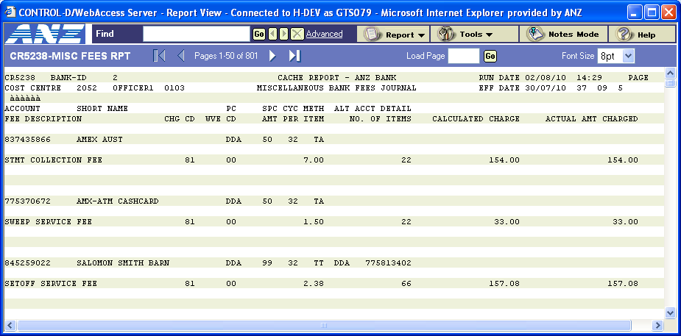

The CR5238 Miscellaneous Bank Fees Journal produced for the July cycle (31/7/2002) displays a Setoff Service Fee of $138.60 was calculated for the setoff arrangement of DDA 99 account 845299999. This amount was calculated using the daily rate of $3.30 multiplied by the no. of items counter which was 42 for the period.

The Actual fee amount charged to the DDA 99 account 845299999 was nil since the Waive Code is recorded as 02 on the account.

The Setoff Service Fee for DDA 99 account number 845299999 has a Waive Code of “02” recorded.

Since this setoff arrangement has 2 accounts linked to the SO account and these individual DDA accounts do not have a Waive Code of 02 recorded, the DDA 99 account No. of Items field will be incremented by X during each nightly batch cycle.

X = the number of customer accounts linked to the setoff via ACAC.

____ DD02 2 IDS DDA INTEREST/FEES 09/02/2010 18.11
DDMN MESSAGE: ACTION SUCCESSFUL
ACTION INQ PRODUCT DDA ACCOUNT 845299999

INTEREST INFORMATION CODE CYCLE
DEBIT INTEREST D2 32 INTEREST PYMT METHOD TT
CREDIT INTEREST C1 32 ACCT TO DR/CR - PROD DDA
- ACCT 399905211
INTEREST TERM - DAYS
DATE NXT DB INT CYCLE

FEES INFORMATION CHARGE CODE WAIVE CODE AMT PER ITEM NO. OF ITEMS
SERVICE CHARGE 00 00
SETOFF SERVICE FEE 81 00 2.38 59

GOV DUTIES PYMT METHOD TT
BANK FEES CYCLE CODE 33 BANK FEES PYMT METHOD TT
ACCT TO DEBIT - PROD DDA
- ACCT 399905211

An enquiry on this DDA 99 account after the nightly batch cycle shows the increment to the No. of Items counter, i.e. 59 to 69.

____ DD02 2 IDS DDA INTEREST/FEES 09/02/2010 18.11
DDMN MESSAGE: ACTION SUCCESSFUL
ACTION INQ PRODUCT DDA ACCOUNT 845299999

INTEREST INFORMATION CODE CYCLE
DEBIT INTEREST D2 32 INTEREST PYMT METHOD TT
CREDIT INTEREST C1 32 ACCT TO DR/CR - PROD DDA
- ACCT 399905211
INTEREST TERM - DAYS
DATE NXT DB INT CYCLE

FEES INFORMATION CHARGE CODE WAIVE CODE AMT PER ITEM NO. OF ITEMS
SERVICE CHARGE 00 00
SETOFF SERVICE FEE 81 00 2.38 69

GOV DUTIES PYMT METHOD TT
BANK FEES CYCLE CODE 33 BANK FEES PYMT METHOD TT
ACCT TO DEBIT - PROD DDA
- ACCT 399905211

____ DD01 2 IDS DDA ACCOUNT CODING STRUCTURE 09/02/2010 18.10
DDMN MESSAGE: ACTION SUCCESSFUL
ACTION INQ PRODUCT DDA ACCOUNT 845299999

ACCOUNT CODING STRUCTURE
SUB-PRODUCT 99 ACCOUNT RESTRAINTS CLASS 1 0 3 0
PORTFOLIO PRODUCT:
COST CENTER 3468 DRIVER PROCESSING INDICATOR 1
DOMICILE BRANCH 3497 O/D LIMIT PRESENT Y
ACCOUNT STATUS 09 ARP INDICATOR N
OFFICER 1 0305 OFFICER 2
OWNERSHIP CODE 02 SETOFF A/C 3052950000
ANZSIC CODE 4619 SETOFF A/C OPEN DATE 02/09/2002
AGENCY TYPE SETOFF START DATE 05/09/2002

LARGE ITEM MONITOR CODE 5 EXCESS FEE AMOUNT
OUT OF BOUNDS PROC. (OBP) CODE 01 EXCESS PAYMENT METHOD
PENALTY INTEREST APPLICABLE (Y/N) Y DDA ACCT TO DEBIT
DATE EXCESS BEGAN
OVERDRAFT LIMIT OVER 100K (Y/N) N TOTAL LIMITS OVER 500K (Y/N)
GROUP LIMIT PARTICIPANT (Y/N) N GROUP LIMIT INTERCHANGE (Y/N) N

EVERGREEN INDICATOR (Y/N) N

____ ACAC 0 CIS ACCT TO ACCT RELATIONSHIPS 09/02/2010 18.14
ACAC MESSAGE: 64149 END OF ACCOUNTS REACHED
PRODUCT SO ACCOUNT 3052-950000

ACT: (VALUES-- A-ADD C-CHANGE D-DELETE) NEXT: 1

SEQ ACT PRD ACCOUNT---------------- RELATIONSHIP-------
0001 DDA 3999-05211 SOI S/O INTEREST
0002 DDA 8328-88888 SOI S/O INTEREST
0003 DDA 8373-99999 SOI S/O INTEREST
0004 DDA 8452-99999 SOA S/O ACCOUNT

____ DD02 2 IDS DDA INTEREST/FEES 09/02/2010 18.17
DDMN MESSAGE: ACTION SUCCESSFUL
ACTION INQ PRODUCT DDA ACCOUNT 837399999

INTEREST INFORMATION CODE CYCLE
DEBIT INTEREST 00 DA INTEREST PYMT METHOD TA
CREDIT INTEREST 00 DA ACCT TO DR/CR - PROD
- ACCT
INTEREST TERM - DAYS
DATE NXT DB INT CYCLE

FEES INFORMATION CHARGE CODE WAIVE CODE AMT PER ITEM NO. OF ITEMS
SERVICE CHARGE 81 00
STMT COLLECTION FEE 81 00 7.00
SWEEP SERVICE FEE 81 00 1.50
STOP PAYMENT FEE 81 00 15.00
SETOFF SERVICE FEE 81 00 2.38

GOV DUTIES PYMT METHOD TA
BANK FEES CYCLE CODE 32 BANK FEES PYMT METHOD TT
ACCT TO DEBIT - PROD DDA
- ACCT 305605211

Waive Code is “00” for each related individual DDA account as the number of items accrues on the DDA99 account and is listed on the individual DDA account for information purposes of how much the fee is.

____ STMT 1 THF STATEMENT FORMAT INQUIRY 27/10/2099 11.11
STFD MESSAGE: 50852 ACTION COMPLETE

ACCOUNT 000000845299999 FROM THRU PAGE
02/09/2009 26/10/2009 00019
VALID ACTN: SDET PREVIOUS BALANCE 7,582,941.42
ACTN POST EFF DESCRIPTION
DATE DATE DEBITS CREDITS BALANCE AFTER
30/09 775400000M POSTING
30/09 5.00 5,462,051.27-
30/09 833400000M
30/09 45,969,316.50 51,431,367.77-
30/09 775300000M
30/09 290,793.10 51,722,160.87-
30/09 775300000M
30/09 213,531.50 51,508,629.37-
30/09 833400000M
30/09 85,933,197.17 34,424,567.80
30/09 SO SVC FEE
30/09 1,099.56 34,423,468.24
30/09 REV FEE
30/09 1,099.56 34,424,567.80

____ SDTD 2 THF SINGLE TRANS DETAIL INQ 27/10/2099 11.16
STFD MESSAGE: 50852 ACTION COMPLETE
ACTION (RVTR, DISH)

PRODUCT DDA ACCOUNT 000000845299999 SUB-PRODUCT 99 BRANCH 3052
TRAN CODE 4673 DESCRIPTION SO SVC FEE

POST DATE 30/09/2009 EFFECTIVE DATE 30/09/2009 TRACE ID I-GEN110093000054062
TRANSACTION AMOUNT 1,099.56 DR/CR D
AUX DOM 100 EX.AUX.DOM COLLECTION ITEMS

BALANCE AFTER POSTING 34,423,468.24

TRANSACTION REVERSED Y
REVERSAL TRANSACTION Y
INTERNALLY GENERATED Y
GLI SOURCE Y

TRANSFER TO ACCT
TRANSFER FROM ACCT

____ SDTD 2 THF SINGLE TRANS DETAIL INQ 27/10/2010 11.18
STFD MESSAGE: 50852 ACTION COMPLETE
ACTION (RVTR, DISH)

PRODUCT DDA ACCOUNT 000000845299999 SUB-PRODUCT 99 BRANCH 3052
TRAN CODE 4674 DESCRIPTION REV FEE

POST DATE 30/09/2010 EFFECTIVE DATE 30/09/2010 TRACE ID I-GEN110093000054063
TRANSACTION AMOUNT 1,099.56 DR/CR C
AUX DOM 100 EX.AUX.DOM COLLECTION ITEMS

BALANCE AFTER POSTING 34,424,567.80

TRANSACTION REVERSED Y
REVERSAL TRANSACTION Y
INTERNALLY GENERATED Y
GLI SOURCE Y

TRANSFER TO ACCT 775300000
TRANSFER FROM ACCT

Error Messages

  - Setoff Error Messages

789 | CHECK SOI R/SHIPS
 | An ‘SOA’ relationship cannot be deleted when there is a valid ‘SOI’ relationship. If the maintenance is attempted on the ACAC screen prior to the SOI relationship being deleted, the system will display the error message.
792 | DDA99 A/C BALANCE NOT ZERO
 | An ‘SOA’ relationship cannot be deleted unless the DDA 99 account balance is zero. If the maintenance is attempted on the ACAC screen prior to the account balance being reduced to zero, the system will display the error message.
798 | CHECK ACAC RELATIONSHIPS
 | The Subproduct 01 SO account cannot be deleted if there are valid “SOA” or “SOI” relationships linked to the account. If the maintenance is attempted on the ACMN screen, the system will display the error message
2054 | INVALID SETOFF START DATE
Maintenance to the Setoff Start Date on the individual DDA account is subject to the following system checks:

- The “Setoff Start Date” cannot be a future date
- The “Setoff Start Date” cannot be less than the “Setoff Open Date”
- The “Setoff Start Date” cannot be less than the current system date minus 60 days.
- The “Setoff Start Date” cannot be less than the account’s Open Date
- The “Setoff Start Date” cannot be a non business day

 | If the date entered in the “Setoff Start Date” does not satisfy the above criteria, or the account is not linked to a SO account (ie. is not in a setoff arrangement) the system will display the error message
2055 | SETOFF START DATE MAINT NOT ALLOW
If the individual DDA account was linked to the arrangement with an incorrect Setoff Start Date and there has been at least one nightly batch cycle completed, the “Setoff Start Date” cannot be maintained.

If the above situation occurs and maintenance is attempted on the “Setoff Start Date”, the system will display the error message

(*)Note: The reversal of the transactions that have been processed to the DDA 99 account must be completed in the order of “last in, first out” to ensure the interest accrual adjustment is correctly processed by the system.

  - Transactions Error Messages

2061 | TRAN INVALID – SETOFF ACCOUNT
 | A DDA 99 account can only have trancodes in the range of 4707 – 4718 posted to the account via DBD$. Trancodes 4673 – 4706 can only be posted to a 3rd party account since all fees for DDA 99 are TT payment method.
2063 | TRANCODE INVALID ONLY FOR DDA99
 | Trancodes in the range of 4707 to 4718 can only be posted to DDA 99 accounts. Invalid for all other subproducts.
2064 | ENTER SETOFF ORIG A/C AS DESC
 | Trancodes in the range of 4707 to 4718 must have the setoff original account number entered as the first 9 bytes of the transaction description.
2065 | CHECK SETOFF ORIG A/C
 | Trancodes in the range of 4707 to 4718 must have the setoff original account number entered as the first 9 bytes of the transaction description. If the DDA 99 account number held on the Original account entered does not match the Transaction account number, then the transaction will reject. Check both account numbers.
2075 | START DATE PRIOR S/O OPEN DATE
When the DDA 99 account open was backdated, if the Limit Start Date entered for Limit 1 is a date prior to the account open date, the system will display the following error message

The OD Limit Start Date cannot be backdated prior to Setoff Open Date
2076 | S/O ACTIVE – CANNOT BACKDATE
When the DDA 99 account open was backdated and the account has become active with movement and/or balance load transactions been processed to it, if the Limit Start Date entered for Limit 1 is backdated to less than the current system date, the system will display the following error message

The Setoff arrangement has been activated therefore the OD Limit Start Date cannot be backdated.
2077 | INVALID START DATE
 | When the DDA 99 account open was not backdated and the Limit Start Date is being attempted to be backdated, the system will display the following error message:
1) Limit Start Date must be in format DD/MM/CCYY
2) Limit Start Date cannot be earlier than current system effective date.
3) DDA 99 account open was not backdated therefore the OD Limit cannot be backdated.

  - DDA 99 Account Relationship System Error Messages

784 | SOA R/SHIP ALREADY EXISTS
 | The DDA 99 account must only be linked to one Setoff SO account and vice versa. If an “SOA” relationship is being added to the SO account or DDA 99 account which is currently linked with another SOA relationship, the system will display an error message
785 | SOA MUST BE ADDED BEFORE SOI
 | An “SOI” relationship cannot be added to the SO account unless the SO account has an active “SOA” account to account relationship with a DDA 99 account. If the maintenance is attempted prior to the “SOA” relationship being established, the system will display an error message
786 | ‘SOA’ ONLY APPLICABLE TO DDA99
 | An “SOA” account to account relationship is not valid for individual DDA accounts. If the addition of an “SOA” relationship between an SO account and an individual DDA account is attempted, the system will display an error message
787 | ‘SOI’ INVALID FOR DDA99 ACCOUNT
 | The only valid account to account relationship for the DDA 99 account is the “SOA” relationship. If the addition of an “SOI” relationship between the SO account and the DDA 99 account is attempted, the system will display an error message
800 | R/SHIP NOT VALID FOR DDA99
 | If an attempt is made to add an invalid account to account relationship, the system will display an error message
791 | INTEREST ACCRUED ON ACCOUNT
 | All accrued debit and credit interest must be manually cycled out of an individual DDA account before it is linked into a setoff arrangement. If an attempt is made to link an individual DDA account into the setoff arrangement and interest accrued is stored on the account, the system will display an error message
799 | USE SOC R/SHIP FOR DDA99 ONLY
 | The “SOC” Account to Customer relationship is only applicable to the DDA 99 account and a valid customer record. If an attempt is made to add the “SOC” relationship to an account that is not a DDA 99 account, the system will display an error message
XXX | 9999999999999999999999
 | If an attempt is made to add a valid account to customer relationship other than “SOC”, e.g. NIN, to a DDA 99 account, the system will display an error message

  - Fee Processing Error Messages

When a DDA 99 account is being opened using the ACSU function, the DD02 screen will display the default amount for the Setoff Service Fee.

Maintenance can be performed on these details during setup of the account.

- When an amount greater than the maximum or less than the minimum allowable value for the Setoff Service Fee is entered, the following error message is to be displayed:

2029 INVALID AMT REFER FEE RANGE

Meaning: The Fee amount entered is not within the allowable minimum and maximum range. Refer Fee Policy and Procedures.

- When an invalid Setoff Service Fee Type Code is entered, the following error message is to be returned:

2030 INVALID CHG CODE

Meaning: The charge code entered is not valid. The following codes can be entered in this field.
‘81’ – means a standard item amount determined by business will be applied.
‘71’ – means non-standard item amount.

- When an invalid Setoff Service Fee Waive Code is entered, the following error message is to be returned:

50913 INVALID WAIVE CODE

Meaning: The waive code entered is not valid. The following codes can be entered in this field.
‘00’ – means do not waive fee.
‘01’ – means waive fee for one cycle.
‘02’ – means waive fee permanently.

Note: Waive Code ‘01’ is not valid for Setoff Establishment Fee.

- The individual DDA account involved in a Setoff arrangement can only have a Setoff Service Fee Waive Code of “00” or “02”, i.e. Waive Code of “01” is not valid for the Setoff Service Fee on the individual DDA account. When a value of “01” is entered in the Setoff Service Fee Waive Code, the following error message is to be returned:

2057 INVALID WAIVE FOR FEE TYPE

Meaning: The waive code for the Setoff Service Fee of the individual DDA account involved in the Setoff arrangement can only be 00 or 02. Use Waive Code 02 to waive this account from the Setoff Service Fee.

Note: A Waive Code of “01” can be loaded on the DDA 99 account.

When a DDA 99 account is being opened using the ACSU function, the DD02 screen will display the default amount for the Setoff Establishment Fee.

Maintenance can be performed on these details during setup of the account.

- When an amount greater than the maximum or less than the minimum allowable value for the Setoff Establishment Fee is entered, the following error message is to be displayed:

2029 INVALID AMT REFER FEE RANGE

Meaning: The Fee amount entered is not within the allowable minimum and maximum range. Refer Fee Policy and Procedures.

- When an invalid Setoff Establishment Fee Type Code is entered, the following error message is to be returned:

2030 INVALID CHG CODE

Meaning: The charge code entered is not valid. The following codes can be entered in this field.
‘81’ – means a standard item amount determined by C & IB will be applied.
‘71’ – means non-standard item amount.

- When an invalid Setoff Establishment Fee Waive Code is entered, the following error message is to be returned:

50913 INVALID WAIVE CODE

Meaning: The waive code entered is not valid. The following codes can be entered in this field.
‘00’ – means do not waive fee.
‘01’ – means waive fee for one cycle.
‘02’ – means waive fee permanently.

Note: Waive Code ‘01’ is not valid for Setoff Establishment Fee.

Maintaining the Setoff arrangement details

  - Adding DDA accounts to the setoff arrangement (Linking)

Existing DDA accounts can be added to a new or existing setoff arrangement using the Account to Account Relationships (ACAC) screen.

Any Debit or Credit Interest Accrued on individual DDA accounts that are to be included in a Setoff Arrangement must be cycled on the day prior to the account being included in the setoff arrangement. The DDA account will not be able to be linked to the arrangement if there is any outstanding interest accured.

  - Group Limit Participant

Ensure the Group Limit Participant flag displayed on the DDA Account Coding Structure (DD01) screen is set to “N” on each DDA account that is added to the setoff arrangement.

Now we have Orion controlling the LIMITS for Setoffs (i.e. Net Limit Arrangements) if the flag is set to “Y” then no Account Maintenance can be performed in Orion until the flag is set to N via the CUHF screen in CACHE.

Previous (to Orion) the GLP field was used to ensure that the individual accounts were not charged an individual Excess Fee for any overdrawn balances. Now this occurs when the Net Limit Arrangement is loaded in Orion, which changes the Group Limit Interchange flag to “C” (which signifies the limit has been loaded in Orion). Once the limit is in Orion the Orion system will grey out the Excess Fee maintenance field and set the fee to 0.00 which then flows to CACHE.

  - Setoff Start Date

The commencement/start date of the individual DDA account being in the Setoff arrangement will be defaulted with the date that the Account to Account Relationship of “SOI” is established between the individual DDA account and the Setoff SO account.

If the commencement/start date is required to be an earlier date, maintenance to the date must be performed on the IDS DDA Account Coding Structure (DD01) screen for the individual DDA account. This maintenance must be completed on the date that the “SOI” relationship is established.

If it is determined that the account MUST be included in the setoff arrangement effective for the earlier date, the following steps must be taken:

- The “SOI” account to account relationship must be deleted,
- All transactions that have been posted to the DDA 99 account from the individual DDA account must be reversed (*),
- The “SOI” account to account relationship be re-added to the SO account, and
- The Setoff Start Date be maintained on the DD01 screen for the individual DDA account.

The commencement/start date of the individual DDA account being included in the Setoff arrangement can be specified to a date up to 60 days prior to today’s system date or to the open date of the DDA Subproduct 99 account, whichever is the later date. This backdating allows for the inclusion of an account within the setoff arrangement when an error/omission had occurrred with the arrangement setup.

The open date of the DDA Subproduct 99 account is displayed on the DDA Account Coding Structure (DD01) screen for information purposes.

  - Manual Calculation of Interest

When an individual DDA account has been included in a setoff arrangement with a backdated Setoff Start Date, any interest adjustment for the backdated period must be manually calculated and posted to a Third Party DDA account prior to it being added to the setoff arrangement.

Example

Current system date is 19/01/2010. DDA account was to be linked to the Setoff arrangement with an effective date of 16/01/2010.

The accrued interest charged/paid to the account for the period 16/9 to 19/9 must not be charged/paid to the customer because the account’s interest will be included in the calculation by the DDA 99 account. The DDA account’s interest payment method should be changed to TT with a Manager account for the purpose of the “cycling” out of accrued interest on 19/09/2002, i.e. with the “DA” cycle code.

On 20/01/2010, the interest component for the period 16/09 to 19/09 for the individual DDA account must be written off to the General Ledger. The DDA account can now be linked to the setoff arrangement with a Setoff Start Date of 16/09/2002. Interest will be calculated on the setoff account incorporating the newly added DDA account from 16/09/2002.

Procedure:

Pre-requisite: All interest accrued must have been previously cycled from the DDA account being added to the setoff arrangement.

Use this procedure to add an individual DDA account to the setoff arrangement:

Step | Action
1 | Access HCIR > ACAC  Enquire on the SO account that is linked to the DDA 99 account with the “SOA” relationship.
2 | Press: <enter>  Result  Screen message “ACTION SUCCESSFUL” is displayed”  “-ADD” is displayed next to the DDA account being added to the arrangement
  Complete fields | With:
  ACT | A
  PRD | DDA
  ACCOUNT | Individual DDA account number
  RELATIONSHIP | SOI
3 | Does the “SOI” account to account relationship require backdating?  If Yes, go to step 4  If No, go to step 5
4 | Enquire on the DDA Account Coding Structure (DD01) screen for the individual DDA account.  Access IDSR > DDMN > DD01 for the individual DDA account  Press: <enter>  Result  Screen message “ACTION SUCCESSFUL” is displayed”
  Complete fields | With:
  ACTION | CHG
  PRD | DDA
  ACCOUNT | Individual DDA account number
  SETOFF START DATE | Start Date of account being linked to the setoff arrangement

Step | Action
5 | Next Day  Access Control-D/Control-D Web  - View the CR5286 Setoff Arrangement Details Report  Confirm the addition (“ADD”) of the DDA account into the setoff arrangement is displayed on the report.  - View the CR5199 Maintenance Audit Journal  Verify the Individual DDA accounts are reported with the “Setoff” details such as Link Type (“I”), DDA 99 account number, DDA 99 account Open Date, DDA account Setoff Start Date being displayed in the “New Data” and the “Old Data” displaying blanks  Verify the Individual DDA accounts’ Debit and Credit Interest Codes are reported as being changed from their original code to be “00” in the “New Data”  Note: If the DDA account had a “00” Interest Code prior to its inclusion into the setoff arrangement, the maintenance will not be reported.  - View the CR0091 DDA Driver Relationship Report  Enquire on the individual DDA account added to the setoff arrangement  Verify the account is displayed as an “Originating account of” the DDA 99 account.  Enquire on the DDA 99 account and verify the DDA 99 account is displayed as a “Related account of” the indvidual DDA account.

  - Deleting DDA accounts from the setoff arrangement

Accounts can be removed from the setoff arrangement on the current system date or for a backdated effective date.

Accounts are removed from a Setoff arrangement by deleting the “SOI” relationship between the individual DDA accounts and the SO Account on the Account to Account Relationship (ACAC) screen.

The balance of the individual DDA account must also be manually removed from the DDA 99 account balance by posting an appropriate transaction to the DDA 99 account using the DBD$ function.

The Debit Interest Code and Credit Interest Code of the individual DDA account will automatically be changed to the codes that were applicable for the account prior to its participation in the setoff arrangement. These codes are displayed on the DDMU 78 screen for the individual DDA account.

Example below is the DDMU screen # 78 (also known as DDMU78)

ACCOUNT # 000000837399999 ACTION INQ PROD DDA
FIELD 78 (97=MENU) RESULT ACTION COMPLETE
MAINTENANCE DDA ANZ SPECIFIC DATA2
-- MISCELLANEOUS BANK FEES TABLE DATA -- -- SETOFF FIELD VALUES --
TY WV FEE PER ITEM TOTAL ITEMS SETOFF ACAC LINK TYPE: I
1. 81 00 0.00 0 SETOFF ACCOUNT NO : 845299999
2. 81 00 0.00 0 SETOFF DDA99 OPEN : 02/09/2002
3. 81 00 0.00 0 SETOFF START DATE : 22/10/2003
4. 81 00 0.00 0 SETOFF LOAD DATE : 23/10/2003
5. 0.00 0 SETOFF REL DRV SEQ: 3
6. 0.00 0 SETOFF FEE CHARGED:
7. 0.00 0
8. 0.00 0 LAST DR INT CODE : D2
9. 0.00 0 LAST DR INT CD CHG: 23/10/2003
10. 0.00 0 LAST CR INT CODE : C2
LAST CR INT CD CHG: 23/10/2003

SUB PRODUCT CODE : 50
PORTFOLIO PRODUCT CODE:
COST CENTRE OVERRIDDEN:

The above example illustrates the DDA account 837399999 had a Debit Interest Code of “D2” and a Credit Interest Code of C2 recorded prior to it being linked to the Setoff arrangement on 23/10/2003.

Note: The interest cycle codes are not stored in DDMU78. Therefore when the account is deleted from the setoff arrangement (delinked) the interest cycle codes will be the sub product defaults. This is done to ensure a valid cycle code is loaded when DDMU78 reloads the old Debit and Credit interest codes.

The following fields on the IDS DDA Account Coding Structure (DD01) screen are automatically reset to blanks when the indivdual DDA account is removed from the Setoff arrangement:

- “Setoff A/C”
- “Setoff A/C Open Date”
- “Setoff Start Date”

The “Setoff Account” field on the CIS DDA Account Detail (ACDT) screen is automatically reset to blanks when the indivdual DDA account is removed from the Setoff arrangement.

  - Procedure

Any effective dated transactions (on the DDA account being removed) that have been posted to the DDA 99 account up to the date the account is to be removed from the arrangement, must be reversed from the DDA 99 account. In addition, any Net Movement transactions for the account after the required removal date must also be reversed from the DDA 99 account.

The value of the DDA account being removed from the setoff arrangement must be manually removed from the net balance of the DDA 99 account. This transaction must be posted to the DDA 99 account using the DBD$ function with an effective date of the day the account is to be removed from the setoff arrangement. The required transaction amount is sourced from the CR5159 Trial Balance report.

The final step is to delink the account from the setoff arrangement using the Account to Account Maintenance function.

  - De-linking an account today

When the delinking of the account from the setoff arrangement is to be effective on the same day, any backdated transactions that have been posted today to the DDA 99 account originating from the delinked account must be reversed using the Transaction History RVTR functionality.

The closing balance of the individual DDA account for the previous day must then be removed from the DDA 99 account, for example, if the balance was $200K Debit, a $200K credit must be posted to the DDA 99 account using the DBD$ function with a trancode of 4709. The account number of the individual DDA account being removed from the arrangement must be entered in the Description field on the DBD$ screen.

The closing balance of the individual DDA account is be obtained from the CR5159 Trial Balance report for the previous day.

Procedure Table

Use this procedure to remove the individual DDA account from the setoff arrangement effectively “today”, ie. the removal is not required to be backdated.

Step | Action
1 | Access THMU or THFP/R  Enquire on Transaction History for the DDA 99 account  Result  THF Statement Format Inquiry (STMT) screen
2 | Have any effective dated “E” transactions, displayed on the DDA account being removed, been posted today?  If Yes, go to step 3  If No, go to step 6
3 | Is the Effective Date of the “E” transaction prior to the required “delink date”?  If Yes, go to step 4  If No, go to step 5
4 | Access IDSR> TRAS > DBD$  Post an “opposite” value transaction for the “E” transaction with an effective date of the required “delink date”  If the “E” transaction is a Debit with trancode 4717, a Credit trancode 4716 is required to be posted  If the “E” transaction is a Credit with trancode 4716, a Debit trancode 4717 is required to be posted  Confirm the transaction has been posted successfully and is displayed as an “E” transaction.  Repeat this step for all identified “E” transactions  i.e. if more “E” transaction - Return to Step 3
  Complete fields | With:
  Account | DDA 99 account number
  Trancode | 4716 or 4717 – refer details above.
  Amount | Amount of effective dated transaction
  Effective Date | Date of required delink date, ie today
  Description | Account Number of the DDA account

Step | Action
5 | Reverse the “E” transaction using the RVTR action code on the SDET screen for the particular transaction.  Note: The transactions must be reversed in the reverse order that they were posted to the account, ie “Last In, First Out” approach.  Result: Confirm the transaction has been reversed successfully and is displayed as an “R” transaction (i.e. Description is the Account number followed by the alpha character “R”) on Transaction History for the DDA 99 account.  Repeat this step for all identified “E” transactions.
6 | Access the CR5159 Trial Balance Report on Control-D for yesterday’s processing.  Identify the “Current Balance” for the DDA account being removed from the Setoff arrangement.
7 | Access IDSR > TRAS > DBD$  Post a matched transaction to remove the effect of the DDA account balance from the DDA 99 account;  - If the balance of the DDA account was in debit on the CR5159, a credit transaction using Trancode 4708 is to be posted to the DDA 99 account.  - If the balance of the DDA account was in credit on the CR5159, a debit transaction using Trancode 4709 is to be posted to the DDA 99 account.  Result: Confirm the transaction has been posted successfully and is displayed as a “B” transaction (i.e. Description is the Account number followed by the alpha character “B”) on Transaction History for the DDA 99 account.
  Complete fields | With:
  Account | DDA 99 account number
  Trancode | 4708 or 4709 – refer details above
  Amount | Balance of DDA account displayed on CR5159
  Effective Date | Date of required delink date, ie today
  Description | Account Number of the DDA account
8 | Access HCIR > ACAC  Enquire on the SO account for the setoff arrangement.  Result: DDA accounts related to the SO account with a “SOI” account to account relationship code are displayed.
9 | Remove the DDA account from the setoff arrangement.  Move cursor to the ACT field for the DDA account to be removed.  Type: “D” and press <enter>.  Result: Screen message “64000 ACTION SUCCESSFUL” is displayed”  “-DEL” is displayed next to the DDA account being removed from the arrangement.

Step | Action
10 | Access IDSR > DDMN  Enquire on the interest details for the DDA account displayed on DDA Interest/Fees (DD02) screen.  The Debit and Credit Interest Codes will have been reset to the codes that were loaded on the DDA account prior to its inclusion in the setoff arrangement.  Maintain the Interest Codes and Payment details if required.
11 | Confirm the DDA account has been successfully removed from the setoff arrangement.  Enquire on DDA Account Coding Structure (DD01) screen for the DDA account.  Confirm “blanks” are displayed in the following fields:  - Setoff A/C  - Setoff A/C Open Date  - Setoff Start Date  Enquire on Account Profile (ACPR) screen for the DDA account.  Confirm “blanks” are displayed in the “DDA Setoff A/C” field.
12 | Next Day:  Access Control-D/Control-D Web  - View the CR5286 Setoff Arrangement Details Report  Confirm the deletion of the DDA account from the setoff arrangement is displayed on the report.  - View the CR5199 Maintenance Audit Journal  Verify the Individual DDA accounts are reported with the “Setoff” details such as Link Type (“I”), DDA 99 account number, DDA 99 account Open Date, DDA account Setoff Start Date being displayed in the “Old Data” and the “New Data” displaying blanks.  Verify the automated maintenance applied to the individual DDA account’s Debit and Credit Interest Codes resulting from the removal from the setoff arrangement.  Confirm any operator initiated maintenance to details of the individual account performed after removal from the setoff arrangement, eg new interest structures.

  - Backdate an account De-linking

When the delinking of the account from the setoff arrangement is to be backdated, all daily net movement transactions to the DDA 99 account must be reversed up to and including the effective date of the delinking.

Any backdated transactions that have been posted to the DDA 99 account must be reversed up to and including the effective date of the delinking.

If a backdated transaction had been posted to the DDA99 account with an effective date prior to the effective date of the account delinkage, this transaction must be removed from the account by posting the opposite transaction, eg the backdate was a $10K Debit, then a $10K Credit must be posted to the account with an effective date of the account delinkage effective date.

The closing balance of the individual DDA account must be removed by posting an effective dated entry to the DDA 99 account.

Example

Current system date is 15/05/2002. A request is received from the Account Manager to remove the DDA account 795300000 from the setoff arrangement of DDA 99 account 845299999 with an effective date of 8/05/2002.

Identify all transactions that have been posted to the DDA 99 account that are attributable to the DDA account 795300000 from “today’s date” until the date of the required effective delink date. This will include any “M” (movement transactions) & “E” (effective dated transactions).

____ STMT 1 THF STATEMENT FORMAT INQUIRY 15/07/2002 17.33
STFD MESSAGE: 50852 ACTION COMPLETE

ACCOUNT 000000845299999 FROM THRU PAGE
02/07/2002 15/07/2002 00002
VALID ACTN: SDET PREVIOUS BALANCE
ACTN POST EFF DESCRIPTION
DATE DATE DEBITS CREDITS BALANCE AFTER
05/05 795322222M POSTING
05/07 25,814.26 895,610.09-
DELINK DATE====================================================================
08/05 795300000M
08/07 19,168.68 876,441.41-
08/05 795311111E
05/07 507.50 875,933.91-
08/05 795311111M
08/07 53,138.84 929,072.75-
09/05 795300000M
09/07 12,719.44 916,353.31-
09/05 795311111M
09/07 45,452.65 870,900.66-
10/05 795300000M
10/07 8,602.77 862,297.89-

____ STMT 1 THF STATEMENT FORMAT INQUIRY 15/05/2010 17.33
STFD MESSAGE: 50852 ACTION COMPLETE

ACCOUNT 000000845299999 FROM THRU PAGE
02/05/2010 15/05/2010 00003
VALID ACTN: SDET PREVIOUS BALANCE
ACTN POST EFF DESCRIPTION
DATE DATE DEBITS CREDITS BALANCE AFTER
10/05 795322222M POSTING
10/07 4,528.95 857,768.94-
11/05 795300000E
10/07 937.50 858,706.44-
11/05 795300000E
02/07 937.50 857,768.94-
11/05 795300000M
11/07 180.52 857,588.42-
11/05 795322222M
11/07 4,583.84 862,172.26-
12/05 795300000M
12/07 37,644.61 824,527.65-
12/05 795322222M
12/07 31,158.06 793,369.59-

- The “E” (effectively dated) transactions must be removed before any “M” (movement) transactions. All “E” & “M” transactions must be reversed prior to removing the balance..

- The following effective dated transactions must be removed from the DDA 99 account balance:

Post Date | Effective Date | Description | Debit amount | Credit amount
11/05 | 10/05 | 795300000E | 937.50
11/05 | 02/05 | 795300000E |  | 937.50

The Credit of $937.50 was effective dated to a date prior to the required delink date, therefore the “opposite” type transaction must be posted to the DDA 99 account, ie. a debit, using a trancode of 4717 and an effective date of 08/05/2010 via the IDSR > TRAS > DBD$ function.

The Debit of $937.50 was effective dated to a date after the required delink date, therefore it must be reversed using the RVTR action on the THFR/P > SDET screen with an effective date of 10/05.

- The following Movement transactions attributed to the DDA account 795300000 must then be reversed from the DDA 99 account using the RVTR action with an effective date of 08/05/2010 which is the effective date of the delink:

Post Date | Description | Debit amount | Credit amount
12/05 | 795300000M |  | 37,644.61
11/05 | 795300000M |  | 180.52
10/05 | 795300000M |  | 8,602.77
09/05 | 795300000M |  | 12,719.44
08/05 | 795300000M |  | 19,168.68

These reversal transactions and effective dated transactions must be posted in the reverse order that the original transactions have been posted to the DDA 99 account, ie “last in, first out” so that the interest accrual adjustments are calculated correctly by the system for the DDA 99 account.

Only once ALL “E” and “M” transactions for the dates covered in the request to delink the account are reversed can the balance (found from the CR5159) be posted to the account to effectively remove all funds from the DDA99 account and thus all Setoff for Interest calculations.

Procedure Table

Use this procedure to remove the individual DDA account from the setoff arrangement with a backdated effective date.

Step | Action
1 | Access THMU or THFP/R  Enquire on Transaction History for the DDA 99 account.  Result  THF Statement Format Inquiry (STMT) screen.
2 | Have any effective dated “E” transactions, displayed on the DDA account being removed, been posted today?  If Yes, go to step 3  If No, go to step 6
3 | Is the Effective Date of the “E” transaction prior to the required “delink date”?  If Yes, go to step 4  If No, go to step 5
4 | Access IDSR > TRAS > DBD$  Post an “opposite” value transaction for the “E” transaction with an effective date of the required “delink date”.  If the “E” transaction is a Debit with trancode 4717, a Credit trancode 4716 is required to be posted.  If the “E” transaction is a Credit with trancode 4716, a Debit trancode 4717 is required to be posted.  Confirm the transaction has been posted successfully and is displayed as an “E” transaction.  Repeat this step for all identified “E” transactions.  Return to Step 3
  Complete fields | With:
  Account | DDA 99 account number
  Trancode | 4716 or 4717 – refer details above.
  Amount | Amount of effective dated transaction
  Effective Date | Date of required delink date
  Description | Account Number of the DDA account

Step | Action
5 | Reverse the “E” transaction using the RVTR action code on the SDET screen for the particular transaction.  Note: The transactions must be reversed in the reverse order that they were posted to the account, ie “Last In, First Out” approach.  Result  Confirm the transaction has been reversed successfully and is displayed as an “R” transaction (i.e. Description is the Account number followed by the alpha character “R”) on Transaction History for the DDA 99 account.  Repeat this step for all identified “E” transactions.
6 | Have any Net Movement “M” transactions been posted on the DDA account being removed, for the period from the effective date of the “delink” and today?  If Yes, go to step 7  If No, go to step 8
7 | Identify the Net Movement “M” transactions that have occurred for the days between “today” and the required effective date of the delink.  Each “M” transaction must be reversed from the DDA 99 account balance using the RVTR action on the SDET screen for the particular transaction.  Note: The transactions must be reversed in the reverse order that they were posted to the account, ie “Last In, First Out” approach.  Result  Confirm the transaction has been reversed successfully and is displayed as an “R” transaction (ie. Description is the Account number followed by the alpha character “R”) on Transaction History for the DDA 99 account.
8 | Access the CR5159 Trial Balance Report on Control-D for the processing day prior to the effective date of the “delink”, e.g. if the delink was to be effective from 4/7/2002, the CR5159 for 3/7/2002 is to be used.  Identify the “Current Balance” for the DDA account being removed from the Setoff arrangement.

Step | Action
9 | Access IDSR > TRAS > DBD$  Post a matched transaction to remove the effect of the DDA account balance from the DDA 99 account;  - If the balance of the DDA account was in debit on the CR5159, a credit transaction using Trancode 4708 is to be posted to the DDA 99 account.  - If the balance of the DDA account was in credit on the CR5159, a debit transaction using Trancode 4709 is to be posted to the DDA 99 account.  Result  Confirm the transaction has been posted successfully and is displayed as a “B” transaction (ie. Description is the Account number followed by the alpha character “B”) on Transaction History for the DDA 99 account.
  Complete fields | With:
  Account | DDA 99 account number
  Trancode | 4708 or 4709 – refer details above
  Amount | Balance of DDA account displayed on CR5159
  Effective Date | Date of required delink date
  Description | Account Number of the DDA account
10 | Access HCIR > ACAC  Enquire on the SO account for the setoff arrangement.  Result  DDA accounts related to the SO account with a “SOI” account to account relationship code are displayed.
11 | Remove the DDA account from the setoff arrangement.  Move cursor to the ACT field for the DDA account to be removed.  Type: “D” and press <enter>.  Result  Screen message “64000 ACTION SUCCESSFUL” is displayed”  “-DEL” is displayed next to the DDA account being removed from the arrangement
12 | Access IDSR > DDMN > DD02  Enquire on the interest details for the DDA account displayed on DDA Interest/Fees (DD02) screen.  The Debit and Credit Interest Codes will have been reset to the codes that were loaded on the DDA account prior to its inclusion in the setoff arrangement.  Maintain the Interest Codes and Payment details if required.

Step | Action
13 | Confirm the DDA account has been successfully removed from the setoff arrangement.  Enquire on DDA Account Coding Structure (DD01) screen for the DDA account.  Confirm “blanks” are displayed in the following fields:  - Setoff A/C  - Setoff A/C Open Date  - Setoff Start Date  Enquire on Account Profile (ACPR) screen for the DDA account.  Confirm “blanks” are displayed in the “DDA Setoff A/C” field.
14 | Next Day  Access Control-D/Control-D Web  - View the CR5286 Setoff Arrangement Details Report  Confirm the deletion of the DDA account from the setoff arrangement is displayed on the report.  - View the CR5199 Maintenance Audit Journal  Verify the Individual DDA accounts are reported with the “Setoff” details such as Link Type (“I”), DDA 99 account number, DDA 99 account Open Date, DDA account Setoff Start Date being displayed in the “Old Data” and the “New Data” displaying blanks  Verify the automated maintenance applied to the individual DDA account’s Debit and Credit Interest Codes resulting from the removal from the setoff arrangement.  Confirm any operator initiated maintenance to details of the individual account performed after removal from the setoff arrangement, eg new interest structures.

  - Closing the DDA 99 account

The DDA 99 account is to be closed according to the current setoff closure checklist.

The Account to Account Relationships (ACAC) must be delinked manually and the respective values of each individual DDA account in the DDA 99 account must be manually reversed.

Any Accrued Debit or Credit Interest outstanding on the DDA 99 account is processed automatically during batch processing to the nominated account when the DDA Subproduct 99 account is closed.

The “SOA” account to account relationship between the DDA 99 account and the SO account must be removed after the DDA 99 account has closed in batch (i.e. next day) and any interest accrued on the account has been cycled.

The “SOA” relationship must not be delinked from the SO account until the interest has cycled and consequently the Customer Advice has been generated by the system.

The Setoff SO product account is to be closed according to the current process of deleting the account using the CIS SO Account Maintenance (ACMN) screen. The system ensures that the SO account cannot be deleted when there is a current “SOA” account to account relationship with a DDA Subproduct 99 account.

Note: The DDA 99 should NEVER BE DELETED MANUALLY or DELINKED FROM CUSTOMER! If the customer is removed via (ACCU) then the AIIR file will not know who to identify with.

  - Rejected Closure of DDA 99 account

The closure of the DDA 99 account will be rejected to OTP during the batch cycle and reported on the SR0005 OTP Input List if any of the following conditions exist;

- The balance of the DDA 99 account is not zero (Reject Code 2072),
- An “SOI” link exists for the arrangement (Reject Code 2071).

Procedure for closing a DDA 99 account (Day 1):

Pre-requisite: Ensure the new Debit and Credit Interest Codes required for the individual DDA accounts have been confirmed.

Step | Action
1 | Access THMU or THFP/R  Enquire on Transaction History for the DDA 99 account  Result: THF Statement Format Inquiry (STMT) screen
2 | Have any effective dated “E” transactions been posted to the DDA account today?  If Yes, go to step 3  If No, go to step 6
3 | Is the “E” transaction to be included in the interest calculation for the DDA 99 acccount?  If Yes, go to step 5  If No, go to step 4
4 | Reverse the “E” transaction using the RVTR action  Manually calculate the interest adjustment required for the Effective Dated transaction. Use DBD$ to post the manual interest adjustment to the Interest Payment Third Party DDA account for the setoff arrangement.  Repeat this step for all identified “E” transactions  Go to step 6
5 | Access IDSR > TRAS > DBD$  Post an “opposite” value transaction for the “E” transaction with an effective date of “today’s date”.  If the “E” transaction is a Debit with trancode 4717, a Credit trancode 4716 is required to be posted.  If the “E” transaction is a Credit with trancode 4716, a Debit trancode 4717 is required to be posted.  Confirm the transaction has been posted successfully and is displayed as an “E” transaction.  Repeat this step for all identified “E” transactions.
  Complete fields | With:
  Account | DDA 99 account number
  Trancode | 4716 or 4717 – refer details above.
  Amount | Amount of effective dated transaction
  Effective Date | System date
  Description | Account Number of the DDA account

Step | Action
6 | Access HCIR > ACAC for the SO account.  Confirm all DDA accounts linked to the SO account with the “SOI” account to account relationship code.
7 | Access CR5159 Trial Balance report to identify the balance of each DDA account to be removed from the DDA 99 account balance.
8 | Access IDSR > TRAS > DBD$  Post a matched transaction to remove the effect of the DDA account balance from the DDA 99 account;  - If the balance of the DDA account was in debit on the CR5159, a credit transaction using Trancode 4708 is to be posted to the DDA 99 account.  - If the balance of the DDA account was in credit on the CR5159, a debit transaction using Trancode 4709 is to be posted to the DDA 99 account.  Repeat this for every account linked to the setoff arrangement.  Result: Confirm the transaction has been posted successfully and is displayed as a “B” transaction (ie. Description is the Account number followed by the alpha character “B”) on Transaction History for the DDA 99 account.
  Complete fields | With:
  Account | DDA 99 account number
  Trancode | 4708 or 4709 – refer details above
  Amount | Balance of DDA account displayed on CR5159
  Effective Date | Today’s system date
  Description | Account Number of the DDA account
9 | Access HCIR > ACPR for the DDA 99 account  Is the value of 0.00 (zero) displayed in the Balance field?  - If Yes, go to step 10  - If No, return to step 3 since there may have been additional “E” transactions posted to the DDA 99 account  Note: the DDA 99 account balance must be reduced to zero to allow it to be closed.
10 | Access HCIR > ACAC  Enquire on the SO account number.  Use the “D” line action in the “ACT” field for the DDA accounts with the “SOI” account to account relationship.  DO NOT DE-LINK THE DDA 99 (SOA) FROM THE SO ACCOUNT PRIOR TO ALL INTEREST, CHARGES AND STATEMENT BEING PRODUCED!  Press: <enter>.  Result: Screen message 64000 ACTION SUCCESSFUL is displayed  “-DEL” is displayed against each deleted account.

Step | Action
11 | Press: <enter>.  Result  Screen message 64149 END OF ACCOUNTS REACHED is displayed  Confirm the “SOA” account to account relationship with the DDA 99 account is displayed.  The “SOA” relationship cannot be removed if there is any interest accrued on the DDA 99 account and should be retained for the production of the Customer Advice.
12 | Access IDSR > DDAC to record the close account order on the DDA 99 account.
13 | The Debit and Credit Interest Code details of the individual DDA accounts will automatically return to the codes prior to the account being linked to the setoff arrangment.  Confirm these details remain applicable for the DDA accounts.  Use IDSR > DDMN > DD02 and DD11/12/13 to Maintain the Debit and Credit Interest Codes of the individual DDA accounts if requested by the Account Manager.

Note: Remember to complete the “Next Day” maintenance activities to complete the DDA 99 account closure.
Procedure for closing a DDA 99 account (Day 2):

Step 1: Next Day

- Confirm Interest has been cycled for the DDA 99 account

Access IDSR > DDMN > DD04 for the DDA 99 account.

Verify that the interest was cycled in “last night’s” batch cycle.

Verify there is no outstanding value in the Accrued Debit and Credit Interest fields.

Access Control-D/Control-D PC.

Enquire on the CR5285 Interest Cycled on Setoff Account Report.

Confirm the appropriate interest amounts are displayed on the report;

- Confirm the successful posting of the transactions to the DDA 99 account.

Enquire on the CR5149 Transaction Posting Journal for the DDA 99 account.

Confirm the “matching” balance “B” transactions and reversal transactions are displayed on the report.

Confirm the Setoff Service Fee transactions are displayed on the report (if the Waive Code is 00) for the accounts.

Confirm the Closing Balance (Tran Code 1562) is displayed on the report;

- Confirm the Account Close transaction has successfully processed for the DDA 99 account.

Access HCIR > ACPR for the DDA 99 account.

Verify the Status of the account is “07”.

Access Control-D/Control-D Web.

Enquire on the CR0011 Closed/Transferred Accounts Report.

Verify the closure of the DDA 99 account is displayed on the report;

- Confirm the deletion of the “SOI” account to account relationships for the setoff arrangement.

Enquire on the CR5286 Setoff Arrangement Details Report.

Verify the “DEL” actions are displayed for each “SOI” account to account relationship.

Enquire on the CR5199 Maintenance Audit Journal.

Verify the Individual DDA accounts are reported with the “Setoff” details such as Link, Start Date, DDA 99 aaccount Load Date being displayed in the “Old Data” and the “New Data” displaying blanks;

- Confirm the maintenance to the Account to Account relationships and Account to Customer relationships have been reported.

Enquire on the AR0004 CIS Maintenance Audit Report.

Verify the “deletion” of the “SOI” relationships are displayed on the report;

- Confirm Setoff Service Fee for the DDA 99 account has been processed during the account closure.

Enquire on the CR5238 Miscellaneous Bank Fees Journal.
Verify the processing of the Setoff Service Fee for the DDA 99 account.

Step 2
Enquire on the CR5203 Account Exceptions Report.
Enquire on the DDA 99 account number.

The “SOA” account to account relationship has not been removed from the account so the details will be displayed on this report with the Exception Condition “SOA LINK ON CLOSED DDA99”

Step 3
Access HCIR > ACAC for the SO account.

Use the “D” line action in the “ACT” field for the DDA 99 account with the “SOA” account to account relationship.
Press: <enter>.

Result: Screen message ACTION SUCCESSFUL is displayed

Step 4
Access HCIR > ACCU
Enquire on SO account number.

Use the “D” line action in the “ACT” field for the customer with the “NIN” account to customer relationship.
Press: <enter>.

Result: Screen message 692 NO PRIMARY CUSTOMER FOUND is displayed
The relationship for the Customer record and the SO account has been removed.

Step 5
Access HCIR > ACCU
Enquire on DDA 99 account number.

Use the “D” line action in the “ACT” field for the customer with the “SOC” account to customer relationship.
Press: <enter>.

Result: Screen message 692 NO PRIMARY CUSTOMER FOUND is displayed
The relationship for the Customer record and the DDA 99 account has been removed.

Step 6
Access HCIR > ACMN for the SO account.

Use “DEL” action code to delete the SO account from the database.
Press: <enter>.

Result: Screen message ACTION SUCCESSFUL is displayed.

Step 7
Confirm the production of the Customer Advice document on Control-D Web.

Action the relevant file held on Control-D Web depending on whether the DDA 99 account is reported in the “In Balance file” (CMMDR327) or the “Out of Balance file” (CMMDR328).

Refer Setoff Arrangement Customer Reporting Reference Module for instructions.

Step 8
Complete any manual procedures, e.g. filing of Setoff Schedule of Arrangements Form, Request for maintenance/closure of Setoff Arrangement.

Next Day Procedure

Step 1: Next Day

- Confirm the deletion of the “SOA” account to account relationships for the setoff arrangement.

Enquire on the CR5286 Setoff Arrangement Details Report.
Verify the “DEL” action is displayed for the “SOA” account to account relationship.

Enquire on the CR5203 Account Exceptions Report.
Confirm the DDA 99 account is no longer reporting with a message “SOA LINK ON CLOSED DDA99”.

- Confirm the maintenance to the Account to Account relationships and Account to Customer relationships have been reported.

Enquire on the AR0004 CIS Maintenance Audit Report.
Verify the “deletion” of the “SOA”, “SOC” and “NIN” relationships are displayed on the report.

Example:

The screen prints below illustrate an example of the transactions that will be displayed for a DDA 99 account when the setoff arrangement is no longer required and the account is being closed, i.e. the closure of the DDA 99 account.

This setoff arrangement involved the following accounts:

DDA 99 account 8452-00000

DDA accounts 8444-66655
8444-66577
8444-66777

SO Subproduct 01 account 3052-950000

____ STMT 1 THF STATEMENT FORMAT INQUIRY 25/06/2002 16.15
STFD MESSAGE: 50852 ACTION COMPLETE

ACCOUNT 000000845200000 FROM THRU PAGE
19/09/2003 02/10/2003 00003
VALID ACTN: SDET PREVIOUS BALANCE
ACTN POST EFF DESCRIPTION
DATE DATE DEBITS CREDITS BALANCE AFTER
01/10 RV INT POSTING
01/10 5,768.23 11,599,947.48
02/10 8444666666
02/10 800,000.00 12,399,947.18
02/10 8444477777
02/10 199,977.38 12,199,978.10
02/10 8444666666
02/10 12,199,978.10 .00
02/10 CLOSE BAL
02/10 .00 .00
02/10 SO SVC FEE
02/10 19.88 19.88-
02/10 REV FEE
02/10 19.88

The account balances for the individual DDA accounts have been posted to the account using the values reported on the CR5159 Trial Balance report for the previous day. These transactions were posted to the DDA 99 account via the DBD$ function and are reflected as “B” transactions on Transaction History.

The Setoff Service Fee has been calculated and charged to the DDA 99 account for the number of days the arrangement has operated within the current fee charging cycle.

Balance Load Debit transaction on a DDA99 account.

____ SDTD 2 THF SINGLE TRANS DETAIL INQ 09/02/2099 18.33
THDI MESSAGE: 50852 ACTION COMPLETE
ACTION (RVTR, DISH)

PRODUCT DDA ACCOUNT 000000845299999 SUB-PRODUCT 99 BRANCH 3497
TRAN CODE 4709 DESCRIPTION 399900000B 503591

POST DATE 02/10/2099 EFFECTIVE DATE 02/10/2099 TRACE ID SOIGN109100200000294
TRANSACTION AMOUNT 855.89 DR/CR D
AUX DOM EX.AUX.DOM COLLECTION ITEMS

BALANCE AFTER POSTING 279,378.18-

TRANSACTION REVERSED N
REVERSAL TRANSACTION N
INTERNALLY GENERATED
GLI SOURCE 6

TRANSFER TO ACCT
TRANSFER FROM ACCT

Balance Load Credit transaction on a DDA99 account.

____ SDTD 2 THF SINGLE TRANS DETAIL INQ 09/02/2099 18.11
THDI MESSAGE: 50852 ACTION COMPLETE
ACTION (RVTR, DISH)

PRODUCT DDA ACCOUNT 000000845299999 SUB-PRODUCT 99 BRANCH 3497
TRAN CODE 4708 DESCRIPTION 399900000B 533591

POST DATE 02/10/2099 EFFECTIVE DATE 02/10/2099 TRACE ID SOIGN109100200000294
TRANSACTION AMOUNT 855.89 DR/CR C
AUX DOM EX.AUX.DOM COLLECTION ITEMS

BALANCE AFTER POSTING 279,378.18-

TRANSACTION REVERSED N
REVERSAL TRANSACTION N
INTERNALLY GENERATED
GLI SOURCE 6

TRANSFER TO ACCT
TRANSFER FROM ACCT

Movement Credit transaction on a DDA99 account.

____ SDTD 2 THF SINGLE TRANS DETAIL INQ 09/02/2010 18.03
THDI MESSAGE: 50852 ACTION COMPLETE
ACTION (RVTR, DISH)

PRODUCT DDA ACCOUNT 000000845299999 SUB-PRODUCT 99 BRANCH 3497
TRAN CODE 4712 DESCRIPTION 399900000M 503468

POST DATE 02/10/2009 EFFECTIVE DATE 02/10/2009 TRACE ID SOIGN109100200000294
TRANSACTION AMOUNT 855.89 DR/CR C
AUX DOM EX.AUX.DOM COLLECTION ITEMS

BALANCE AFTER POSTING 279,378.18-

TRANSACTION REVERSED N
REVERSAL TRANSACTION N
INTERNALLY GENERATED Y
GLI SOURCE Y

TRANSFER TO ACCT
TRANSFER FROM ACCT 388805211

Movement Debit transaction on a DDA99 account.

____ SDTD 2 THF SINGLE TRANS DETAIL INQ 09/02/2010 18.04
THDI MESSAGE: 50852 ACTION COMPLETE
ACTION (RVTR, DISH)

PRODUCT DDA ACCOUNT 000000845299999 SUB-PRODUCT 99 BRANCH 3497
TRAN CODE 4713 DESCRIPTION 399900000M 503468

POST DATE 05/10/2009 EFFECTIVE DATE 05/10/2009 TRACE ID SOIGN109100500000071
TRANSACTION AMOUNT 6,004.76 DR/CR D
AUX DOM EX.AUX.DOM COLLECTION ITEMS

BALANCE AFTER POSTING 285,383.46-

TRANSACTION REVERSED N
REVERSAL TRANSACTION N
INTERNALLY GENERATED Y
GLI SOURCE Y

TRANSFER TO ACCT
TRANSFER FROM ACCT 399905211

____ DD01 2 IDS DDA ACCOUNT CODING STRUCTURE 09/02/2010 18.10
DDMN MESSAGE: ACTION SUCCESSFUL
ACTION INQ PRODUCT DDA ACCOUNT 845299999

ACCOUNT CODING STRUCTURE
SUB-PRODUCT 99 ACCOUNT RESTRAINTS CLASS 1 0 3 0
PORTFOLIO PRODUCT:
COST CENTER 3468 DRIVER PROCESSING INDICATOR 1
DOMICILE BRANCH 3497 O/D LIMIT PRESENT Y
ACCOUNT STATUS 07 ARP INDICATOR N
OFFICER 1 0305 OFFICER 2
OWNERSHIP CODE 02 SETOFF A/C 3052950000
ANZSIC CODE 4619 SETOFF A/C OPEN DATE 02/09/2002
AGENCY TYPE SETOFF START DATE 05/09/2002

LARGE ITEM MONITOR CODE 5 EXCESS FEE AMOUNT
OUT OF BOUNDS PROC. (OBP) CODE 01 EXCESS PAYMENT METHOD
PENALTY INTEREST APPLICABLE (Y/N) Y DDA ACCT TO DEBIT
DATE EXCESS BEGAN
OVERDRAFT LIMIT OVER 100K (Y/N) N TOTAL LIMITS OVER 500K (Y/N)
GROUP LIMIT PARTICIPANT (Y/N) N GROUP LIMIT INTERCHANGE (Y/N) N

EVERGREEN INDICATOR (Y/N) N

An enquiry on the DDA Account Coding Structure (DD01) screen for the DDA 99 account will illustrates the Account Status of the account has automatically changed to “07” after the nightly batch cycle that processed the Close transaction.

Once the DDA 99 account has successfully closed, the account to account relationships between the SO account (“SOA”) and the customer record (“SOC”) can be removed.

An enquiry on the Account to Account Relationships (ACAC) screen for the SO Subproduct 01 account illustrates that all relationships, i.e. “SOI” and “SOA” have been removed from the SO account.

Once these relationships and the Account to Customer relationships have been deleted, the SO account is left on the CACHE system so files to the ATO (namely AIIR) can report correctly.

____ ACAC 0 CIS ACCT TO ACCT RELATIONSHIPS 09/02/2010 18.14
ACAC MESSAGE: 64149 END OF ACCOUNTS REACHED
PRODUCT SO ACCOUNT 3052-950000

ACT: (VALUES-- A-ADD C-CHANGE D-DELETE) NEXT: 1

SEQ ACT PRD ACCOUNT---------------- RELATIONSHIP-------
0001 DDA 6999-00000 SOI S/O INTEREST
0002 DDA 8328-88888 SOI S/O INTEREST
0003 DDA 8373-99999 SOI S/O INTEREST
0004 DDA 8452-99999 SOA S/O ACCOUNT

If the account to account relationship of “SOA” is not removed from the DDA 99 account when the account has been closed, the CR5203 Account Exceptions Report will report the condition with the following message: SOA Link on Closed DDA 99.

This condition will continue to report until the SOA link is removed from the DDA 99 account.

The “SOA” relationship must be removed from the SO account and the DDA 99 account by using the “D” action code in the “Seq” field.

____ STMT 1 THF STATEMENT FORMAT INQUIRY 25/06/2002 16.10
STFD MESSAGE: 50852 ACTION COMPLETE

ACCOUNT 000000845399999 FROM THRU PAGE
19/09/2003 02/10/2003 00001
VALID ACTN: SDET PREVIOUS BALANCE
ACTN POST EFF DESCRIPTION
DATE DATE DEBITS CREDITS BALANCE AFTER
19/09 844455555B POSTING
19/09 2,000,000.00 2,000,000.00-
19/09 844466666B
19/09 1,000,000.00 1,000,000.00-
19/09 SO EST FEE
19/09 100.00 1,000,100.00-
19/09 REV FEE
02/10 100.00 1,000,000.00-
26/09 844477777M
26/09 800,000.00 1,800,000.00-
26/09 844488888M
26/09 800,000.00 2,600,000.00-
26/09 844499999M
26/09 800,000.00 3,400,000.00-

____ STMT 1 THF STATEMENT FORMAT INQUIRY 25/06/2002 16.14
STFD MESSAGE: 50852 ACTION COMPLETE

ACCOUNT 000000845399999 FROM THRU PAGE
19/09/2003 02/10/2003 00002
VALID ACTN: SDET PREVIOUS BALANCE
ACTN POST EFF DESCRIPTION
DATE DATE DEBITS CREDITS BALANCE AFTER
30/09 844444444M POSTING
30/09 14,999,970.10 11,599,978.10
30/09 855555555M
30/09 22.78 11,599,947.48
01/10 INTEREST
01/10 6,643.73 11,686,591.13
01/10 WTHLD TAX
01/10 3,222.00 11,683,369.13
01/10 WTHLD TAX
01/10 3,222.00 11,686,591.13
01/10 RV INT
01/10 6,643.73 11,599,947.48
01/10 INTEREST
01/10 5,768.23 11,594,187.17

____ STMT 1 THF STATEMENT FORMAT INQUIRY 09/02/2010 18.02
STFD MESSAGE: 50852 ACTION COMPLETE

ACCOUNT 000000845299999 FROM THRU PAGE
02/10/2009 14/10/2009 00001
VALID ACTN: SDET PREVIOUS BALANCE 278,318.84-
ACTN POST EFF DESCRIPTION
DATE DATE DEBITS CREDITS BALANCE AFTER
02/10 399900000E POSTING
01/10 35.24 278,354.08-
02/10 INTEREST
02/10 .52 278,354.60-
02/10 RV INT
02/10 .52 278,354.08-
02/10 399900000E
01/10 1,879.99 280,234.07-
02/10 399900000M
02/10 855.89 279,378.18-
05/10 399900000E
01/10 .52 279,378.70-
05/10 399900000M
05/10 6,004.76 285,383.46-

  - DDA 99 Account Maintenance

Maintenance to the following details of the DDA 99 account are performed on the HCIR > ACMN CIS DDA Account Maintenance screen using a “CHG” action code:

- Short Name
- Officer Code
- Account Name
- Account Title
- Mailing Title
- Mailing Address

The Mailing Title and Address of the DDA 99 account is used for the mailing of the Customer Advice document to the customer.

____ ACMN 0 CIS DDA ACCOUNT MAINTENANCE 09/02/2011 18.42
ACMN MESSAGE: 64000 ACTION SUCCESSFUL

ACTION: INQ (INQ NXT NXTNA ADDNA CHG DEL DELNA)
PRODUCT DDA ACCOUNT 8452-99999 LAST MAINT 02/10/2009
SHORT NAME: J-----------DK SOI OFFICER 1 0305 OFFICER 2
NAME/ADDR: ADDRESS USE CODE ST SEQ WITHIN USE CODE 00
TEMP (Y/N)? N INQ. EFF. DATE 09/02/2010 LAST MAINT 02/09/2002
ADDRESS DATES: EFFECTIVE DATE 11/11/1911 EXPIRY DATE 99/99/2799

ACCOUNT NAME LINE 1: J------------DK GROUP
LINE 2:
LINE 3:
ACCOUNT TITLE:

MAILING TITLE LINE 1: THE SECRETARY JDK GROUP
LINE 2:

ACCOUNT ADDRESS: LINE 1: TIE 1
LINE 2: PO BOX 666
LINE 3:
SUBURB: TULLAMARINE STATE: VIC
POSTCODE: 03043 COUNTRY:
ADDIT. MAINT. SCREENS: ACCU? ACRM? ACAC?

  - SO Subproduct 01 Account Maintenance

Maintenance to the following details of the SO Subproduct 01 account is performed on the HCIR/ACMN CIS SO Account Maintenance screen using a “CHG” action code:

- Domicile Branch
- Cost Centre
- Officer Code
- Short Name
- Account Name
- Account Title
- Account Address

____ ACMN 0 CIS SO ACCOUNT MAINTENANCE 09/02/2010 18.41
ACMN MESSAGE: 64000 ACTION SUCCESSFUL

ACTION: INQ (INQ NXT ADDNA CHG DEL DELNA)
PRODUCT SO ACCOUNT 3052-950000
DDA SETOFF ACCOUNT 845299999
SUB-PRODUCT 01 OPEN DATE 02/11/1993 CLOSE DATE
DOMICILE BRANCH 3052 COST CENTRE 3468 OFFICER 1 0305 OFFICER 2
ACCOUNT SHORT NAME J----------DK SOI

ACCOUNT NAME LINE 1: J------------DK SETOFF INTEREST PURPOSES
LINE 2:
LINE 3:

ACCOUNT TITLE:

ADDRESS: LINE 1: TIE 18
LINE 2: PODIUM
LINE 3: 5/530 COLLINS ST
SUBURB: MELBOURNE STATE: VIC
POSTCODE: 03000 COUNTRY:

ADDIT.MAINT. SCREENS: ACCU? ACRM? ACAC?

  - Regulatory Requirements
There are no regulatory requirements for Setoffs.

Trancodes

The following is a summary of the new trancodes that have been introduced to CACHE for processing to the DDA 99 account.

  - DDA 99 Trancodes

The online posting of transactions to the DDA 99 account using the DBD$ (access via IDSR > TRAS) function is restricted to a specific range of trancodes.

The range of trancodes 4707 to 4718 has been created to be posted to the DDA 99 account and cannot be posted to an account that is not a subproduct 99 account.

When an attempt is made to post a trancode within the range of 4707 to 4718 to an account that is not a subproduct 99 account, the system will display the error message 2063.

2063
Message TRANCODE VALID ONLY FOR DDA99 :
Meaning TRANCODES IN THE RANGE OF 4707 TO 4718 CAN ONLY
> BE POSTED TO DDA99 ACCOUNTS. INVALID FOR ALL
> OTHER SUBPRODUCTS.

The following table summarises the transactions that can be posted to the DDA 99 account for the purpose of account balance update:

Trancode | Description
4707 | Reverse Setoff Credit Balance Load
4708 | Setoff Credit Balance Load
4709 | Setoff Debit Balance Load
4710 | Reverse Setoff Debit Balance Load
4711 | Reverse Setoff Daily Movement Credit
4712 | Setoff Daily Movement Credit
4713 | Setoff Daily Movement Debit
4714 | Reverse Setoff Daily Movement Debit
4715 | Reverse Setoff Backdated Credit
4716 | Setoff Backdated Credit
4717 | Setoff Backdated Debit
4718 | Reverse Setoff backdated Debit

When an attempt is made to post a transaction that is not an allowable trancode to the DDA 99 account, the system will display the error message 2061.

2061
Message TRAN INVALID - SETOFF ACCOUNT :
Meaning A DDA99 CAN ONLY HAVE TRANCODES IN THE RANGE OF
> 4707 - 4718 POSTED TO THE ACCOUNT VIA DBD$.
> TRANCODES 4673 - 4706 CAN ONLY BE POSTED TO
> 3RD PARTY SINCE ALL FEES FOR DDA99 ARE TT.
> REOPEN TRANS FOR DDA99 ACCOUNTS WILL ALSO REJECT.

- The details of the individual DDA account that is requiring the transaction to be posted to the DDA 99 account using the DBD$ must be entered for audit trail purposes.

When an allowable trancode is being posted to the DDA 99 account without the details of the originating account being entered in the “Description” field on DBD$ (access via IDSR > TRAS), the system will display the error message 2064.

2064
Message ENTER SETOFF ORIG A/C AS DESC :
Meaning TRANCODES IN THE RANGE OF 4707 TO 4718 MUST
> HAVE THE SETOFF ORIGINAL ACCOUNT NUMBER ENTERED
> AS THE FIRST 9 BYTES OF THE TRANSACTION DESCRIPTION.

- The DDA 99 account number that is being posted must be the same as the DDA 99 account number recorded on the individual DDA account that is entered in the “Description” field on the DBD$ screen (access via IDSR > TRAS).

When the DDA 99 account number held on the original individual DDA account number entered in the “Description” field does not match the DDA 99 account number entered in the “Account” field on the DBD$ screen (access via IDSR > TRAS), the system will display the error message 2065.

2065
Message CHECK SETOFF ORIG A/C :
Meaning TRANCODES IN THE RANGE OF 4708 TO 4718 MUST
> HAVE THE SETOFF ORIGINAL ACCOUNT NUMBER ENTERED
> AS THE FIRST 9 BYTES OF THE TRANSACTION DESCRIPTION.
> IF THE DDA99 A/C NUMBER HELD ON THE ORIGINAL A/C
> ENTERED DOES NOT MATCH THE TRAN A/C NUMBER THEN THE
> TRANSACTION WILL REJECT. CHECK BOTH A/C NUMBERS.

  - Fee Trancodes

The table below details the trancodes applicable for the Setoff Service Fee

Trancode | Description
4673 | Setoff Service Fee
4674 | Setoff Service Fee Reversal
4675 | Setoff Service Fee – Third Party
4676 | Setoff Service Fee – TT Reversal

The table below details the trancodes applicable for the Setoff Establishment Fee:

Trancode | Description
4701 | Setoff Establishment Fee
4702 | Reversal Setoff Establishment Fee
4703 | Setoff Establishment Fee Third Party Account
4704 | Reverse Setoff Establishment Fee TT Account
4706 | Setoff Establishment Fee Waive

Screens
  - Screen References

Screen ID | Screen Name | Brief Description | Document Link
HCIS/R | CIS Common Functions Menu |  | PVCS/CACHE_ORION/Baseline Documentation/CACHE/Other/CACHE SCREENS MANUAL.doc
ACSU | Account Setup | Used for opening new current accounts (DDA), term deposit accounts (CDA), liability accounts (LA) and set-off accounts (SO). Different screen maps for CDA, DDA, LA, & SO. | PVCS/CACHE_ORION/Baseline Documentation/CACHE/Other/CACHE SCREENS MANUAL.doc
ACMN | Account Maintenance | Used for maintaining current accounts (DDA), term deposit accounts (CDA), liability accounts (LA) and set-off accounts (SO). Different screen maps for CDA, DDA, LA, & SO. | PVCS/CACHE_ORION/Baseline Documentation/CACHE/Other/CACHE SCREENS MANUAL.doc
ACPR | Account Profile | Used to display an overview of the account information such as; Balance, Branch, Cost Centre, Account Name and Address, Related Customers and Accounts, Account Remarks. It also forms part of the account setup flow and appears automatically after the CUPR screen. Use this screen to verify data entered on previous setup screens. | PVCS/CACHE_ORION/Baseline Documentation/CACHE/Other/CACHE SCREENS MANUAL.doc
DD01 | Account Coding Structure | Used to inquire and maintain the different types of codes on ‘DDA’ accounts.  This screen also forms part of the ‘DDA’ account set-up flow and appears automatically after the ‘ACPR – Account Profile’ screen. | PVCS/CACHE_ORION/Baseline Documentation/CACHE/Other/CACHE SCREENS MANUAL.doc
DD02 | Account Interest/Fees Information | Used to inquire and maintain debit or credit interest codes, fee codes, cycle codes and the accounts to which interest, fees and government taxes or duties are to be charged.  This screen also forms part of the ‘DDA’ account setup flow and appears automatically after the ‘DD01 – DDA Account Coding Structure’ screen. | PVCS/CACHE_ORION/Baseline Documentation/CACHE/Other/CACHE SCREENS MANUAL.doc
DD03 | DDA statement Definitions | Used to inquire and maintain statement cycles and number of statement copies.  This screen also forms part of the ‘DDA’ account setup flow and appears automatically after the ‘DD02 – DDA Interest/Fees Information’ screen. | PVCS/CACHE_ORION/Baseline Documentation/CACHE/Other/CACHE SCREENS MANUAL.doc
DD04 | Cycle-to-date information | Used to inquire on account cycle-to-date information for debit and credit interest, balance data and account activity. | PVCS/CACHE_ORION/Baseline Documentation/CACHE/Other/CACHE SCREENS MANUAL.doc
DD05 | Driver Information – Originating Account | Used to display driver (Sweep) information on an originating account. | PVCS/CACHE_ORION/Baseline Documentation/CACHE/Other/CACHE SCREENS MANUAL.doc
ACAC | Account to Account Relationships | Used to display and maintain the relationships of accounts to an account. | PVCS/CACHE_ORION/Baseline Documentation/CACHE/Other/CACHE SCREENS MANUAL.doc
ACCU | Account to Customer Relationships | Used to display and maintain the relationships of accounts to a customer. | PVCS/CACHE_ORION/Baseline Documentation/CACHE/Other/CACHE SCREENS MANUAL.doc
CUMN | Customer Maintenance | Used to maintain data on both the individual and company customers. | PVCS/CACHE_ORION/Baseline Documentation/CACHE/Other/CACHE SCREENS MANUAL.doc
DDMU | DDA Inquiry / Maintenance Menu | Main menu screen
DDMU op 78 | Maintenance DDA ANZ Specific Data2 | Background screen used to store database values. Setoff Field Values held here.

  - Screen Flow Diagram
Does not add value, not applicable.

Letters / Notices
  - Letter / Notice References
Letter / Notice ID | Letter / Notice Name | Brief Description | Online/Batch | Brief Description | Document Link
Set-Off Customer Advice | Set-Off Customer Advice | Refer Section 19.3 | Batch | File sent to xPression application who then produce the advice. | Refer Section 19.3 & 19.5 of this document.

  - Letter / Notice Flow Diagram
Does not add value, not applicable.

  - Purpose of the Customer Advice

The Customer Advice provides a daily record of the following items for the setoff arrangement, i.e. the DDA 99 account:

- Debit Interest Rate
- Credit Interest Rate
- Net Debit Balance after backdates
- Net Credit Balance after backdates
- Interest amount on Net Debit Balance plus margin
- Penalty Interest component of the Debit Interest amount
- Interest amount on Net Credit Balance
- Totals of the each of the above interest amounts for the reported period.

The Customer Advice also details the:

- account numbers of all accounts participating in the setoff arrangement as at the end of the reporting period,
- debit interest rate structure as at the end of the reporting period,
- credit interest rate structure as at the end of the reporting period,
- penalty interest limit and % rate (if applicable) for the arrangement.

Note: The daily interest and Total Interest figures are calculated to 8 decimal places by CACHE though only shown to 2 decimal places on the Customer Advice.

  - Printed Form

The DDA 99 account is a “phantom” account, i.e. it is an internal bank account that exists to calculate a net balance for all accounts within the setoff arrangement for the customer.

ANZ Legal Risk & Compliance have advised that it is not appropriate to use standard Statement of Account stationery for the printing of the Customer Advice since the account is not a true Customer account. Consequently the Customer Advice must be printed on current ANZ Letterhead stationery.

The Set-Off Customer Advice is produced and printed using programs from the application xPression. xPression’s programs are included within the CACHE batch cycle.

The Set-Off Customer Advice is also produced and stored on Control-D.

Note: If changes are required to the Set-Off Customer Advice, the xPression application must be engaged for them to make the appropriate changes to their programs with the CACHE Batch Cycle.

  - Example of Customer Advice

An example of a Setoff Customer Advice document (page 1 of 2) viewed using Control-D Web is displayed below as an illustration of the layout and content provided to the customer.

Customer details in the below images have been sanitised for security.
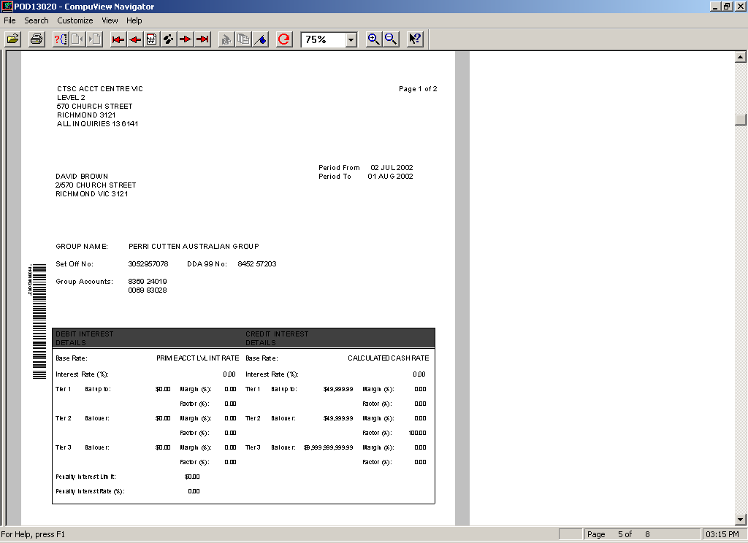

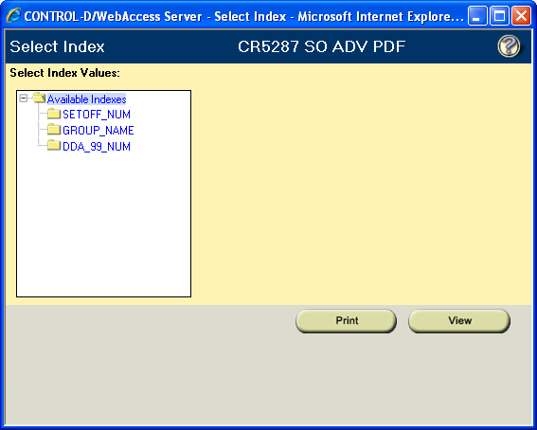
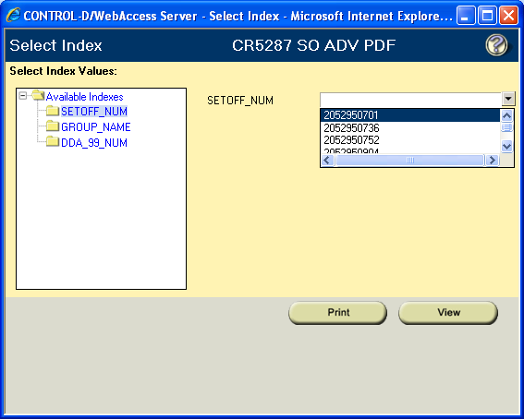

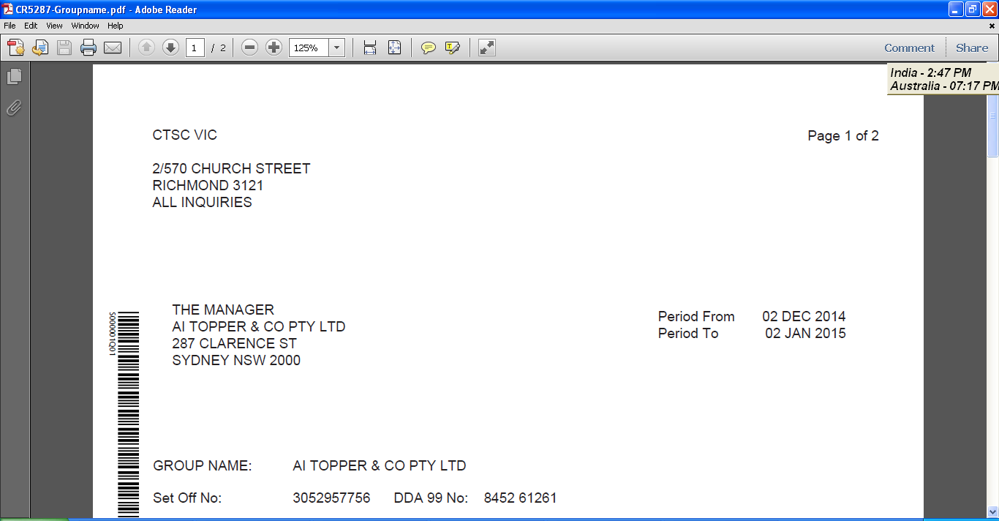

  - Multiple Copies

Multiple copies of the Customer Advice can be specified if requested by the customer. The required number of copies is recorded on the DDA 99 account using the DDA Statement Definitions (DD03) screen.

If multiple copies of the document are specified for a DDA 99 account, the Customer Advice will display “ORIGINAL” on the first document and then subsequent documents will display “COPY X OF X”.

Example:

A DDA 99 account has a value of 03 recorded in the “Number of Copies” field. The following narratives on the Customer Advice will be displayed:

- ORIGINAL
- Copy 1 of 2
- Copy 2 of 2.

Note: Each document will be mailed in a separate envelope to the customer since Output Services do not currently provide co-envelope functionality and the maximum number of pages that can fit in the envelope is 7 pages – any more than 7 pages causes the Printer to jam.

____ DD03 2 IDS DDA STATEMENT DEFINITIONS 09/02/2010 18.11
DDMN MESSAGE: ACTION SUCCESSFUL
ACTION INQ PRODUCT DDA ACCOUNT 845299999

STATEMENT DEFINITIONS

STATEMENT CYCLE 1 IM DATE NEXT DUE 01/11/2009
CYCLE 2 00 DATE NEXT DUE

MAILING CODE 97 DATE LAST ISSUE 01/10/2009

NUMBER OF COPIES 03 CASUAL REQUEST(Y/N) N

ACCOUNT SHORT NAME R------------- SOI

  - Production Method

The Customer Advice is produced by CACHE and reported into one of 2 files:

- the “in balance” file, or
- the “out of balance” file.

The Customer Advice is created by CACHE at the end of the reporting period, e.g. monthly interest cycle, by recalculating the daily interest rate and interest amounts applicable for each daily net balance including backdated transactions.

Note: A few customers in the past have had an additional copy emailed in PDF format. This has historically been a manual action performed by Operations Australia.

  - “In balance” file

The “In balance” file is produced from the CACHE Jobname CMMDR327.

All documents that are held in the “in balance” file are automatically printed at Output Services and mailed directly to the customer.

  - Accessing the “In balance” file

The “In balance” file is accessed from Control-D Web by entering the Job Name “CMMDR327” as shown below:
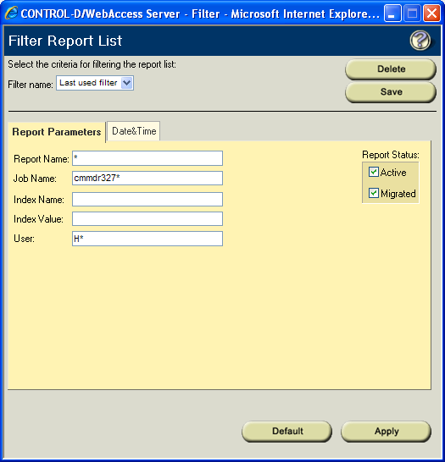

Additional copies or reprints of the Customer Advice can be produced by accessing this file and printing the document on ANZ Letterhead.

  - “Out of balance” file

The “Out of balance” file is produced from the CACHE Jobname CMMDR328.

Documents held in this file are NOT printed at Output Services.

All documents held in this file MUST be reviewed and actioned by the Melbourne Operations Setoff Team, immediately following the interest has cycled on the DDA 99 account, i.e. after the monthly interest cycling or when the DDA 99 account has been closed.

The CMMDR328 file will not be produced in Control-D Web if there are no DDA 99 accounts that have met the “Out of balance” criteria for the interest cycle.

  - “Out of balance” criteria

DDA 99 accounts will report in the “out of balance” file under the following circumstances;

- If credit interest as calculated by the Customer Advice does not equal the amount of credit interest paid to the DDA 99 account
- If debit interest as calculated by the Customer Advice does not equal the amount of debit interest charged to the DDA 99 account
- If both Total debit and credit interest amounts calculated by the Customer Advice equals zero
- If the DDA 99 account became operational during the reporting period but has an effective date prior to the reporting period, i.e. backdated DDA 99 account open.
- If there is a discrepancy of an amount of $0.01 or more between the actual debit or credit interest amount charged/paid to the DDA 99 account and the amount detailed on the Customer Advice, the DDA 99 account will be reported on the CR5203 Account Exceptions Report with the message:

CHECK CR5287 INT ACCRUAL

The Debit and Credit Interest amounts calculated by the Customer Advice are likely to differ to the amounts charged and paid to the DDA 99 account if there have been more than 2 interest rate structures applied to the DDA 99 account during the interest charging period. Refer Setoff Arrangement Interest Processing Reference Module for further details regarding the maintenance to the interest rate structure for the DDA 99 account.

  - Accessing the “Out of balance” file

The “Out of balance” file is accessed from Control-D Web by entering the Job Name “CMMDR328” as shown below:

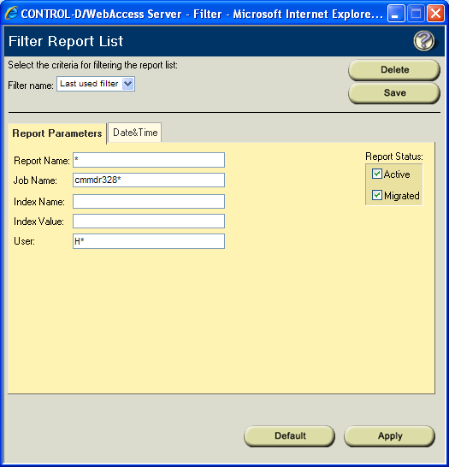

  - Review of “Out of balance” file

If the account is produced in the “out of balance” file, the Customer Advice must be reviewed to determine the reason of it being reported in this file.

The daily net balance and interest rates displayed on the document must be verified against the daily balances displayed on the DDA Balance History (IDSR > DDMN > DD06) screen and the interest rate history (IDSR > DDMN > DD11, DD12 and DD13) screens respectively for the DDA 99 account.

If subsequent review of the document determines that the details displayed on the Customer Advice are correct, the document must be printed on ANZ Letterhead and mailed to the customer.

If subsequent review of the document determines that the details are incorrect, the Customer Advice must be manually reproduced using the Excel template created and held by the Melbourne Operations Setoff Team.

Refer to the Setoff Arrangement Interest processing Reference Module for details such as the calculation of the daily weighted average interest rate, procedure for enquiring on historical interest rate structures for the DDA 99 account etc.

  - Mailing of Customer Advice

- The Customer Advice is mailed automatically to the Mailing Address of the DDA 99 account if the account is produced in the “In balance” file.

- If the Customer Advice is printed from the “Out of balance” file after confirming the details displayed on the document are correct, the document must be printed on ANZ Letterhead stationery and mailed to the customer.

- If the Customer Advice is produced using the Excel template by the Melbourne Operations Setoff Team, the document must be printed on ANZ Letterhead stationery and mailed to the customer.

  - Statement of Account

The “normal” Statement of Account produced by CACHE is suppressed for the DDA 99 account by recording the Statement Mailing Code of “97” on the DDA Statement Definitions (DD03) screen.

ANZ Legal & Risk Compliance advised that the transaction record of the DDA 99 account must not be printed on the Statement of Account stationery normally used for statements distributed to customers because it is a “phantom” account.

However, the statement file can be viewed by accessing the file through Control-D Web under “CMM-SUPR-STMT-BACKUP”. This file may be useful for internal enquiry purposes by Operations & Help Desk staff but must NOT be reprinted and provided to the customer.

Report References
The following CACHE reports relate to the automated calculation of interest for setoff arrangements:

External link | Refer to Reports BFS.  This can be located via PVCS – click here for Web Access.  Location: X\Projects\CACHE_ORION\Baseline Documentation\CACHE\.....

Report ID | Report Name | Brief Description | Document Link
AR0004 | CIS Maintenance Report
CR0010 | New/Reopened Transferred Report
CR0011 | Closed/Transferred Accounts Report
CR0091 | DDA Driver Relationship Report
CR0099 | Interest Paid Journal
CR0105 | Debit Interest Journal
CR0152 | Value Dated Items Report
CR0290 | DDA Maintenance Audit Journal
CR5149 | Transaction Posting Journal
CR5159 | Trial Balance
CR5199 | Lending Maintenance Audit Journal
CR5203 | Account Exceptions Report
CR5225 | Online Transaction Posting Journal
CR5266 | Withholding Tax Collected Transaction Journal
CR5285 | Interest Cycled on Setoff Account Report
CR5286 | Setoff Arrangement Details Report
CR5301 | Monthly Interest Rate Report
SR0005 | OTP Input List
XP5143 | Daily Set-off Balances Report
XP5144 | Weekly Set-off Interest Accrued Report
XP5145 | Set-off Backdated Transactions Report

  - CR0010 New/Reopened/Transferred Accounts Report
Displays DDA 99 account open details.

  - CR5286 Setoff Arrangement Details Report
Displays “SOA” relationship created between the SO account and the DDA 99 account, and “SOI” relationship created between the SO account and the individual DDA accounts.

  - CR0290 DDA Maintenance Audit Journal
Displays maintenance details for DDA 99 account; e.g. ANZIC Code, Withhold Code, Penalty Interest Indicator, Third Party Interest Payment DDA account number.

  - CR5199 Maintenance Audit Journal
Displays maintenance details for DDA 99 account Tiered Interest, Third Party Bank Fee Payment DDA account number, Setoff Service Fee, DDA 99 account Load Date and related SO account number.

  - AR0004 CIS Maintenance Audit Report
Displays maintenance details for DDA 99 account name, Mailing Title and Account to Customer relationship details.

  - CR0091 Driver Relationship Report
Displays details of SO Driver created for the individual DDA account with the DDA 99 account being the Related Account.

  - CR5149 Transaction Posting Journal
Displays details of Balance Load transactions posted to the DDA 99 account
Any Movement transactions (if open date was backdated) and Effective Dated transactions posted to the DDA 99 account.
Setoff Establishment Fee transaction posted to the DDA 99 account will also be included.

  - CR5159 Trial Balance Report
Displays DDA 99 account Current Balance, Limit, Debit Interest Accrued and Credit Interest Accrued details.

  - CR5285 Interest Cycled on Setoff Account Report
The CR5285 Interest Cycled on Setoff Account Report is produced after the cycling of interest on the DDA 99 account, i.e. monthly and at account closure.
The following information is displayed on this report:
- DDA 99 account number
- SO account number
- DDA 99 account name
- Total amount of Debit Interest Charged for the period
- Previous month amount of Debit Interest Charged
- % Change in amount of Debit Interest charged from the Previous month
- Total amount of Credit Interest Charged for the period
- Amount of Withholding Tax Collected
- Previous month amount of Credit Interest Charged
- % Change in amount of Credit Interest charged from the Previous month
- Third Party DDA account number for interest charged/paid
Example of CR5285

Note the below report has had customer details removed/blocked.

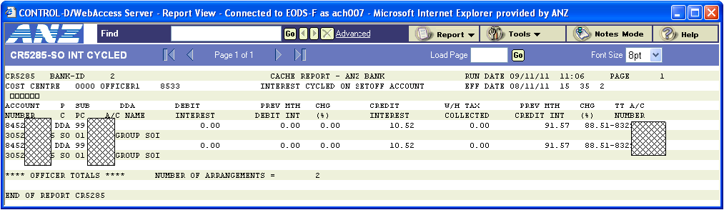

CR5285 BANK-ID 2 CACHE REPORT - ANZ BANK RUN DATE 03/01/10 17:30 PAGE 3
COST CENTRE 0000 OFFICER1 0111 INTEREST CYCLED ON SETOFF ACCOUNT EFF DATE 02/01/10 37 09 5
àààààà
ACCOUNT P SUB DDA DEBIT PREV MTH CHG CREDIT W/H TAX PREV MTH CHG TT A/C
NUMBER C PC A/C NAME INTEREST DEBIT INT (%) INTEREST COLLECTED CREDIT INT (%) NUMBER
845255544 DDA 99 8,342.55 4,538.23 83.82 631.58 0.00 1,406.40 55.09-833433333
2052950000 SO 01 AAAAAXXXXXXX
845299999 DDA 99 687.02 1,375.51 50.05- 839.35 0.00 431.00 94.74 775411111
2052951111 SO 01 AAAAAXXXXXX SOI
845255577 DDA 99 1,993.93 1,121.97 77.71 258.54 0.00 1,437.70 82.01-835577777
3052000000 SO 01 AAAAAA SETOFF AC

**** OFFICER TOTALS **** NUMBER OF ARRANGEMENTS = 3

  - CR5286 Setoff Arrangement Details Report

The CR5286 Setoff Arrangement Details Report is produced whenever there is an addition or removal of an account to account relationship for a new or existing setoff arrangement on CACHE.

The following information is displayed on this report:
- SO Account Name | - SO Subproduct Code
- SO Account Number | - DDA 99 Account Name
- DDA 99 Account Number | - Individual DDA Account Number
- Individual DDA Subproduct Code | - Individual DDA Account Name
- Account to Account Relationship Code | - Action
- Operator ID | - Date of activity
- Time of activity
This report can be viewed using Control-D/PC.

Action: Confirm the successful maintenance to the setoff arrangement using the Setoff Arrangement Schedule form.

Example CR5286
Note the below reports have had customer details removed/blocked.
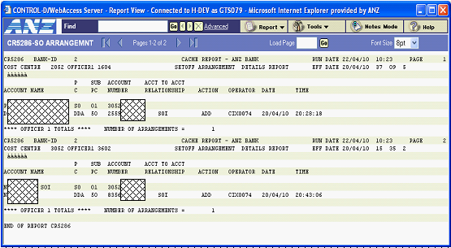

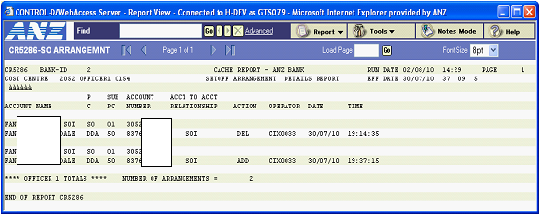

  - CR5203 Account Exceptions Report

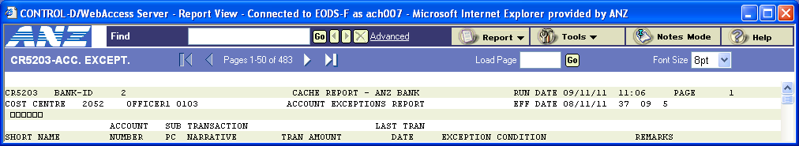

Backdated and Reversal transactions effective dated prior to the last interest cycle and/or last interest code change that are processed to the DDA 99 account are displayed on this report for appropriate action.

The integrity of the automated interest calculation for setoff arrangements is dependant on the complete and accurate setup of the individual DDA accounts, the DDA 99 account and the SO Setoff account.

To assist the monitoring of the setoff arrangements, the following Exception Conditions are reported for attention and required corrective action:

- DDA 99 account without SO account – “No SO a/c linked to DDA 99”
- SO account without any SOI relationships, due to no Drivers relationships on the DDA 99 account – “No SOI links exist”
- DDA 99 account that has been closed however the SOA relationship has not been removed – “SOA link on closed DDA 99”.

In addition to these exception conditions, the DDA 99 account will be reported when the Customer Advice has been produced into the “Out of Balance” file – Check “CR5287 Int Accrual”. Refer Setoff Arrangement Customer Reporting Reference Module for required action.

  - SR0005 OTP Input List

Note the below report has had customer details removed/blocked.

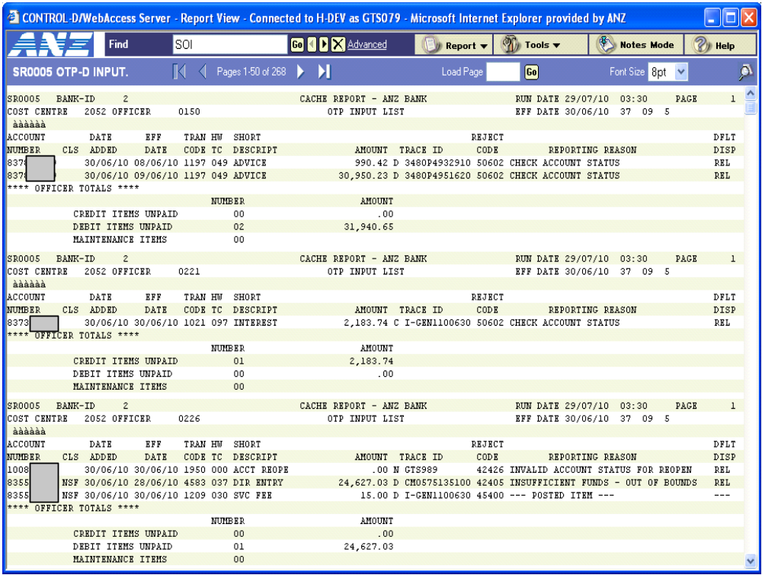

The closure of a DDA 99 account is reported on the SR0005 OTP Input List if either of the following situation occurs:

- If the individual DDA account balances have not been removed from the DDA 99 account prior to the account closure transaction being processed, the transaction will be rejected to the SR0005 OTP Input List. Condition Code 2072 ‘DDA 99 balance not zero’ will be displayed on the report for information purposes.

  - CR5149 Transaction Posting Journal

All CACHE transactions posted to the DDA 99 account are displayed on the CR5149 Transaction Posting Journal.

The CR5149 Transaction Posting Journal includes a field to identify whether an account is involved in a setoff arrangement to assist the ACR Balancing Tool used for System Balancing verification.

The “SO” field displays the following:

- a value of “A” if the account number is the DDA 99 account
- a value of “I” if the account number is related to an SO account with a “SOI” relationship
- a value of “space” if the account number is not involved in a setoff arrangement.

Note the below report has had customer details removed/blocked.

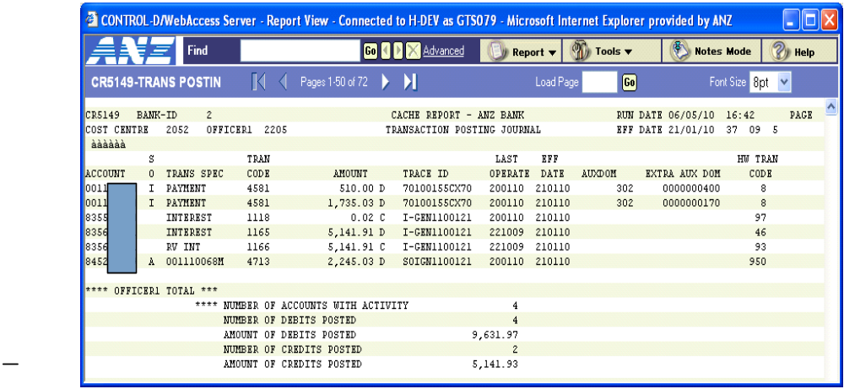

  - CR5159 Trial Balance Report

The DDA 99 account is displayed on the CR5159 Trial Balance Report.

The CR5159 Trial Balance Report includes a field to identify whether an account is involved in a setoff arrangement to assist the ACR Balancing Tool used for System Balancing verification.

The “SO” field will display the following:

- a value of “A” if the account number is the DDA 99 account
- a value of “I” if the account number is related to an SO account with a “SOI” relationship
- a value of “space” if the account number is not involved in a setoff arrangement.

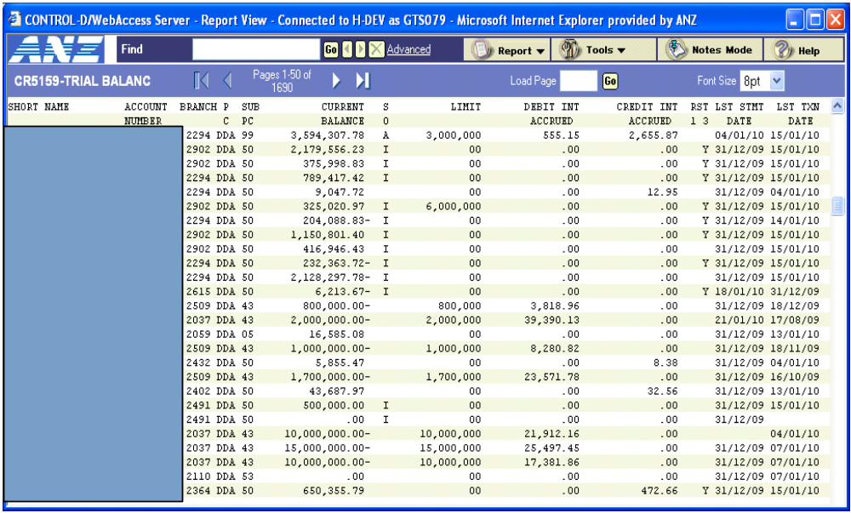

Note the above report has had customer details removed/blocked.

PCD / Parameter Tables
  - PCD / Parameter Table References

PCD 76007 - Sub Product Description (Alt 1607)
User Key DDA
Sub Product Code 99
Company ID DFLT
Effective Date 85/01/01

Entry displayed as follows:
Sub-Product Description DDA SETOFF GROUP LEVEL INTEREST
Account Code 108
Account Type IBA
Account Class 18
Fixed Indicator N
Load or Overdraft Indicator O

PCD 1600 - Account Coding Structure
User Key DDA99
Company ID 2
Effective Date 85/01/01
Details are the same as DDA02 except for the following:
Service Charge Type Code 00
Service Charge Waive Code 00

PCD 71024 - Account Coding Defaults (Alt 1619)
User Key DDA99
Company ID 2
Effective Date 85/01/01
Details are the same as DDA70 except for the following:
Statement Cycle – First IM
Mailing Code 97
Debit Interest Pay Cycle Code 32

PCD 1623 - Account Demographic Defaults
User Key DDA99
Company ID DFLT
Effective Date 85/01/01
Details are the same as DDA50 except for the following:
Short Name SETOFF INT

PCD 71089 – Penalty Interest Note: This is a non-migratable PCD.
User Key DDA99
Company ID 2
Effective Date 85/01/01
Details are the same as DDA70.

PCD 71148 – Default Values for ANZ DDA fields
(Mismatch on IMSQ & IMSA => Restore IMSA PCD from Prod)
User Key DDA99
Company ID 2
Effective Date 85/01/01
Details are the same as DDA70.

PCD 59002 – HSS Prod/Subproduct Defaults
User Key DDA99
Company ID DFLT
Effective Date 85/01/01
Details are the same as DDA05.

PCD 1641 - Transaction processing control
User Key 00044204673
Company ID DFLT
Effective Date 85/01/01

Interfaces

  - Online
- ORION: While there are no Setoffs established within Orion there is a requirement that the Net Limit Facility Arrangement be created and maintained correctly within Orion to ensure the correct fees and interest.
Users should note that on any limit loading on any account within a Setoff for Interest Purposes that there should be NO PENALTY interest and all references to Penalty Interest for GROSS or NET limit excesses should be set to 0.00 in the Facility Arrangement.

  - Batch

- GIW: The nightly TIP files to GIW will have unique trancodes included.

The PIP file from DR0160 has been separated into two files in CMMID986 to allow GIW to receive the DDA99 file separately. To have had it designed differently would have required many changes to GIW JCL and programs to exclude DDA99 from certain processes.

GIW caters for the Setoff Interest accruals, payments and fees on DDA99 accounts so that figures from GIW for G/L balancing and MARS reporting are in line with CACHE. For automation GIW had changes to a daily focus due to 1st of month processing within CACHE which conflicted with the end of month table loads for GIW.

Two files were created when setoffs were automated, these are sent from CMMID989:

CACSETOA:

This file contains the raw format for XP5143 Setoff Daily Balances Report from CMMDR320 to get gross daily debit and credit balances for accounts within a setoff arrangement.

CACSETOB:

This file contains the raw format for report CR5287 Monthly Customer Advice strings prior to xPression software reformat. This provides GIW with a picture of the entire month’s daily interest weighted rate and recalculated Interest and penalty accrual.
The files would get updated by xPression and the customer advices would be loaded into PDF format by CACHE job CMMDR327/CMMDR328 .

Hints and Tips
  - Testing Considerations

- Open DDA sub product 99 account (using mix of Auto-Populated and Pre-Allocated account numbers);
  - include a backdated open date to start of cycle (i.e. first business day of monthly interest cycle).
  - include an account opened under the current system date.
  - include a backdated open date a few days back (system date wise).

- Open SO sub product 01 account (setoff for interest purposes), using mix of Auto-Populated and Pre-Allocated account numbers.
  - include a backdated open date to start of cycle (i.e. first business day of monthly interest cycle).
  - include an account opened under the current system date.
  - include a backdated open date a few days back (system date wise).

- Link a minimum of 2 valid sub product DDA accounts to new setoff, with a
  - Validate screen flow.
  - Ensure the “Interest Codes” (both DR & CR) automatically change to “00”.
  - Validate the old interest codes are stored in DDMU78.
  - Validate the Setoff Driver via CACHE DD05 & DP00 screen for the account added.
  - Ensure the “Setoff State Date” field on the CACHE DD01 screen is populated with the current system date.
    - Ensure field is editable (only for date linked).
    - Ensure the field is not editable post batch.

- Ensure after batch for an account being linked and backdated into a SOI (setoff) that the DDA 99 account reflects a load of the historic balances, i.e. that BALANCE LOAD (“B”) transactions are generated and displayed correctly as account number for 9 digits followed by “B”; “#########B”. The account number shown on the “B” transaction would be the account the balance is in reference too.

- Link a valid sub product DDA account to existing setoff.
  - Verify the account “Group Limit Interchange (Y/N)” field on CACHE screen DD01 is correctly displaying “C” meaning it has been created as a Group Limit within Orion.

- Ensure Fee Details are correct (DD02) for the DDA 99 account:
  - Ensure “Third Party Account to Debit for Government Charges” and “Third Party Account to Debit for Bank Fees” fields are mandatory.
  - Ensure Service Charge Type Code is defaulted to “00” (Exemption from Fees) and is disabled.
  - Ensure Waive Code defaults to “00” (Default-Do Not Waive) and is disabled.

- Validate the following fields on DD02:
  - Setoff Service Fee Charge Code. Ensure default value is “81” (Default Code) and field is editable.
  - Setoff Service Fee Waive Code. Ensure default value is “00” (Default-Do Not Waive) and field is editable.
  - Setoff Service Fee Amt Per Item. Ensure default value is “2.38” and field is disabled. Ensure if Setoff Service Fee Charge Code is changed to “71” (Non Standard), field is enabled.
  - Setoff Establishment Charge Code. Ensure default value is “81” (Default Code) and field is enabled.
  - Setoff Establishment Waive Code. Ensure default value is “00” (Default-Do Not Waive) and field is enabled.
  - Setoff Establishment Fee. Ensure default value is “100.00” and field is disabled. Ensure if Setoff Service Fee Charge Code is changed to “71”, field is enabled.

- Ensure that Monthly Setoff statement is generated;
  - Statement Cycle Code is “IM” (Monthly on nominated date), and cannot be amended.
  - Ensure statement date is not a weekend or public holiday, must be Business Day.
  - Validate both types: IN BALANCE & OUT OF BALANCE statements.
  - Ensure Mailing Code is defaulted to “97” (Suppress Statement), and cannot be amended.

- Validate report CR5159 Trial Balance Report for account Balance.
  - Ensure accounts are shown with “I” indicator for setoff participant.
  - Validate all account balances on report equal the setoff balance.

Post transaction via DBD$ and have transaction approved via TRAS (Transaction Approval System). Then after batch verify the DDA 99 reflects a “M” (Movement) transaction for the account you changed the balance for. Ensure you check that the M is the total difference from the previous days total (refer CR5159 Trial Balance Report)

- Create a backdated transaction via DBD$.
  - Verify the DDA 99 account shows an “E” (Effectively Dated) transaction with the reflected effective date.
  - Verify the “E” transaction shows the account number you performed a backdate on as part of the description. The format should be the account number as the first 9 digits followed by the “E”: “#########E”. The account number shown on the “E” transaction would be the account the transaction is in reference too.
  - Attempt to reverse a DDA 99 transaction, to create an “R” (Reversal) transaction. Like others the “R” will be the 10th character after the account number of the transaction reversed, “#########R”.

- Delink (remove) account from the Setoff (SO) account via ACAC using DEL.
  - Remove balance prior to DEL
  - For other account do not remove balance and delink (this will create an out of balance account for statement purposes, it will also THROW OUT SYSTEM BALANCING!
  - Validate the old interest codes (prior to being added to setoff) that were held in DDMU78 are reloaded automatically by CACHE one accounts have been removed from Setoff (ACAC SOI relationship).

- Ensure that at the end of the CACHE monthly cycle (end of the first business day of the month) that:
  - Interest has cycled out correctly.
  - The Customer Set-Off Advice has generated with correct details.
  - The statement has been generated on Control-D and reflects the correct interest amount.
  - That the GL entry has been correctly generated.

Negative tests – to ensure validations are still operating:

- Attempt to link a DDA 99 account to a Setoff for other purposes (SO 02).
- Attempt via ACAC screen to have two SOA (DDA 99) accounts linked to SO Account.
- Attempt to Backdate “Setoff State Date” of account to Setoff to a period in the previous month [prior cycle] (via DD01 screen).
- Attempt to Backdate “Setoff State Date” of account to Setoff to a period prior to the Setoff A/C Open Date (via DD01 screen).

  - CACHE Setoff Arrangements FAQs

An Interest Set Off is a concession granted to a single entity or group of entities whereby credit and debit balances are set off for the purpose for calculating interest.

A Setoff arrangement allows the customer to operate accounts in both debit and credit yet pay interest only on the Group aggregate net debit balance of those accounts or, if applicable, be paid interest on an aggregate net credit balance.

When the automation of Setoff calculation was installed in 2002 the Business Requirement was that interest now be calculated and charged automatically by CACHE at Set Off Group Level, i.e. interest is calculated at Set Off Group Level on the NET Set Off Account Balance.

1. Could you please advise the purpose of the Net Setoff Limit?

A ‘Gross Limit’ is a limit on the aggregate debit balances of accounts for a customer/customer group.

A ‘Net Limit’ is a limit on the aggregate net debit balance of eligible accounts for a customer / customer group.

A Gross and Net Limits arrangement allows the customer to operate separate accounts in either debit or credit with a specified gross limit available to cover aggregate debit balances, subject to the net debt not exceeding an agreed Net Limit.

A Net Limit (which must be less than the Gross Limit) may be required for:

- Pricing and profitability purposes, whereby the Bank can rely on the net debit balance not exceeding the agreed Net Limit and report net balances to the Reserve Bank of Australia for Non Callable Deposit, Prime Asset Ratio and capital adequacy purposes; and / or
- Credit purposes, in that:
  - Access to the Gross Limit is subject to the condition that the net debit balance does not exceed the agreed Net Limit; and
  - As a measure of comfort to the Bank that it has the right to immediately, without limitation, set off the debit balances to reduce debt without prior reference to the customer.

Sourced: IBB Credit Management, Product Policy & Procedures, August 1997

2. If there are Gross Limits at the SOI accounts, can the Net Setoff limit be zero?

A Gross and Net Limits arrangement must be for different amounts, with the net limit lower than the gross limit. Therefore the Net limit can be zero.

If the customer is required to operate on a net credit basis, the Net Limit is recorded as zero.

3. There are accounts (SOI) within the setoff group that contain gross individual limits, does the Net Setoff limit override all the individual gross limits?

Where Setoff arrangements exist, excesses must be analysed on both a gross and net basis.

4. For Setoff interest calculations, if there is a Net Setoff limit will this be used as the calculation process for excesses or will it be the total of the gross individual limits?

Where customers have gross and net limit arrangement in connection with overdrafts on current accounts, the Credit Limit reported in the credit memoranda is to be based upon the gross requirement.

5.1. Is there such a thing as Setoff for Principal (Outstandings) purposes. i.e. that the Setoff interest is calculated based on either the net or gross method (dependent on answers above) but reporting of the limit against the outstandings, will it be the Net Limit?

Setoff of Principal allows the Bank to set off the principal balances of accounts of a customer entity or number of customer entities. Setoff for Principal can be based on either Gross or Net Limits.

Setoff for Other Purposes (i.e. principal) Groups was excluded from the automation of CACHE Setoffs.

55.2. I have identified where there are CACHE Sub Product 99 (SOA) accounts where there are (1) Net Setoff Limits greater than zero and (2) zero balance accounts. If a Net Limit is to be used but it is zero and within this Setoff Group i.e. SOI accounts have individual account Limits are we to use this as the Total Limits for this Group.

In the above example where the net Limit is zero it would not be used. The Gross Limit would be taken into consideration. This example and other like it should however be directed to the Setoff Team in Operations (Richmond or Bangalore) to ensure the account structure is set up correctly.

Tiered Interest Rate Structure Examples:
Example 1:

To charge Business Deposit Rate up to $10,000,000.00, then 2 points over $10,000,000.00, enter the following details on the DD13 screen:

 | Percentage Factor % | Points Difference | Limit
Level 1 | 1.00000 | 0.00000 | 9,999,999.99
Level 2 | 1.00000 | 2.00000 | 99,999,999,999.99
Level 3 |  |  | 99,999,999,999.99
Level 4 |  |  | 99,999,999,999.99
Level 5 |  |  | 99,999,999,999.99
Level 6 |  |  | 99,999,999,999.99
Level 7 |  |  | 99,999,999,999.99
Level 8 |  |  | 99,999,999,999.99
Level 9

If the Business Deposit Rate is 2.80%, the interest rate on the DDA 99 account will be:
- 2.80% up to $10,000,000.00, then
- 4.80%

Example 2:

To charge 80% of the Business Deposit Rate plus 2 points up to $10,000,000.00, then 100% of Business Deposit Rate minus 1 point, enter the following details on the DD13 screen:

 | Percentage Factor % | Points Difference | Limit
Level 1 | 0.80000 | 2.00000 | 9,999,999.99
Level 2 | 1.00000 | -1.00000 | 99,999,999,999.99
Level 3 |  |  | 99,999,999,999.99
Level 4 |  |  | 99,999,999,999.99
Level 5 |  |  | 99,999,999,999.99
Level 6 |  |  | 99,999,999,999.99
Level 7 |  |  | 99,999,999,999.99
Level 8 |  |  | 99,999,999,999.99
Level 9

If the Business Deposit Rate is 2.80%, the interest rate on the DDA 99 account will be:
- 4.24% up to $10,000,000.00, then
- 1.80%

Example 3:

To charge 80% of the Business Deposit Rate plus 2 points up to $10,000,000.00, then 100% of Business Deposit Rate plus 1 point up to $20,000,000.00, then 100% of the Business Deposit Rate, enter the following details on the DD13 screen:
 | Percentage Factor % | Points Difference | Limit
Level 1 | 0.80000 | 2.00000 | 9,999,999.99
Level 2 | 1.00000 | 1.00000 | 19,999,999.99
Level 3 | 1.00000 | 0.00000 | 99,999,999,999.99
Level 4 |  |  | 99,999,999,999.99
Level 5 |  |  | 99,999,999,999.99
Level 6 |  |  | 99,999,999,999.99
Level 7 |  |  | 99,999,999,999.99
Level 8 |  |  | 99,999,999,999.99
Level 9

If the Business Deposit Rate is 2.80%, the interest rate on the DDA 99 account will be:
- 4.24% up to $10,000,000.00, then
- 3.80% up to $20,000,000.00, then
- 2.80%

Example 4:

To charge NO interest up to $10,000,000.00, then 80% of the Business Deposit Rate plus 2 points up to $100,000,000.00, then 100% of Business Deposit Rate minus 1 point, enter the following details on the DD13 screen:

 | Percentage Factor % | Points Difference | Limit
Level 1 | 0.00000 | 0.00000 | 9,999,999.99
Level 2 | 0.80000 | 2.00000 | 99,999,999.99
Level 3 | 1.00000 | -1.00000 | 99,999,999,999.99
Level 4 |  |  | 99,999,999,999.99
Level 5 |  |  | 99,999,999,999.99
Level 6 |  |  | 99,999,999,999.99
Level 7 |  |  | 99,999,999,999.99
Level 8 |  |  | 99,999,999,999.99
Level 9

If the Business Deposit Rate is 2.80%, the interest rate on the DDA 99 account will be:
- 0% up to $10,000,000.00, then
- 4.24% up to $100,000,000.00, then
- 1.80%

Summary of Amendments
Additional amendments must be added after the previous amendment.

Date | Section | WR/AHD# | Implementation release and date | Author | Brief description of change
26/05/2010 | ALL | NA | NA | John Kirk | Initial Draft
27/10/2010 | ALL | NA | NA | John Kirk | Second Draft
14/01/2010 | ALL | NA | NA | John Kirk | Third Draft
10/11/2011 | ALL | NA | NA | John Kirk | Fourth Draft
21/11/2011 | ALL | NA | NA – post review | John Kirk | Approved Copy
28/05/2015 | All | WR22073 | Rel 15.2  23/05/2015 | Surya Prakash Raju | Changed for Customer advice reports.

